**PREGUNTA 1**

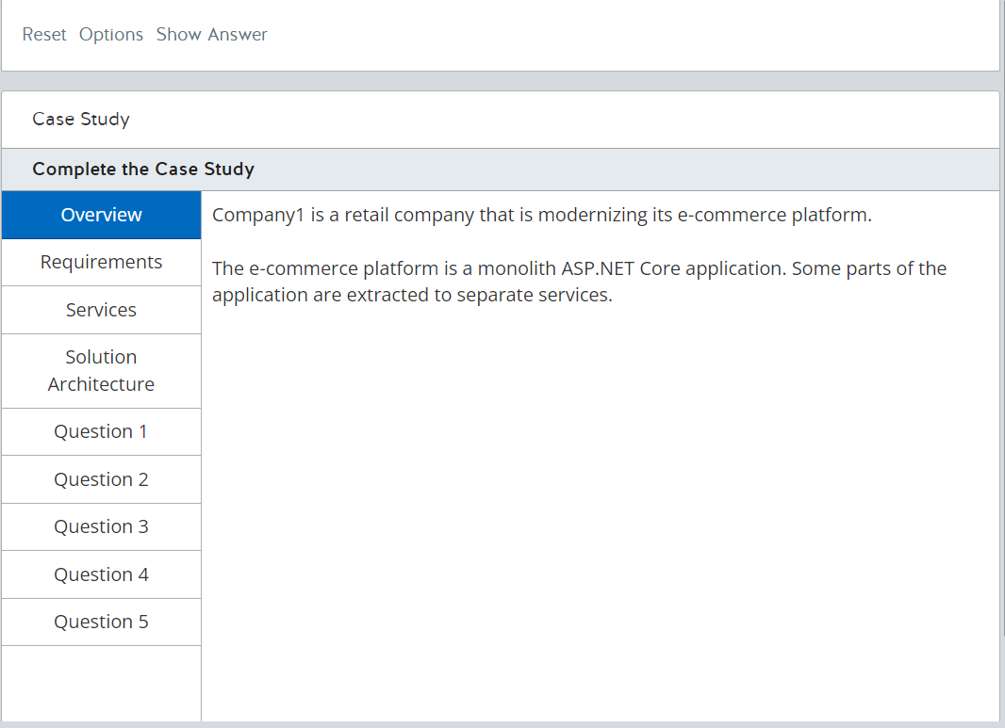

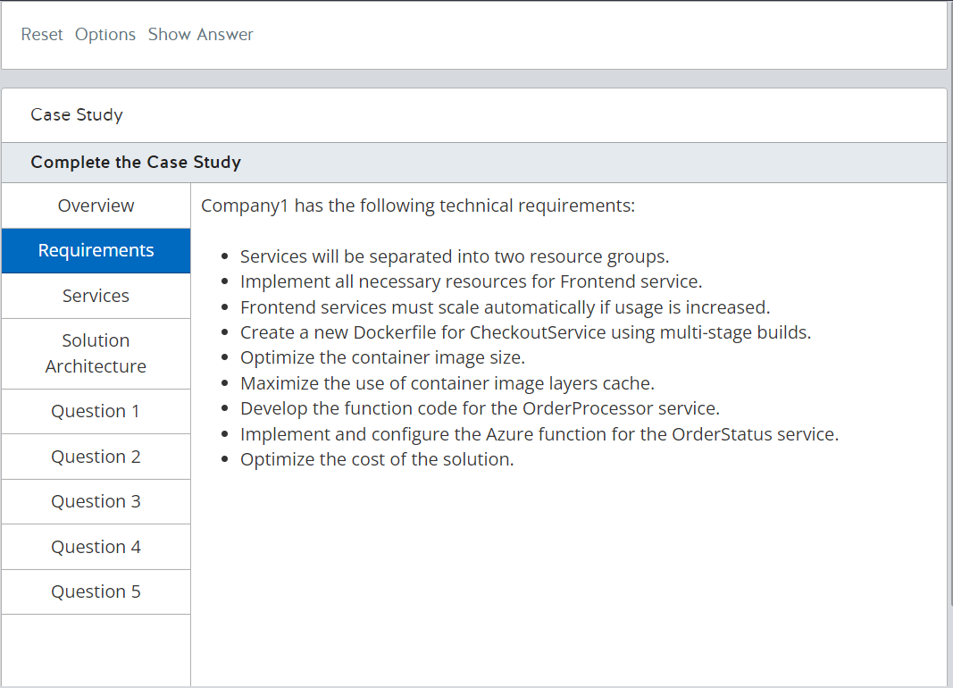

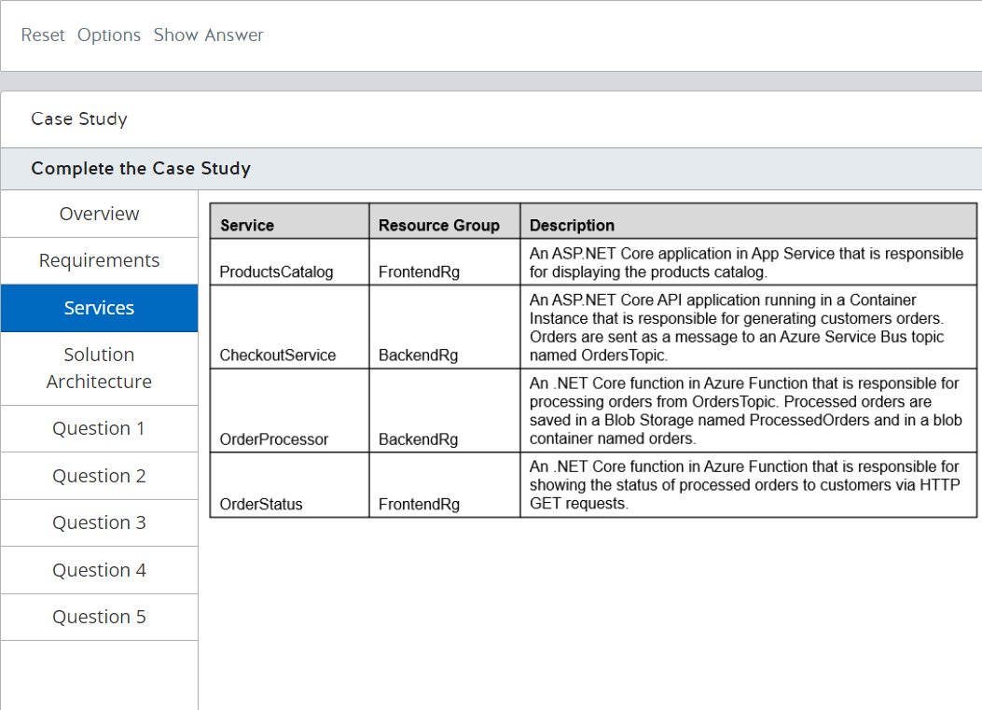

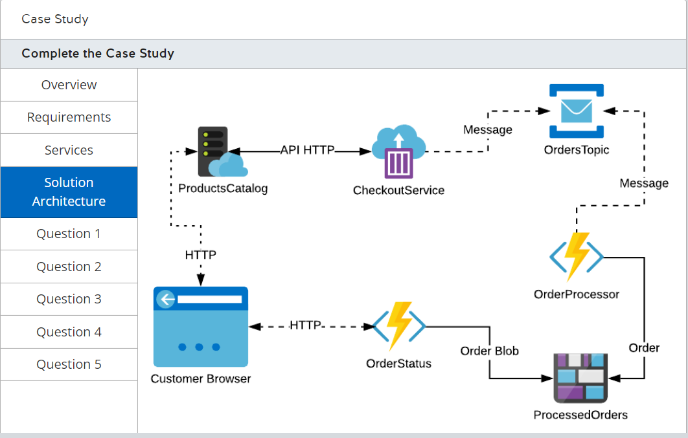

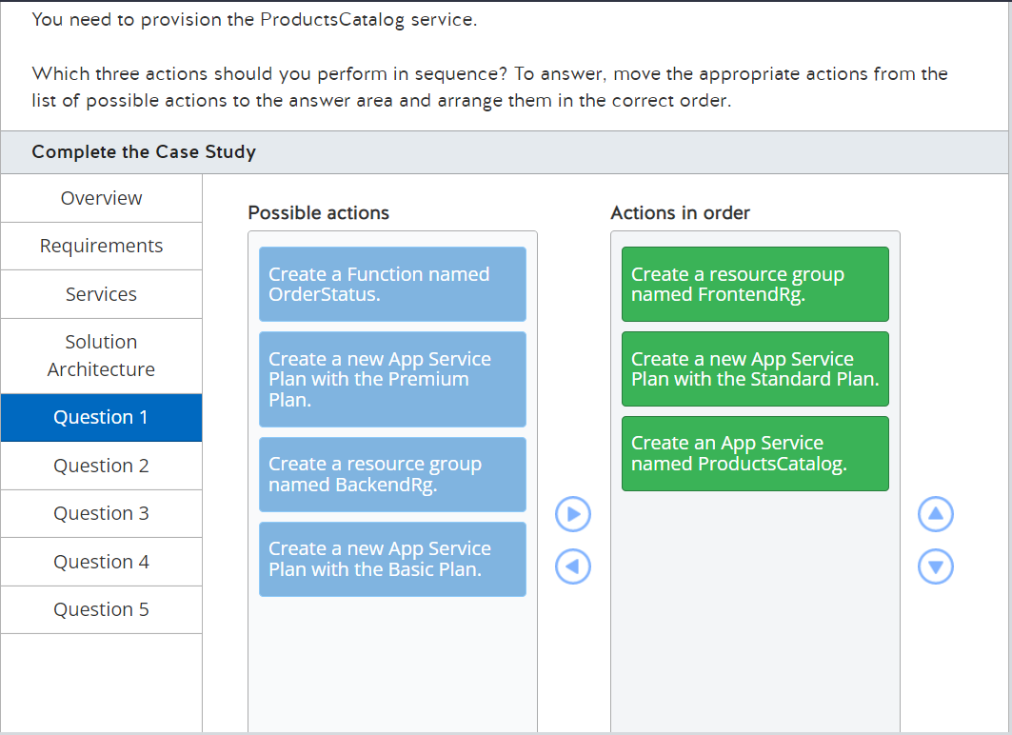

You should perform the following actions in order:

1. Create a resource group named FrontendRg.
2. Create a new App Service Plan with the Standard Plan.
3. Create an App Service named ProductsCatalog.

You should create a resource group named FrontendRg. This resource group is used to provision the Frontend services.  
  
You should also create a new App Service Plan with the Standard Plan. This is the most cost-efficient plan that supports automatic scaling.  
  
Finally, you should create an App Service named ProductsCatalog to host the ProductsCatalog service.  
  
You should not create a resource group named BackendRg. This Resource group should not be used with the Frontend service.  
  
You should not create a new App Service Plan with the Basic Plan. This plan does not support automatic scaling.  
  
You should not create a new App Service Plan with the Premium Plan. This plan supports automatic scaling. However, the Standard plan is more cost-efficient and also supports automatic scaling.  
  
You should not create a function named OrderStatus. This function should be created in another service.  
  
**References**  
  
[Quickstart: Deploy an ASP.NET web app](https://docs.microsoft.com/en-us/azure/app-service/containers/quickstart-dotnetcore)  
  
[Azure App Service plan overview](https://docs.microsoft.com/en-us/azure/app-service/overview-hosting-plans?toc=/azure/app-service/containers/toc.json)

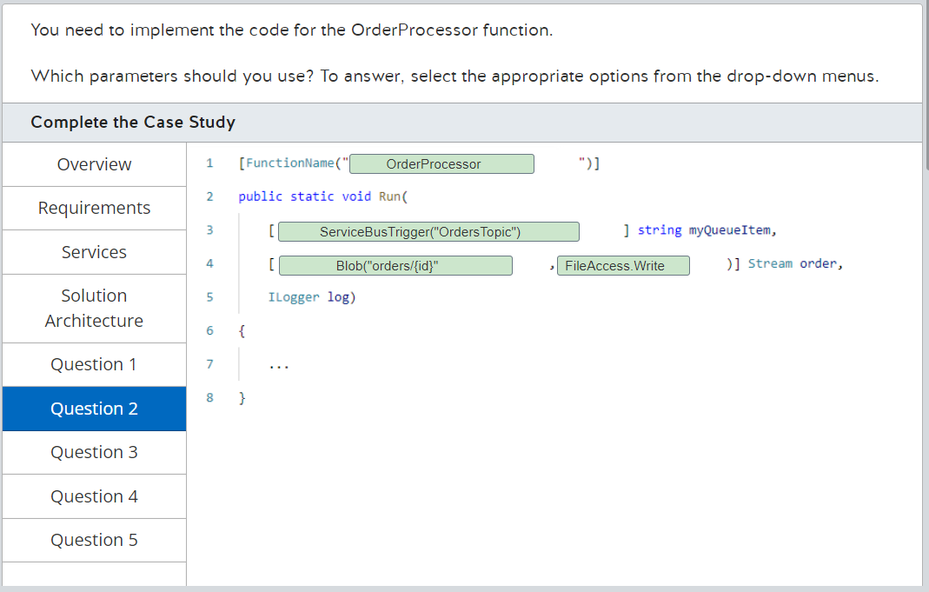

You should complete the code as shown below:  
  
[FunctionName("OrderProcessor")]  
public static void Run(  
    [ServiceBusTrigger("OrdersTopic")] string myQueueItem,   
    [Blob("orders/{id}", FileAccess.Write)] Stream order,   
    ILogger log)  
{  
    ...  
}  
  
You should complete the FunctionName as OrderProcessor to correctly name the service.  
  
You should also use the ServiceBusTrigger("OrdersTopic") parameter. You can bind this parameter as a Service Bus trigger to start the function when a new message is available in the topic.  
  
Finally, you should use the Blob("orders/{id}", FileAccess.Write) parameter. You can bind this parameter to persist the processed order in the Blog storage container named orders.  
  
You should not complete the FunctionName as OrderStatus. You should use this function name in another service.  
  
You should not use the BlobTrigger parameter. You should use this parameter to trigger a function when a new blob is stored in a Blob storage container.  
  
You should not use the ServiceBus parameter. You should use this parameter to send a new message to a Service Bus topic or queue.  
  
You should not use the FileAccess.Read parameter option. You should use this parameter option to read a blob in a Blob storage container.  
  
**References**  
  
[Azure Functions triggers and bindings concepts](https://docs.microsoft.com/en-us/azure/azure-functions/functions-triggers-bindings)  
  
[Azure Blob storage output binding for Azure Functions](https://docs.microsoft.com/en-us/azure/azure-functions/functions-bindings-storage-blob-output?tabs=csharp)  
  
[Azure Service Bus trigger for Azure Functions](https://docs.microsoft.com/en-us/azure/azure-functions/functions-bindings-service-bus-trigger?tabs=csharp)

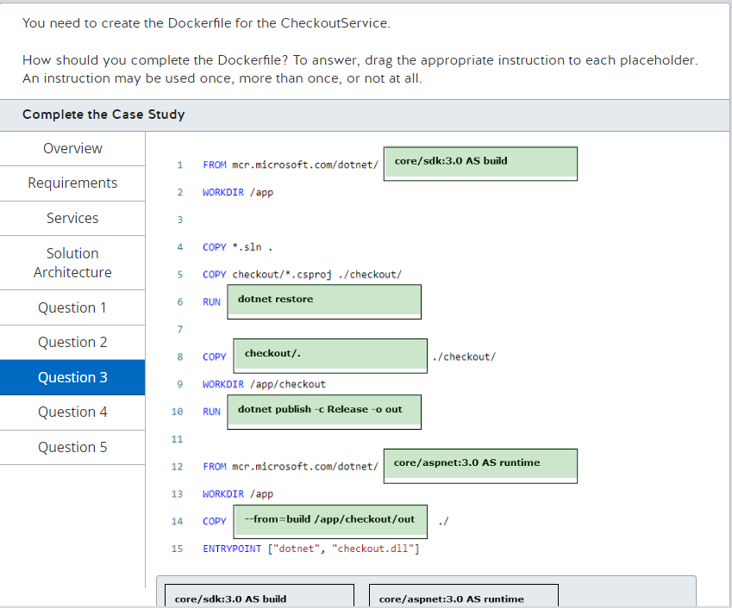

You should complete the code as shown below:  
  
[FunctionName("OrderProcessor")]  
public static void Run(  
    [ServiceBusTrigger("OrdersTopic")] string myQueueItem,   
    [Blob("orders/{id}", FileAccess.Write)] Stream order,   
    ILogger log)  
{  
    ...  
}  
  
You should complete the FunctionName as OrderProcessor to correctly name the service.  
  
You should also use the ServiceBusTrigger("OrdersTopic") parameter. You can bind this parameter as a Service Bus trigger to start the function when a new message is available in the topic.  
  
Finally, you should use the Blob("orders/{id}", FileAccess.Write) parameter. You can bind this parameter to persist the processed order in the Blog storage container named orders.  
  
You should not complete the FunctionName as OrderStatus. You should use this function name in another service.  
  
You should not use the BlobTrigger parameter. You should use this parameter to trigger a function when a new blob is stored in a Blob storage container.  
  
You should not use the ServiceBus parameter. You should use this parameter to send a new message to a Service Bus topic or queue.  
  
You should not use the FileAccess.Read parameter option. You should use this parameter option to read a blob in a Blob storage container.  
  
**References**  
  
[Azure Functions triggers and bindings concepts](https://docs.microsoft.com/en-us/azure/azure-functions/functions-triggers-bindings)  
  
[Azure Blob storage output binding for Azure Functions](https://docs.microsoft.com/en-us/azure/azure-functions/functions-bindings-storage-blob-output?tabs=csharp)  
  
[Azure Service Bus trigger for Azure Functions](https://docs.microsoft.com/en-us/azure/azure-functions/functions-bindings-service-bus-trigger?tabs=csharp)

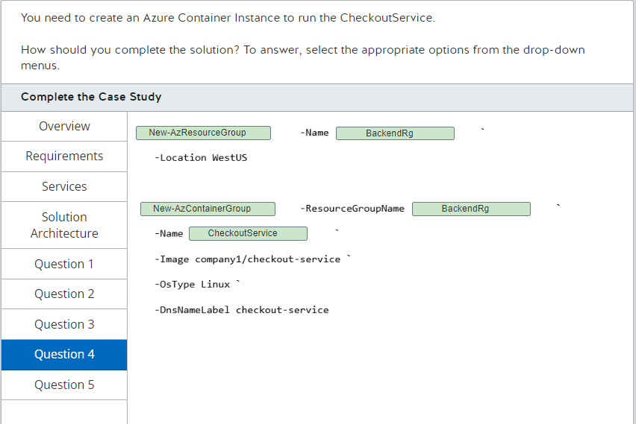

You should complete the solution as follows:  
  
New-AzResourceGroup -Name BackendRg `  
    -Location WestUS  
  
New-AzContainerGroup -ResourceGroupName BackendRg `  
    -Name CheckoutService `  
    -Image company1/checkout-service `  
    -OsType Linux `  
    -DnsNameLabel checkout-service  
  
You should use the New-AzResourceGroup cmdlet to create a new Resource Group, and use the -Name BackendRg parameter to create a resource group for the Backend services resources.  
  
You should also use the New-AzContainerGroup cmdlet to create a new Azure Container Instance. You should use the -Name CheckoutService parameter and the -ResourceGroupName BackendRg to implement the service in the appropriate resource group.  
  
You should not use the New-AzContainerService cmdlet to create a new Azure Container Service cluster. Azure Container Service is a deprecated service to manage container orchestrators such as Kubernetes, Swarm and DC/OS. You should use Azure Kubernetes Services to manage Kubernetes clusters.  
  
You should not use the FrontendRg Resource Group. This Resource group should not be used with the CheckoutService.  
  
You should not use ProductsCatalog and OrderStatus services. These services should be provisioned in the FrontendRg Resource Group and be implemented using App Service and Functions, respectively.  
  
**References**  
  
[Quickstart: Deploy a container instance in Azure using Azure PowerShell](https://docs.microsoft.com/en-us/azure/container-instances/container-instances-quickstart-powershell)  
  
[New-AzContainerService](https://docs.microsoft.com/en-us/powershell/module/az.compute/new-azcontainerservice?view=azps-3.8.0)

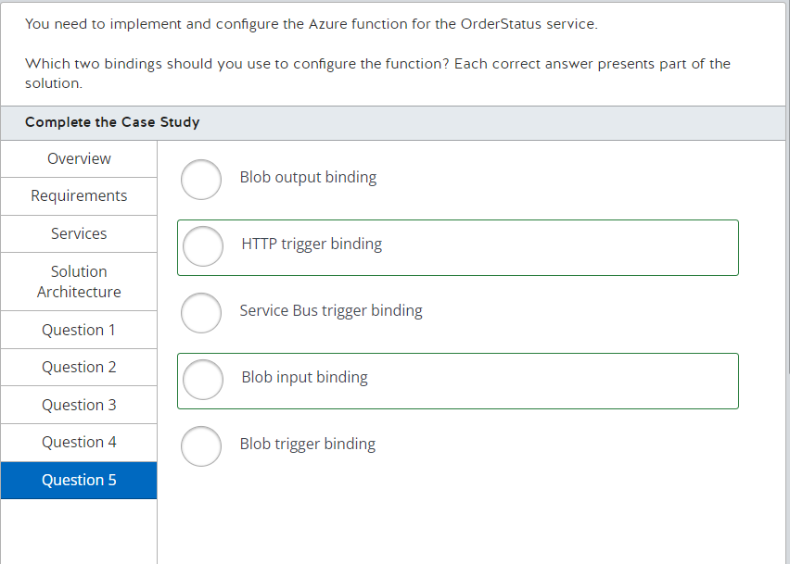

You should use the HTTP trigger binding to trigger the function from an HTTP endpoint.  
  
You should also use the blob input binding to read a processed order stored in the Blob storage.  
  
You should not use the blob trigger binding. You can use this binding to trigger a function when a new blob is saved in Blob storage.  
  
You should not use the Service Bus trigger or the blob output bindings. You should use these bindings in the OrderProcessor function service to trigger the function when a new message is sent to OrdersTopic and store the processed order in the Blob storage.  
  
**References**

[Azure Functions triggers and bindings concepts](https://docs.microsoft.com/en-us/azure/azure-functions/functions-triggers-bindings)  
  
[Azure Functions HTTP trigger](https://docs.microsoft.com/en-us/azure/azure-functions/functions-bindings-http-webhook-trigger?tabs=csharp)  
  
[Azure Blob storage bindings for Azure Functions overview](https://docs.microsoft.com/en-us/azure/azure-functions/functions-bindings-storage-blob)  
  
[Azure Service Bus trigger for Azure Functions](https://docs.microsoft.com/en-us/azure/azure-functions/functions-bindings-service-bus-trigger?tabs=csharp)

**PREGUNTA 2**

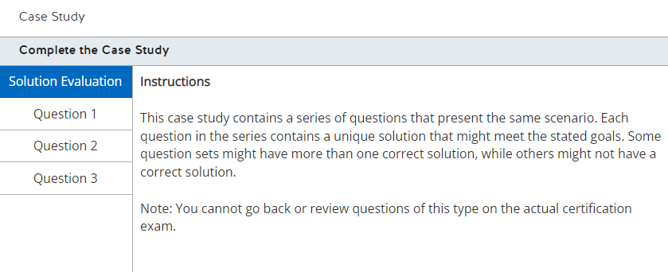

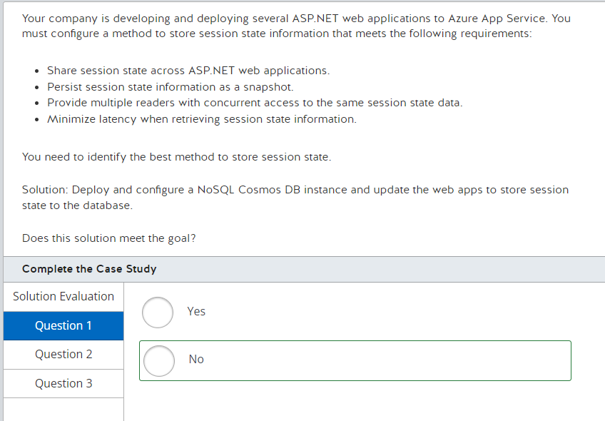

This solution does not meet the goal. You should not deploy and configure a NoSQL Cosmos DB instance and update the web apps to store session state to the database. ASP.NET applications support saving session state data to a SQL Server database, but they do not support storage to a NoSQL data store.  
  
**References**  
  
[Understanding the differences between NoSQL and relational databases](https://docs.microsoft.com/en-us/azure/cosmos-db/relational-nosql)  
  
[What is Azure Database for PostgreSQL?](https://docs.microsoft.com/en-us/azure/postgresql/overview)  
  
[About Azure Cache for Redis](https://docs.microsoft.com/en-us/azure/azure-cache-for-redis/cache-overview)  
  
[Configure data persistence for a Premium Azure Cache for Redis instance](https://docs.microsoft.com/en-us/azure/azure-cache-for-redis/cache-how-to-premium-persistence)

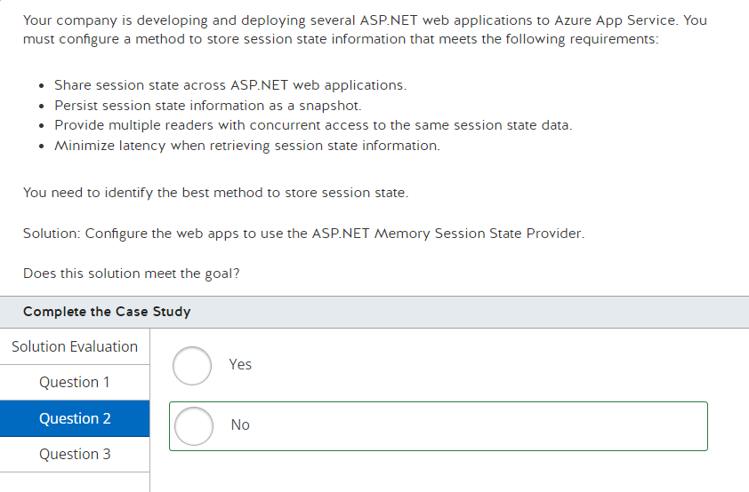

This solution does not meet the goal. You should not configure the web apps to use the ASP.NET Memory Session State Provider. This option stores session state in memory and would meet the requirement for minimizing latency. This does not meet the access requirement because the data is not distributed and would not be available to all web apps.  
  
**References**  
  
[Understanding the differences between NoSQL and relational databases](https://docs.microsoft.com/en-us/azure/cosmos-db/relational-nosql)  
  
[What is Azure Database for PostgreSQL?](https://docs.microsoft.com/en-us/azure/postgresql/overview)  
  
[About Azure Cache for Redis](https://docs.microsoft.com/en-us/azure/azure-cache-for-redis/cache-overview)  
  
[Configure data persistence for a Premium Azure Cache for Redis instance](https://docs.microsoft.com/en-us/azure/azure-cache-for-redis/cache-how-to-premium-persistence)

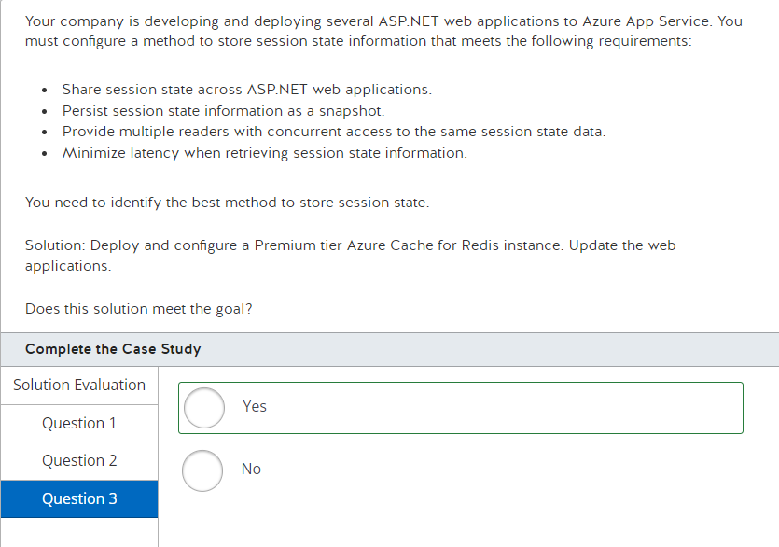 This solution meets the goal. You should deploy and configure a Premium tier Azure Cache for Redis instance and update the web applications. Azure Cache for Redis meets all storage requirements and is implemented as a distributed memory session state provider. Premium tier is required to provide for persisting session state data as a snapshot.  
  
**References**  
  
[Understanding the differences between NoSQL and relational databases](https://docs.microsoft.com/en-us/azure/cosmos-db/relational-nosql)  
  
[What is Azure Database for PostgreSQL?](https://docs.microsoft.com/en-us/azure/postgresql/overview)  
  
[About Azure Cache for Redis](https://docs.microsoft.com/en-us/azure/azure-cache-for-redis/cache-overview)  
  
[Configure data persistence for a Premium Azure Cache for Redis instance](https://docs.microsoft.com/en-us/azure/azure-cache-for-redis/cache-how-to-premium-persistence)

**PREGUNTA 3**

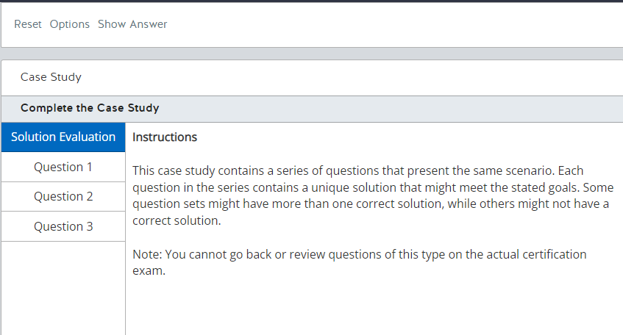

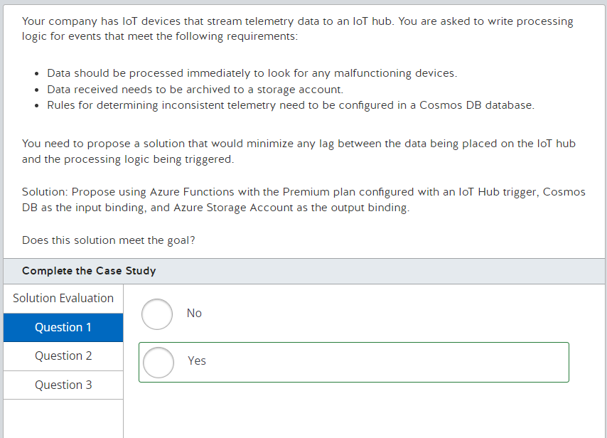

This solution meets the goal. Azure Functions with the Premium plan provide pre-warmed instances for your function runtime. This ensures that the runtime environment is always processing incoming messages. Also, setting IoT Hub as the trigger will fire the code to execute when a message arrives. The application will use the Cosmos DB input binding to get access to the configuration for processing the data and send the message to Azure Storage as a return value using the output binding.  
  
**References**

[Azure Functions triggers and bindings concepts](https://docs.microsoft.com/en-us/azure/azure-functions/functions-triggers-bindings)   
  
[Azure Functions Premium plan](https://docs.microsoft.com/en-us/azure/azure-functions/functions-premium-plan)

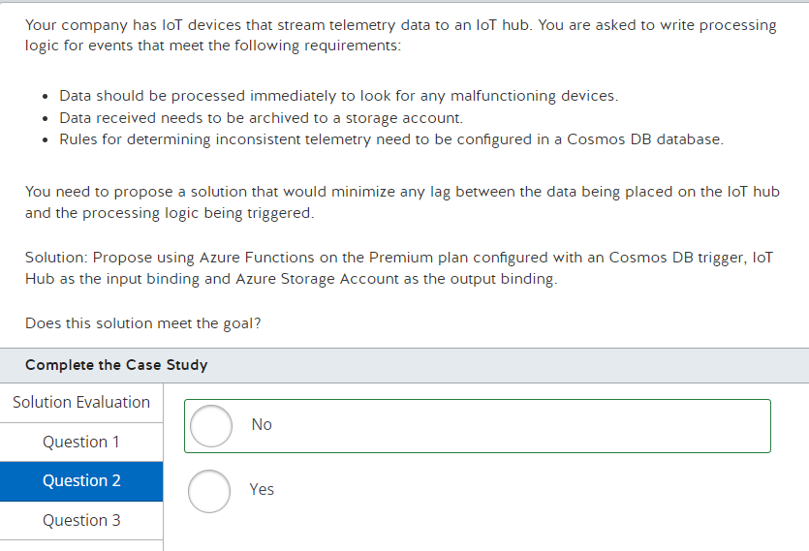

This solution does not meet the goal. In this case, the data is posted in the IoT hub. The function will not trigger because it is configured with Cosmos DB to be the trigger.  
  
**References**  
  
[Azure Functions triggers and bindings concepts](https://docs.microsoft.com/en-us/azure/azure-functions/functions-triggers-bindings)  
  
[Azure Functions Premium plan](https://docs.microsoft.com/en-us/azure/azure-functions/functions-premium-plan)

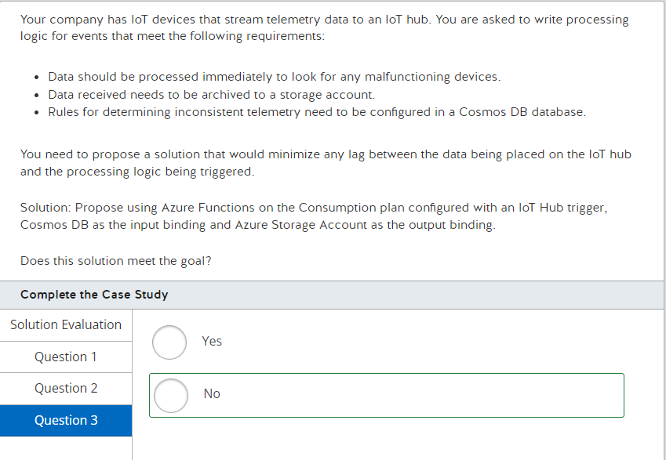

This solution does not meet the goal. In this case, using a consumption plan does not guarantee that a runtime environment will always be available because the cold start could take a while. With consumption plans, Microsoft Azure determines the usage of the execution host as well as the sequence in which function logic is executed.  
  
**References**  
  
[Azure Functions triggers and bindings concepts](https://docs.microsoft.com/en-us/azure/azure-functions/functions-triggers-bindings)  
  
[Azure Functions Premium plan](https://docs.microsoft.com/en-us/azure/azure-functions/functions-premium-plan)

**PREGUNTA 4**

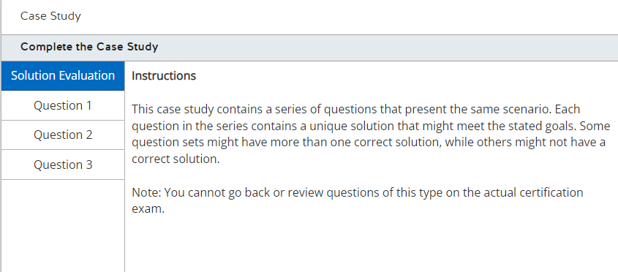

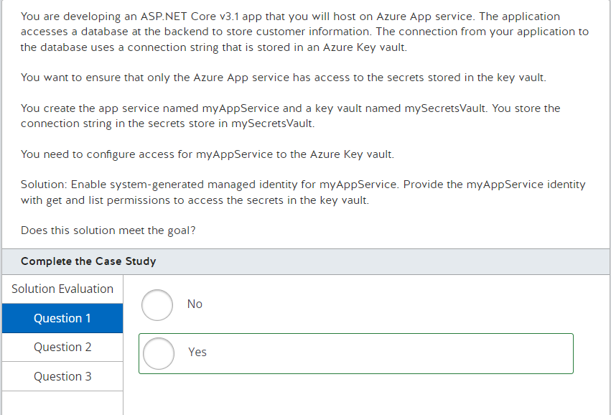

The solution meets the goal. Managed identity configuration for Azure App Services creates an identity named myAppService for the resource. Providing the myAppService identity with get and list permissions to access the secrets in the key vault will enable any code executing in the app service to read the secrets stored in the key vault.  
  
**References**  
  
[How to use managed identities for App Service and Azure Functions](https://docs.microsoft.com/en-us/azure/app-service/overview-managed-identity?tabs=dotnet)  
  
[Azure Key Vault security](https://docs.microsoft.com/en-us/azure/key-vault/key-vault-secure-your-key-vault)

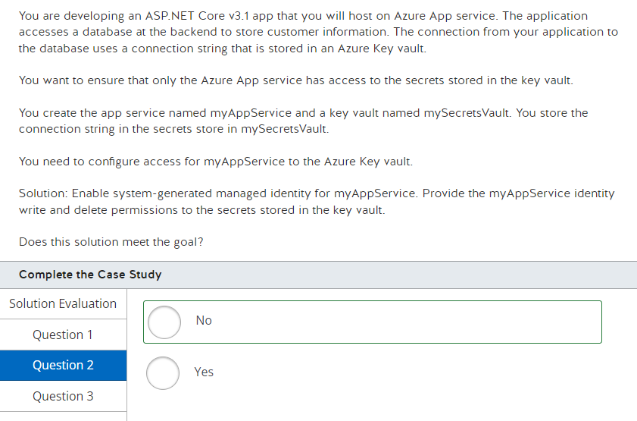 The solution does not meet the goal. Managed identity configuration for Azure App Services creates an identity named myAppService for the resource. Providing this identity access to the key vault to write and delete secrets stored in the key vault will not enable code executing in the app service to read secrets stored in the key vault. You should provide the read and list permissions instead to enable your application to read the connection string value.  
  
**References**  
  
[How to use managed identities for App Service and Azure Functions](https://docs.microsoft.com/en-us/azure/app-service/overview-managed-identity?tabs=dotnet)  
  
[Azure Key Vault security](https://docs.microsoft.com/en-us/azure/key-vault/key-vault-secure-your-key-vault)

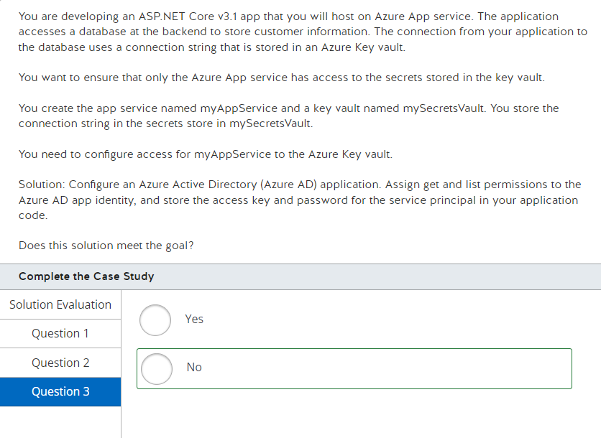

The solution does not meet the goal. Configuring an Azure AD app and providing the permission to the key vault will enable you to write code to execute read calls to the key vault using the access key and password. However, this would be a security concern because the source code will give any user access to the key vault by reading the credentials from the code. The requirement states that only the app service resource should have access to read the secrets in the key vault.  
  
You should configure managed identity for Azure App services, which creates an identity named myAppService for the resource. Providing this identity access to the key vault to read and list secrets stored in the key vault will enable any code executing in the app service to read the secrets stored in the key vault.  
  
**References**  
  
[How to use managed identities for App Service and Azure Functions](https://docs.microsoft.com/en-us/azure/app-service/overview-managed-identity?tabs=dotnet)  
  
[Azure Key Vault security](https://docs.microsoft.com/en-us/azure/key-vault/key-vault-secure-your-key-vault)  
  
[Quickstart: Register an application with the Microsoft identity platform](https://docs.microsoft.com/en-us/azure/active-directory/develop/app-registrations-training-guide-for-app-registrations-legacy-users)

**PREGUNTA 5**

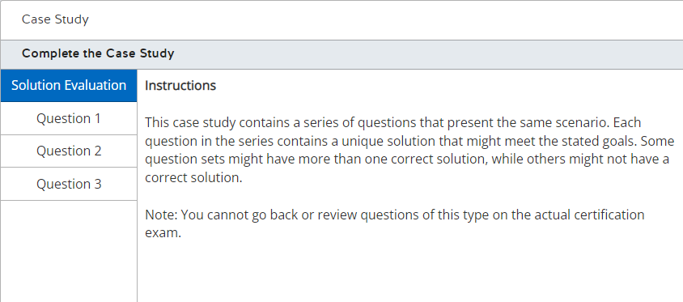

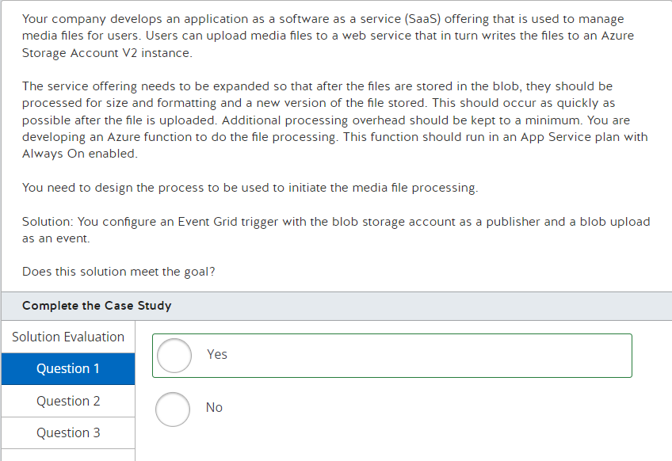

This solution meets the goal. You should configure an Event Grid trigger with the blob storage account as a publisher and a blob upload as an event with your Azure function as an event subscriber. This will enable you to process incoming media files as they are uploaded. You can accomplish the same goal by configuring a blob storage trigger that is triggered from blob upload with your Azure function as a subscriber.  
  
**References**  
  
[Introduction to Azure Functions](https://docs.microsoft.com/en-us/azure/azure-functions/functions-overview)  
  
[Azure Functions developer guide](https://docs.microsoft.com/en-us/azure/azure-functions/functions-reference)  
  
[Azure Functions triggers and bindings concepts](https://docs.microsoft.com/en-us/azure/azure-functions/functions-triggers-bindings)  
  
[Azure Blob storage trigger for Azure Functions](https://docs.microsoft.com/en-us/azure/azure-functions/functions-bindings-storage-blob-trigger?tabs=csharp)  
  
[Azure Event Grid bindings for Azure Functions](https://docs.microsoft.com/en-us/azure/azure-functions/functions-bindings-event-grid)

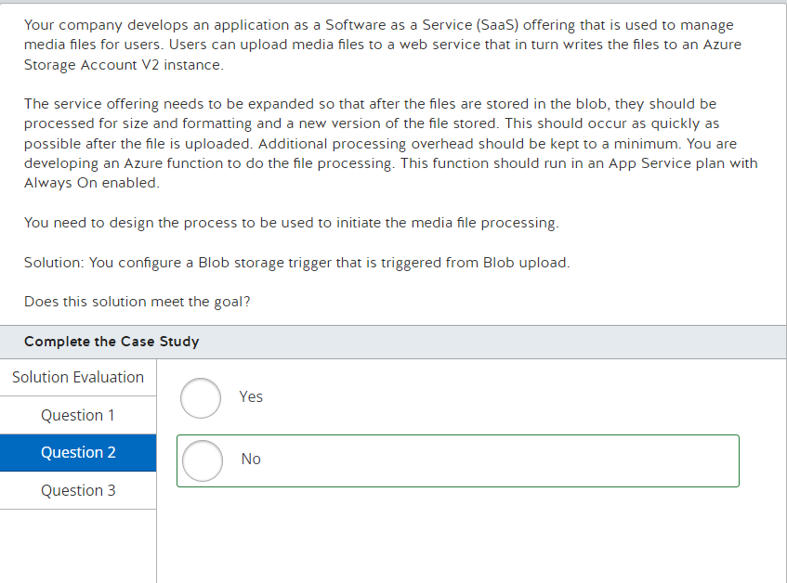

This solution does not meet the goal. Using Blob trigger directly from a storage might skip some blobs, or not trigger the function immediately.  
  
**References**  
  
[Introduction to Azure Functions](https://docs.microsoft.com/en-us/azure/azure-functions/functions-overview)  
  
[Azure Functions developer guide](https://docs.microsoft.com/en-us/azure/azure-functions/functions-reference)  
  
[Azure Functions triggers and bindings concepts](https://docs.microsoft.com/en-us/azure/azure-functions/functions-triggers-bindings)  
  
[Azure Blob storage trigger for Azure Functions](https://docs.microsoft.com/en-us/azure/azure-functions/functions-bindings-storage-blob-trigger?tabs=csharp)  
  
[Azure Event Grid bindings for Azure Functions](https://docs.microsoft.com/en-us/azure/azure-functions/functions-bindings-event-grid)

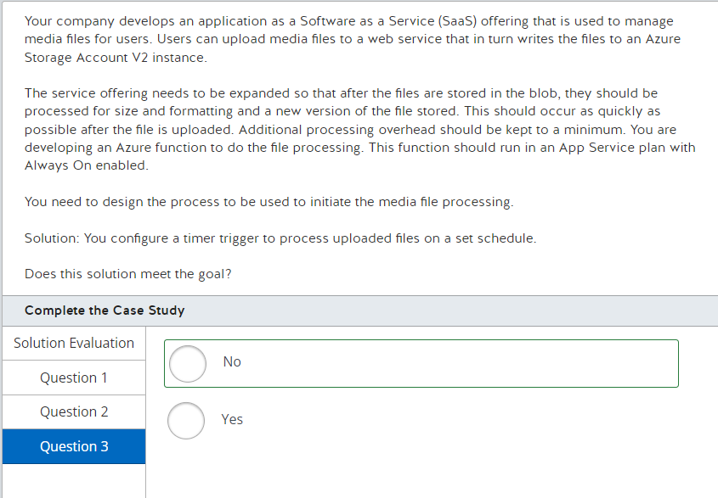

This solution does not meet the goal. A timer trigger will fire on a set schedule without regard for when media files are uploaded. This can result in an increased delay for processing or increased processing overhead when the function is triggered with no additional processing needed.  
  
**References**  
  
[Introduction to Azure Functions](https://docs.microsoft.com/en-us/azure/azure-functions/functions-overview)  
  
[Azure Functions developer guide](https://docs.microsoft.com/en-us/azure/azure-functions/functions-reference)  
  
[Azure Functions triggers and bindings concepts](https://docs.microsoft.com/en-us/azure/azure-functions/functions-triggers-bindings)  
  
[Azure Blob storage trigger for Azure Functions](https://docs.microsoft.com/en-us/azure/azure-functions/functions-bindings-storage-blob-trigger?tabs=csharp)

[Azure Event Grid bindings for Azure Functions](https://docs.microsoft.com/en-us/azure/azure-functions/functions-bindings-event-grid)

**PREGUNTA 6**

You plan to use an existing Azure Resource Manager (ARM) template to provision multiple virtual machine (VM) instances in Azure. You plan to create the ARM template from a resource group named myResourceGroup and save it in the C:\users\public\downloads\template folder. After creating the template, you will use the template as your deployment source. The template you create should include any changes made since myResourceGroup was initially deployed.  
  
You need to create the template to meet these requirements.  
  
Which PowerShell cmdlet should you use?

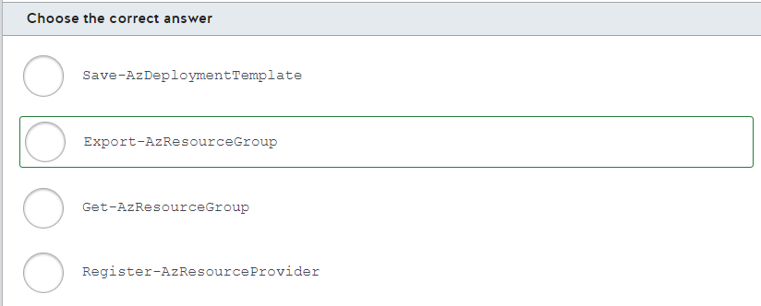

You should use the Export-AzResourceGroup cmdlet. This cmdlet allows you to create a template from a specified resource group. You can use this cmdlet to capture all resources or limit the resources captured, such as capturing a single VM.  
  
You should not use the Register-AzResourceProvider cmdlet. This cmdlet is used to register a resource provider for your Azure account and is not used in resource group management.  
  
You should not use the Get-AzResourceGroup cmdlet. This cmdlet is used to retrieve information about a resource group, but does not provide a way to create an ARM template from the resource group.  
  
You should not use the Save-AzDeploymentTemplate cmdlet. This cmdlet is used to save an existing template to a file, not to create a template from an existing resource group. The saved template would not include any changes made to the resource group after it was deployed.  
  
**References**  
  
[Download the template for a VM](https://docs.microsoft.com/en-us/azure/virtual-machines/windows/download-template)  
  
[Export-AzResourceGroup](https://docs.microsoft.com/en-us/powershell/module/az.resources/export-azresourcegroup?view=azps-3.8.0)  
  
[Register-AzResourceProvider](https://docs.microsoft.com/en-us/powershell/module/az.resources/register-azresourceprovider?view=azps-3.8.0)  
  
[Get-AzResourceGroup](https://docs.microsoft.com/en-us/powershell/module/az.resources/Get-AzResourceGroup?view=azps-3.8.0)

**PREGUNTA 7**

You plan to provision a virtual machine (VM) by uploading a Windows VM from on-premises to Azure.  
  
You plan to upload the on-premise VM with the following configuration:

* Generation 1 VM
* VHDX disk image
* Dynamic disk storage
* Not currently encrypted

You run System File Checker (SFC) on the VM and restart the VM. You want to encrypt the VM.  
  
You need to ensure that the VM is properly prepared for uploading and provisioning in Azure.  
  
For each of the following statements, select Yes if the statement is true. Otherwise, select No.

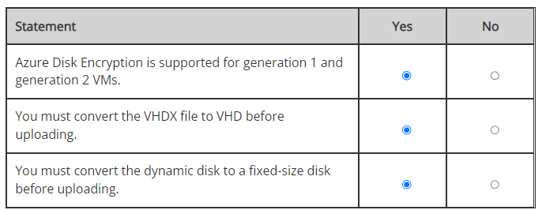

Azure Disk Encryption is supported for both generation 1 and generation 2 VMs. In this scenario, Azure Disk Encryption will be supported.   
  
You must convert the VHDX file to VHD before uploading. The VHDX file format is not supported. You can use the Hyper-V Manager or the Convert-VHD PowerShell cmdlet to convert the file to a VHD file.  
  
You must convert the dynamic disk to a fixed-size disk before uploading. A fixed-size disk is required to support encryption. Converting from VHDX to VHD will also convert the disk to a fixed-size disk.  
  
**References**  
  
[Prepare a Windows VHD or VHDX to upload to Azure](https://docs.microsoft.com/en-us/azure/virtual-machines/windows/prepare-for-upload-vhd-image)  
  
[Azure Disk Encryption for Windows VMs](https://docs.microsoft.com/en-us/azure/virtual-machines/windows/disk-encryption-overview)  
  
[Azure Disk Encryption for Windows virtual machines FAQ](https://docs.microsoft.com/en-us/azure/virtual-machines/windows/disk-encryption-faq)

**PREGUNTA 8**

Your company wants to use Docker container images in Azure. You create a resource group and an Azure container registry to host the Docker images.  
  
You need to generate a container image.  
  
Which command should you use?

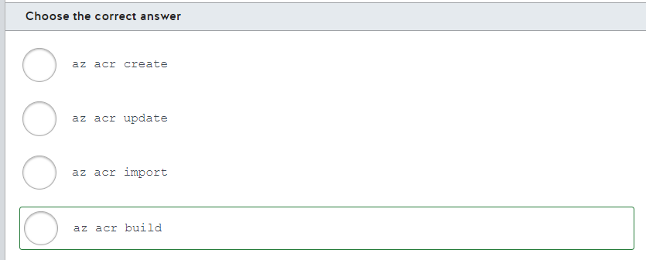

You should use the az acr build command. After a successful build, the image is automatically pushed to your container registry.  
  
You should not use the az acr create command. You would use this command to create a container registry.  
  
You should not use the az acr update command. This command is used to update parameters for an ACR, such as enabling an administrative account or updating tags.  
  
You should not use the az acr import command. This command is used to import an image to an Azure container registry from another container registry.  
  
**References**  
  
[Quickstart: Build and run a container image using Azure Container Registry Tasks](https://docs.microsoft.com/en-us/azure/container-registry/container-registry-quickstart-task-cli)  
  
[az acr](https://docs.microsoft.com/en-us/cli/azure/acr?view=azure-cli-latest)

**PREGUNTA 9**

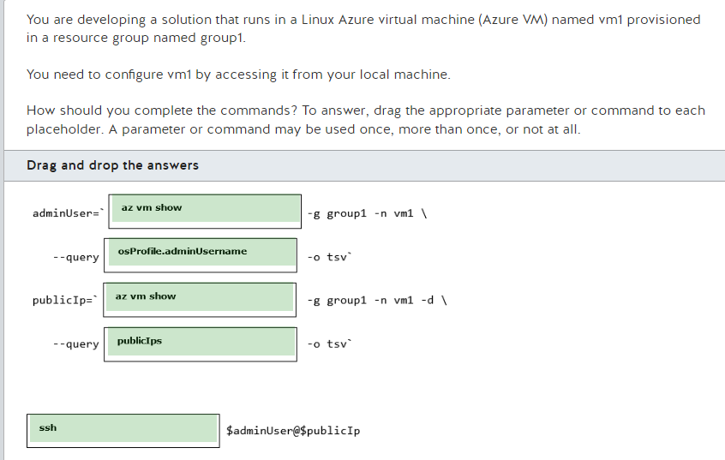

You should complete the commands as shown below:  
  
adminUser=`az vm show -g group1 -n vm1 \  
      --query osProfile.adminUsername -o tsv`  
publicIp=`az vm show -g group1 -n vm1 -d \  
      --query publicIps -o tsv`  
  
ssh $adminUser@$publicIp  
  
You should complete the first command as az vm show and use osProfile.adminUsername for the --query parameter. This command retrieves the admin username configured in vm1 required to access the Azure VM from your local machine. The option -n is used to get the name of the Virtual Machine.  
  
You should complete the second command as az vm show, using publicIps as the --query parameter, and also using the -d parameter. This command retrieves from vm1 the public IP required to access the Azure VM from your local machine. You need the -d parameter to list the publicIps from az vm show. The option -d is used to show public IP addresses, FQDN, and power states.  
  
Finally, you should run the ssh command as $adminUser@$publicIp. This connects with vm1 using the admin username and the public IP using a Secure Shell (SSH) connection from your local machine. To access a Linux Azure VM, you need to have your public SSH key configured in the Azure VM, or use a password that will be prompted by the ssh command.  
  
You should not use the az vm nic show command. You can use this command to show information about a specific network adapter by using the --nic and --vm-name parameters.  
  
You should not use the privateIps parameter. You can use this parameter to query the private IP from an Azure VM. You need to use the public IP to access vm1 from a remote location.  
  
You should not use the mstsc /v: command. You can use this command to start a remote desktop session using Remote Desktop Protocol (RDP). You can use RDP to remote connect with an Azure VM running Windows.  
  
**References**  
  
[Tutorial: Create and Manage Linux VMs with the Azure CLI](https://docs.microsoft.com/en-us/azure/virtual-machines/linux/tutorial-manage-vm)  
  
[How to query Azure CLI command output using a JMESPath query](https://docs.microsoft.com/en-us/cli/azure/query-azure-cli?view=azure-cli-latest)  
  
[Tutorial: Create and Manage Windows VMs with Azure PowerShell](https://docs.microsoft.com/en-us/azure/virtual-machines/windows/tutorial-manage-vm)  
  
[az vm nic](https://docs.microsoft.com/en-us/cli/azure/vm/nic?view=azure-cli-latest)

**PREGUNTA 10**

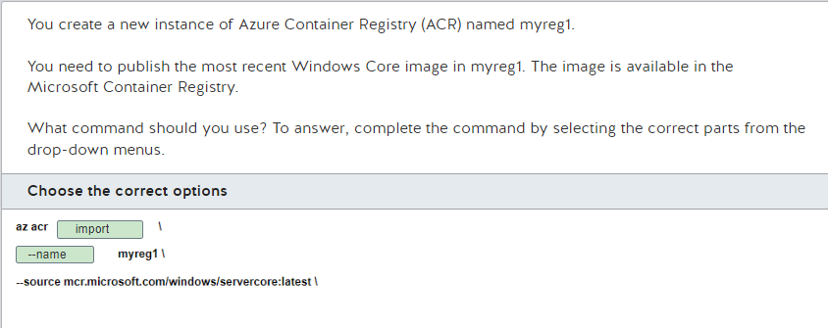

You should run the following command string:  
  
az acr import \  
  --name myreg1 \  
  --source mcr.microsoft.com/windows/servercore:latest \  
  
The az acr import command imports the image into the ACR and publishes it to myreg1. The image will be available for use in myreg1 after the import. The --name parameter identifies the ACR resource name in which the image is published.  
  
You should not use the az acr replication command. This is used to manage geo-replicated regions of ACRs, not the ACR content.  
  
You should not use the az acr update command. This is used to update parameters for an ACR, such as enabling an administrative account or updating tags.  
  
You should not use the az acr create command. This is used to create a new ACR.  
  
You should not specify --registry as the first parameter. This parameter allows you to specify a source registry.  
  
You should not specify --image as the first parameter. This identifies the image you are importing.  
  
**References**  
  
[Import container images to a container registry](https://docs.microsoft.com/en-us/azure/container-registry/container-registry-import-images)  
  
[az acr](https://docs.microsoft.com/en-us/cli/azure/acr?view=azure-cli-latest)  
  
[Tutorial: Build and deploy container images in the cloud with Azure Container Registry Tasks](https://docs.microsoft.com/en-us/azure/container-registry/container-registry-tutorial-quick-task)

**PREGUNTA 11**

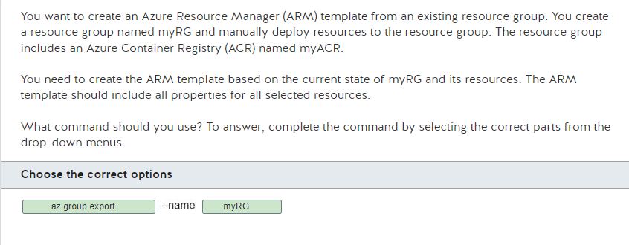

You should run the following command:  
  
az group export --name myRG  
  
The az group export Azure CLI command creates an ARM template from the specified resource group. The template is based on the current state of the resources. You must specify the name of the resource group from which the template is being created, so you must specify myRG.  
  
You should not use the az group create command. This command is used to create a new resource group.  
  
You should not use the az group deployment export. This command is used to export the template used for a deployment.  
  
You should not use the az group deployment create. This command is used to start a deployment from a specified template file.  
  
You should not specify myACR. This is inappropriate for this command because it is the name of your ACR, not a resource group. An ACR provides a way to easily and efficiently build, store, secure, scan, replicate, and manage container images.  
  
**References**  
  
[Use Azure portal to export a template](https://docs.microsoft.com/en-us/azure/azure-resource-manager/templates/export-template-portal)  
  
[Manage Azure Resource Groups by using Azure CLI](https://docs.microsoft.com/en-us/azure/azure-resource-manager/management/manage-resource-groups-cli)  
  
[az group](https://docs.microsoft.com/en-us/cli/azure/group?view=azure-cli-latest)  
  
[az group deployment](https://docs.microsoft.com/en-us/cli/azure/group/deployment?view=azure-cli-latest)

**PREGUNTA 12**

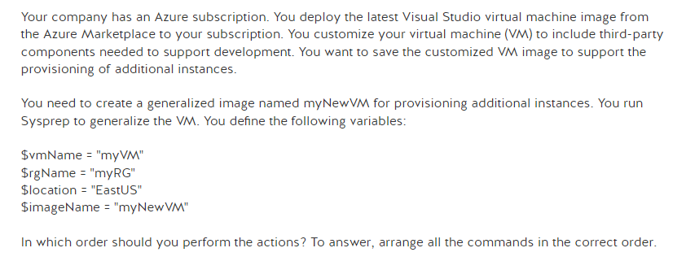

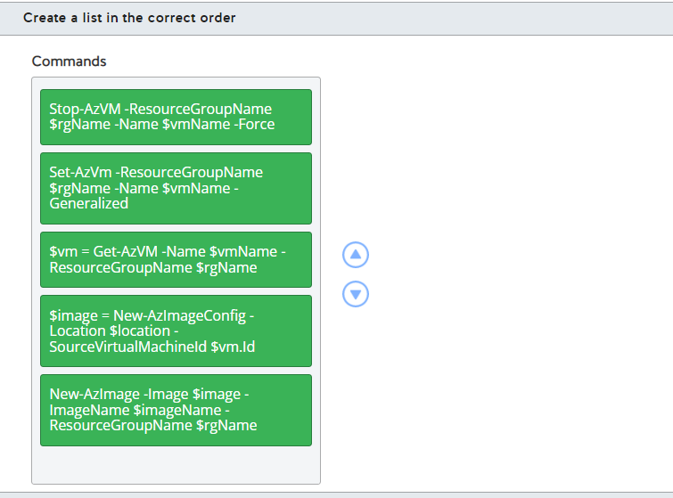

After using Sysprep to generalize the image, you should execute the commands in this order:

1. Stop-AzVM -ResourceGroupName $rgName -Name $vmName -Force
2. Set-AzVM -ResourceGroupName $rgName -Name $vmName -Generalized
3. $vm = Get-AzVM -Name $vmName -ResourceGroupName $rgName
4. $image = New-AzImageConfig -Location $location -SourceVirtualMachineId $vm.Id
5. New-AzImage -Image $image -ImageName $imageName -ResourceGroupName $rgName

The first step after generalizing the VM is to make sure that the VM has been deallocated using the Stop-AzVM command. This makes the VM available for creating an image.   
  
Then, you should run Set-AzVM to set the VM status to generalized. The image has already been generalized. This is done to identify it as such.  
  
The third step is to get the VM loaded into a variable to use this value to create the image configuration. You use the Get-AzVM command and specify the VM name as a filter parameter to retrieve the VM.  
  
The fourth step is to run New-AzImageConfig, specifying the variable from step 3 as the source VM, to create the image configuration and load it into the $image variable.  
  
The last step is to create the image using the $image variable. The values for $imageName and $rgName were set before you started the process.  
  
**References**  
  
[Create a managed image of a generalized VM in Azure](https://docs.microsoft.com/en-us/azure/virtual-machines/windows/capture-image-resource)  
  
[Create a VM from a managed image](https://docs.microsoft.com/en-us/azure/virtual-machines/windows/create-vm-generalized-managed)

**PREGUNTA 13**

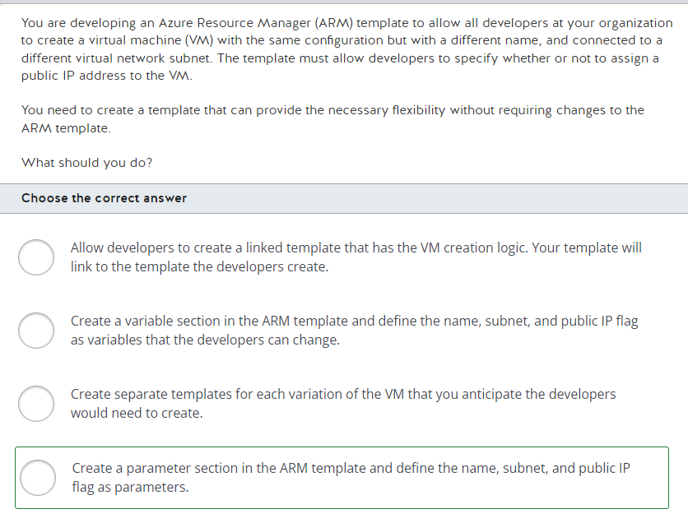

You should create a parameter section in the ARM template and define the name, subnet, and public IP flag as parameters. This will prompt the developers to provide those values when they try to create a VM. The same template can be programmed to configure the VM based on the parameters provided.  
  
You should not create a variable section in the ARM template to provide this flexibility. This will allow each developer to change the value of the variables, but it will require modification of the template for each VM created.  
  
You should not create separate templates for each VM configuration. This will be hard to maintain. Over a period of time, as more developers require variations for the name, subnet, and public IP flag, the number of templates will grow. This approach will also require modification of the ARM template for each developer's needs.  
  
You should not use the linked template approach. Here you would have to rely on each developer to provide the logic to create a VM in their template. This approach will not be scalable, and each developer's code will be duplicated across all the linked templates created.  
  
**References**  
  
[Understand the structure and syntax of ARM templates](https://docs.microsoft.com/en-us/azure/azure-resource-manager/templates/template-syntax)[Parameters in ARM templates](https://docs.microsoft.com/en-us/azure/azure-resource-manager/templates/template-parameters)  
  
[Variables in ARM templates](https://docs.microsoft.com/en-us/azure/azure-resource-manager/templates/template-variables)

**PREGUNTA 14**

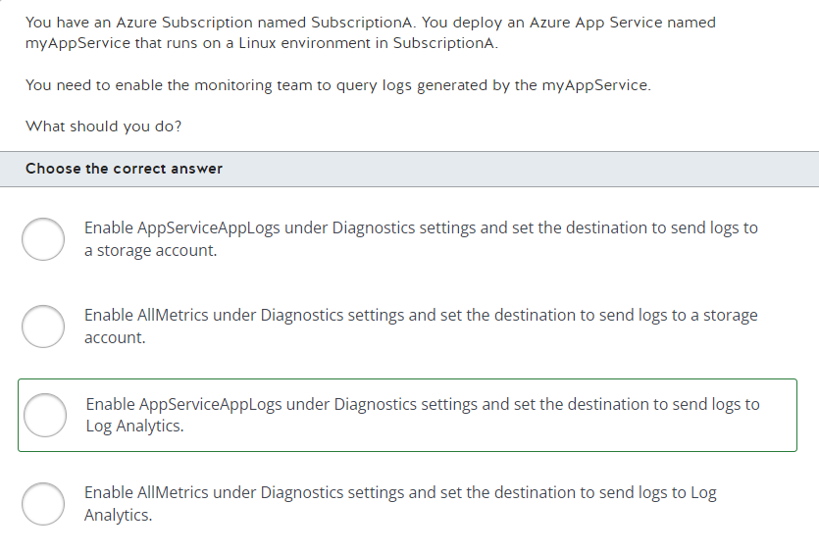

You should enable AppServiceAppLogs under Diagnostics settings and set the destination to send logs to Log Analytics. AppServiceAppLogs are exceptions and/or logs written by the application to the environment's logging utility. Sending the logs to Log Analytics allows various teams to write Kusto queries. The monitoring team would use this utility to analyze the logs.  
  
You should not enable AllMetrics. AllMetrics are collected by agents on the App Service and report the usage of host resources. These are items like CPU usage, memory usage, and disk I/O used.  
  
You should not recommend sending logs to a storage account. Storage accounts are a good option for archiving logs, but they are not available for running queries. Logs stored in a storage account would need to be restored in an environment before you would be able to run any queries on them.  
  
**References**  
  
[Enable diagnostics logging for apps in Azure App Service](https://docs.microsoft.com/en-us/azure/app-service/troubleshoot-diagnostic-logs)

**PREGUNTA 15**

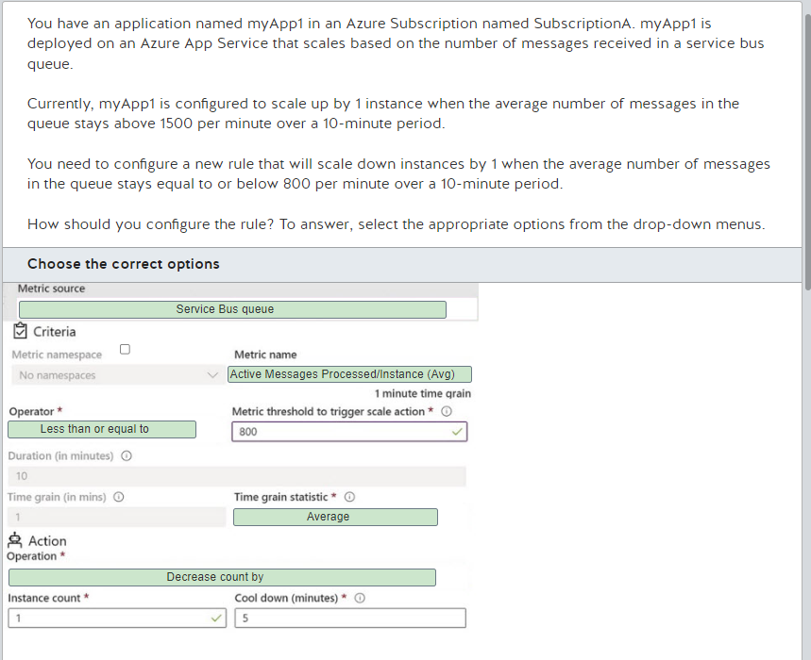

You should set the metric source to Service Bus queue. Metric source is used to specify the service that you want to monitor. This is used to specify the service to which you want to collect logs. The scaling for the instances is based on the messages in the queue. The scenario specifically states that you are monitoring the Service Bus queue. You should not specify Storage Queue, Current Resource, or other resource as these will not provide the metrics needed.  
  
You should clear the Metric namespace checkbox and you should set the Metric name to Active Messages Processed/Instance (Avg). Metric namespace refers to the type of logs you want to monitor. You can specify the logs type such as memory usage, CPU usage, etc., to monitor the service. You are only concerned about messages being processed. In this case, you want to scale up based on the number of messages in the queue that are waiting to be processed. You should not specify Messages Processed/Instance (Avg) because this metric includes messages that are currently in the queue irrespective of whether they are being processed.   
  
You should set the operator to Less than or equal to. In this case, you want to reduce the instance count by 1 when the average active message count is less than or equal to the threshold value specified.  
  
You should not use Greater than or Greater than or equal to because you want to react to average values that fall before the trigger value. You should not select Less than because this would exclude the trigger value which the scenario specified should be included.   
  
You should set Time grain statistics to Average. In this case you want to ensure that the average messages are below 800 for the duration of 10 minutes. Setting it to minimum would just show the least number of messages processed at any given minute during the duration specified. Maximum would show the maximum number of messages processed. Setting it to sum would actually add up the active messages processed in the 10-minute duration.  
  
You should set Operation to Decrease count by because you want to scale down instances by 1. In this case you want to reduce the number of instances relative to the previous number of instances. You do not want to scale down by a percentage or to a specific value.  
  
You should not choose any option to increase the count.  
  
**References**  
  
[Get started with Autoscale in Azure](https://docs.microsoft.com/en-us/azure/azure-monitor/platform/autoscale-get-started?toc=/azure/app-service/toc.json)

**PREGUNTA 16**

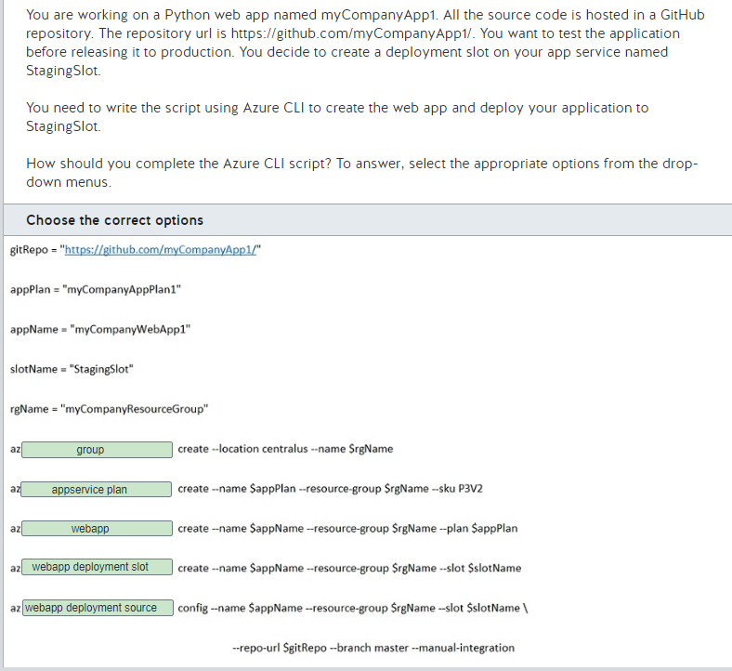

You should complete the CLI script as follows.  
  
gitRepo = "https://github.com/myCompanyApp1/"  
appPlan = "myCompanyAppPlan1"  
appName = "myCompanyWebApp1"  
slotName = "StagingSlot"  
rgName = "myCompanyResourceGroup"  
  
az group create --location centralus --name $resourcegroupname  
az appservice plan create --name $appPlan --resource-group $resourcegroupname --sku P3V2  
az webapp create --name $appName --resource-group $resourcegroupname --plan $appPlan  
az webapp deployment slot create --name $appName --resource-group $resourcegroupname --slot $slotName  
az webapp deployment source config --name $appName --resource-group $resourcegroupname --slot $slotName \  
                                                                           --repo-url $gitRepo --branch master --manual-integration  
  
You should first create the resource group using the az group command.  
  
In the same resource group, you should then create the app service plan using the az appservice plan command.  
  
Once the app service plan is created, you create the app service using the az webapp command.  
  
To create the deployment slot where you want to test your application, you need to create the slot first. When you create an app service, only one slot is created for the production application. You need to run the az webapp deployment slot command to create the staging slot.  
  
Once the deployment slot for testing is created, you can then configure the source of where the source code would be deployed from. In this case, you want to deploy the code from the GitHub repository. You can use the az webapp deployment source command to set the repository for the source code.  
  
**References**  
  
[Create an App Service app and deploy code to a staging environment using Azure CLI](https://docs.microsoft.com/en-us/azure/app-service/scripts/cli-deploy-staging-environment)

**PREGUNTA 17**

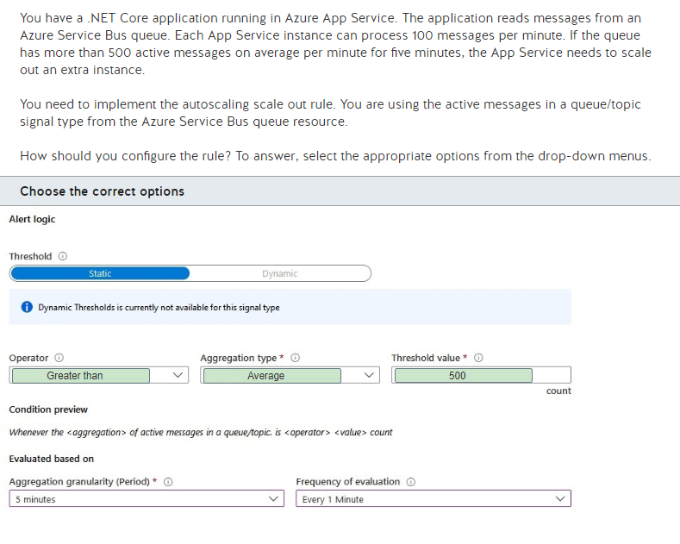

You should configure the Operator as Greater than to scale out when the threshold condition is met.  
  
You should also configure the Aggregation type to Average. The scale out rule aggregates the last five minutes of active messages in a queue/topic signal every minute. The Frequency of evaluation and Aggregation granularity are configurable as well.  
  
Finally, you should configure the Threshold value to 500. This will trigger the alert logic when the active messages in a queue/topic signal reach an average of 500 messages for five minutes.  
  
You should not configure the Operator as Less than or Equal to. This would trigger the alert logic when the number of active messages is below or equals the threshold, respectively. You can use the Less than operator configuration to configure the scale in rule.  
  
You should not configure the Aggregation type to Total or Maximum. The active messages in a queue/topic signal only support the Average aggregation type.  
  
You should not configure the Threshold value to 100 or 1,000. This would trigger the alert logic when the active messages in a queue/topic signal reach the wrong count of messages, resulting in a scale out too soon or too late, respectively.  
  
**References**  
  
[Get started with Autoscale in Azure](https://docs.microsoft.com/en-us/azure/azure-monitor/platform/autoscale-get-started)  
  
[Monitoring Azure Service Bus data reference](https://docs.microsoft.com/en-us/azure/service-bus-messaging/service-bus-metrics-azure-monitor)

**PREGUNTA 18**

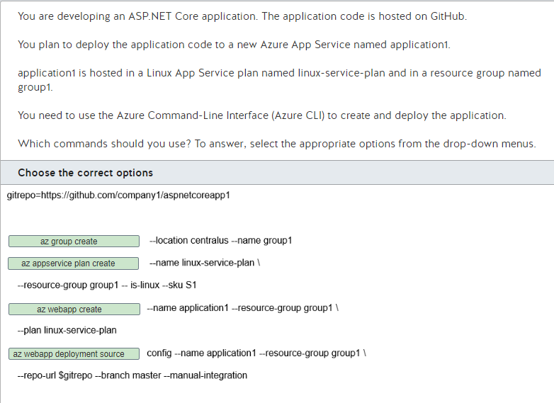

You should complete the code as shown below:  
  
  
gitrepo=https://github.com/company1/aspnetcoreapp1  
  
az group create --location centralus --name group1  
  
az appservice plan create --name linux-service-plan \  
    --resource-group group1 --is-linux --sku S1  
  
az webapp create --name application1 --resource-group group1 \  
    --plan linux-service-plan  
  
az webapp deployment source config --name application1 --resource-group group1 \  
    --repo-url $gitrepo --branch master --manual-integration  
  
  
You should use the az group create command to create the group1 resource group. This resource group will be used later to deploy the other resources of your application.  
  
You should also use the az appservice plan create command to create the linux-service-plan App Service Plan in the group1 resource group. The --is-linux parameter creates an App Service Plan on the Linux platform and the --sku S1 parameter defines the pricing tier and size of the underlying Virtual Machine (VM), which is the Standard pricing tier and a small VM in this case.  
  
You should also use the az webapp create command to create the App Service in linux-service-plan. This resource controls the configuration related to your application, such as the stack runtime, application settings, and the deployment configuration.  
  
Finally, you should use the az webapp deployment source config command to deploy the code from the GitHub repository to application1. The --branch master parameter configures the target branch in the GitHub repository used in the --repo-url parameter, followed by the --manual-integration parameter used to perform a one time deploy, without enabling automatic sync between source control and App Service.  
  
**References**  
  
[Create an App Service app with deployment from GitHub using Azure CLI](https://docs.microsoft.com/en-us/azure/app-service/scripts/cli-deploy-github)

**PREGUNTA 19**

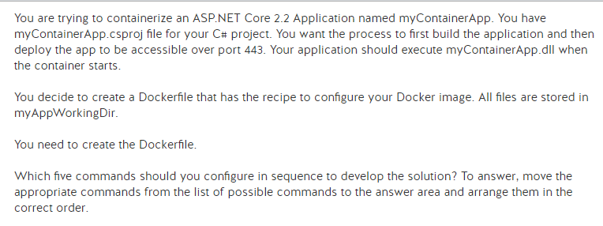

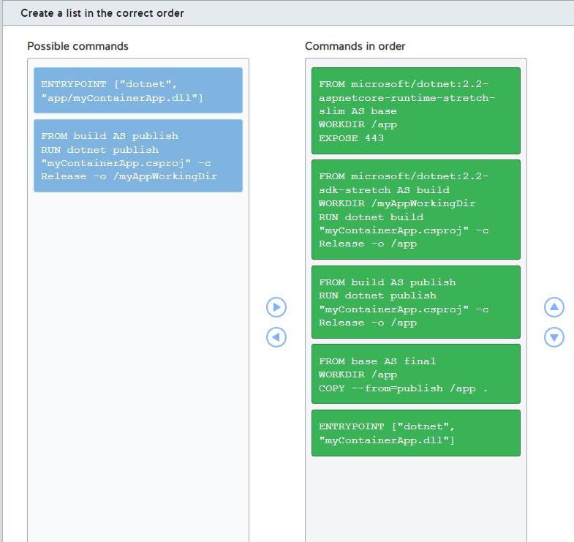

Your Dockerfile should have the following commands, in order:

FROM microsoft/dotnet:2.2-aspnetcore-runtime-stretch-slim AS base

WORKDIR /app

EXPOSE 443

FROM microsoft/dotnet:2.2-sdk-stretch AS build

WORKDIR /myAppWorkingDir

RUN dotnet build "myContainerApp.csproj" -c Release -o /app

FROM build AS publish

RUN dotnet publish "myContainerApp.csproj" -c Release -o /app

FROM base AS final

WORKDIR /app

COPY --from=publish /app .

ENTRYPOINT ["dotnet", "myContainerApp.dll"]

The first command sets up a docker image with the aspnetcore runtime environment. The working directory is set to /app and it exposes port 443.  
  
The second command starts by setting up an image that will be used to build the application. The myContainerApp.csproj file needs to be built into myContainerApp.dll before it can be deployed in a runtime environment.  
  
The next command would create a publish label for myContainerApp.dll. You can use that as a source to deploy the application.  
  
The fourth command takes the runtime image definition (base) and copies the published version of myContainerApp.dll to the app folder.  
  
The final command defines the entry point configuration for your application. This configures your docker image to route requests to myContainerApp.dll.  
  
You should not use these commands:

FROM build AS publish

RUN dotnet publish "myContainerApp.csproj" -c Release -o /myAppWorkingDir

This would publish /myAppWorkingDir, which is not where the application was built. You would need to use /app as the publish location.  
  
You should not use the following command:

ENTRYPOINT ["dotnet", "app/myContainerApp.dll"]

You do not need to specify the app folder because that is set by default. You would just need to specify the entry point of the runtime for your application, which is myContainerApp.dll.  
  
**References**  
  
[Quickstart: Docker in Visual Studio](https://docs.microsoft.com/en-us/visualstudio/containers/container-tools?view=vs-2019)

**PREGUNTA 20**

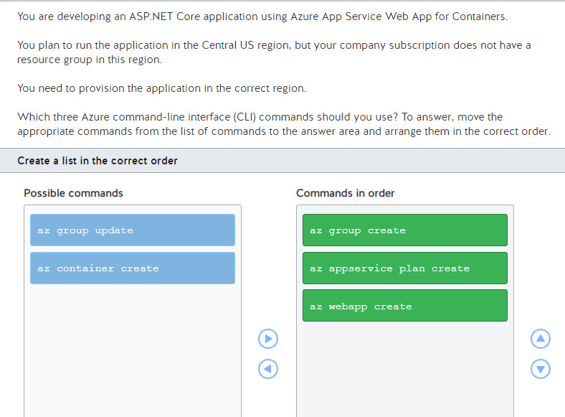

You should use the following commands in order:

1. az group create
2. az appservice plan create
3. az webapp create

First, you should use the az group create command to create a new resource group in the Central US region to provision the application in the planned region.  
  
Then, you should use the az appservice plan create command. This will create the App Service plan that will host the Azure App Service Web App for Containers application.  
  
Finally, you should use the az webapp create command. This will provision the application in the previously created App Service plan in the Central US region.  
  
You should not use the az group update command. You cannot update the region of an existing resource group.  
  
You should not use the az container create command. This command is used to create an Azure Container Instance, not an Azure App Service Web App for Containers.  
  
**References**  
  
[Create an ASP.NET Core app in a Docker container from Docker Hub using Azure CLI](https://docs.microsoft.com/en-us/azure/app-service/scripts/cli-linux-docker-aspnetcore)  
  
[az group](https://docs.microsoft.com/en-us/cli/azure/group)  
[az appservice plan](https://docs.microsoft.com/en-us/cli/azure/appservice/plan)  
  
[az webapp](https://docs.microsoft.com/en-us/cli/azure/webapp)  
  
[az container](https://docs.microsoft.com/en-us/cli/azure/container)

**PREGUNTA 21**

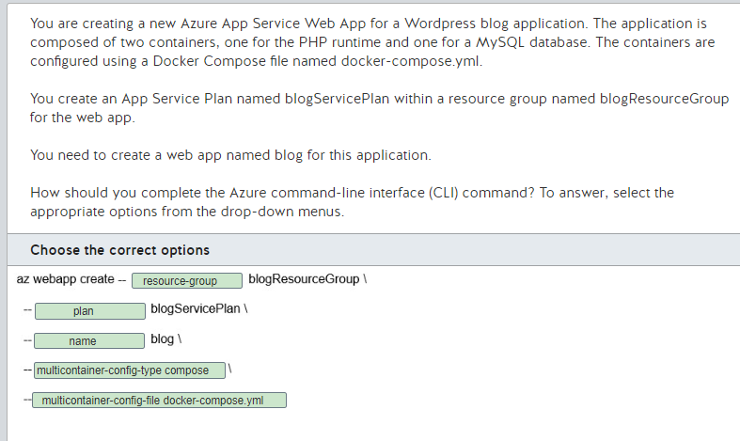

You should complete the command as shown below:  
  
  
az webapp create --resource-group blogResourceGroup \  
  --plan blogServicePlan \  
  --name blog \  
  --multicontainer-config-type compose \  
  --multicontainer-config-file docker-compose.yml  
  
  
You should use blog for the name parameter, blogServicePlan for the plan parameter, and blogResourceGroup for the resource-group parameter to create the web app in the correct App Service Plan.  
  
You should use the --multicontainer-config-type compose parameter to create a web app that uses a Docker Compose file as the application configuration.  
  
You should use the --multicontainer-config-file docker-compose.yml parameter to configure which Docker Compose file the App Service will use to run the application.  
  
You should not use the --multicontainer-config-type kube parameter. This parameter specifies a Kubernetes deployment file as the application configuration. The application uses a Docker Compose file to configure the application containers.  
  
You should not use the --multicontainer-config-file kube.yml parameter. The parameter does not use a configuration file named kube.yml. Instead, you should use a configuration file named docker-compose.yml.  
  
You should not use the --docker-custom-image-name php:apache-7 parameter. This parameter will create a container web app with the default PHP image from Docker Hub. You need to create a web app with more than one container, as defined in the Docker Compose file.  
  
**References**[Tutorial: Create a multi-container (preview) app in Web App for Containers](https://docs.microsoft.com/en-us/azure/app-service/containers/tutorial-multi-container-app)  
  
[az webapp](https://docs.microsoft.com/en-us/cli/azure/webapp?view=azure-cli-latest)  
[Understanding Kubernetes Objects](https://kubernetes.io/docs/concepts/overview/working-with-objects/kubernetes-objects/)

**PREGUNTA 22**

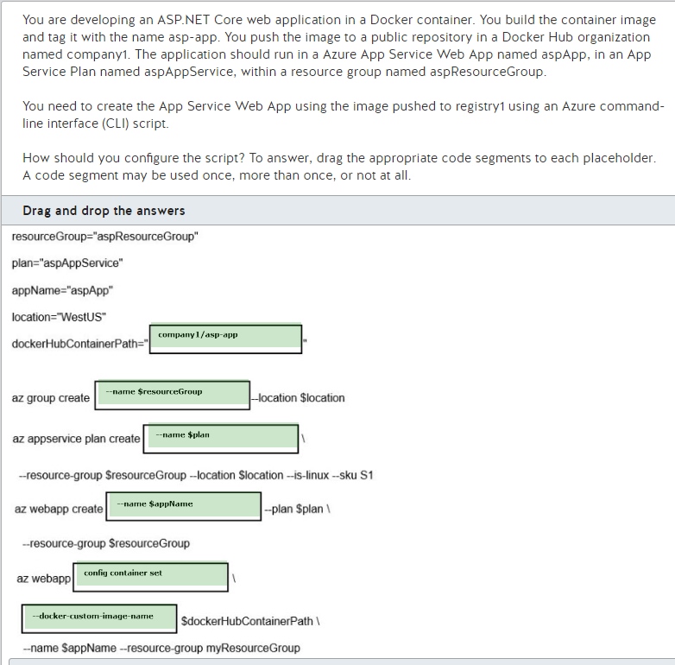

You should configure the script as shown below:  
  
resourceGroup="aspResourceGroup"  
plan="aspAppService"  
appName="aspApp"  
location="WestUS"  
dockerHubContainerPath="company1/asp-app"  
  
az group create --name $resourceGroup --location $location  
az appservice plan create --name $plan \  
   --resource-group $resourceGroup --location $location --is-linux --sku S1  
az webapp create --name $appName --plan $plan \  
   --resource-group $resourceGroup  
az webapp config container set \  
   --docker-custom-image-name $dockerHubContainerPath \  
   --name $appName --resource-group myResourceGroup  
  
You should create the resource group, App Service Plan, and the App Service Web App using the variable corresponding to each one as the --name parameter. This will create all the necessary resources.  
  
You should use the az webapp config container set command to configure the container image pushed to Docker Hub that will be used by the Web App. In this command, you should use the --docker-custom-image-name to reference the container image. To reference an image in Docker Hub registry, you should set the dockerHubContainerPath variable with company1/asp-app, using the pattern <organization/username>/<image>.  
  
You should not use the config set command. This command is used to configure general settings in web app, like Always on or HTTP 2.0 support. You should use config container set for container-related configurations.  
  
You should not use the --docker-registry-server-url command. This command is used to reference a custom Docker container registry. The Docker Hub container registry is the default container registry, and this parameter could be omitted.  
  
You should not use the company1.azurecr.io/asp-app command. This command is used to reference a container image in an Azure Container Registry (ACR) named company1. You push the container image to Docker Hub registry, not to ACR.  
  
**References**  
  
[Create an ASP.NET Core app in a Docker container from Docker Hub using Azure CLI](https://docs.microsoft.com/en-us/azure/app-service/scripts/cli-linux-docker-aspnetcore)  
  
[az webapp config](https://docs.microsoft.com/en-us/cli/azure/webapp/config?view=azure-cli-latest)

**PREGUNTA 23**

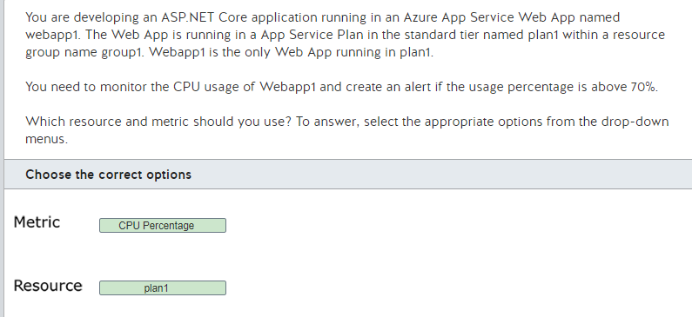

You should use the CPU Percentage metric. This metric contains CPU usage over time for any given App Service Plan. You need to use this metric to configure the alert properly.  
  
You should use the plan1 resource. To monitor the CPU usage of an App Service, you need to choose the App Service Plan resource, which is the plan1 resource in this case. An App Service Plan resource contains the metrics related to virtual machine (VM) usage, like CPU Percentage, Memory Percentage, and Disk Queue Length.  
  
You should not use the webapp1 or group1 resources. As mentioned before, to monitor the CPU usage of an App Service, you need to choose the App Service Plan resource, which is the plan1 resource in this scenario.   
  
You should not use the CPU Time metric. This metric indicates the amount of CPU time in seconds consumed by the Web App. You could use this metric to monitor the CPU usage of Web Apps running in App Service Plans with quota restrictions, like the Free and Shared plans. Webapp1 runs in a Standard tier App Service Plan.  
  
You should not use the Average Response Time metric. This metric measures the average time the app takes to serve requests, in seconds. This is not directly related to CPU usage.  
  
**References**[Monitor apps in Azure App Service](https://docs.microsoft.com/en-us/azure/app-service/web-sites-monitor)

**PREGUNTA 24**

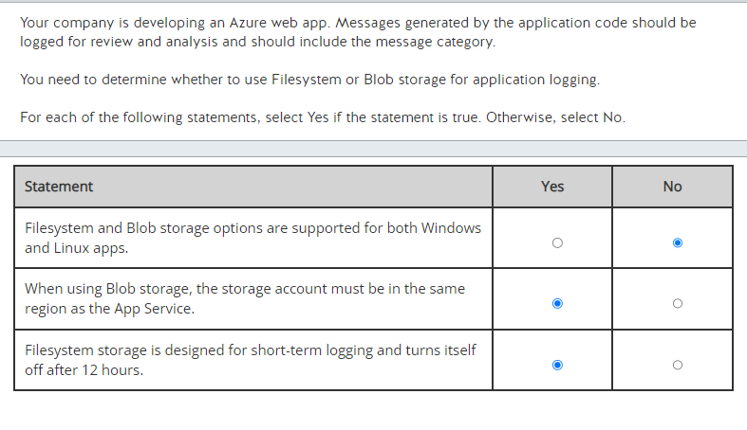

Filesystem and Blob storage options are not supported for both Windows and Linux apps. Filesystem and Blob storage are supported for Windows apps. Filesystem storage is the only storage option supported for Linux apps.  
  
When using Blob storage, the storage account must be in the same region as the App Service. This is a requirement for Blob storage.  
  
Filesystem storage is designed for short-term logging and turns itself off after 12 hours. Blob storage is designed for long-term storage of logging information.  
  
**References**  
  
[Enable diagnostics logging for apps in Azure App Service](https://docs.microsoft.com/en-us/azure/app-service/troubleshoot-diagnostic-logs)  
  
[Monitor apps in Azure App Service](https://docs.microsoft.com/en-us/azure/app-service/web-sites-monitor)

**PREGUNTA 25**

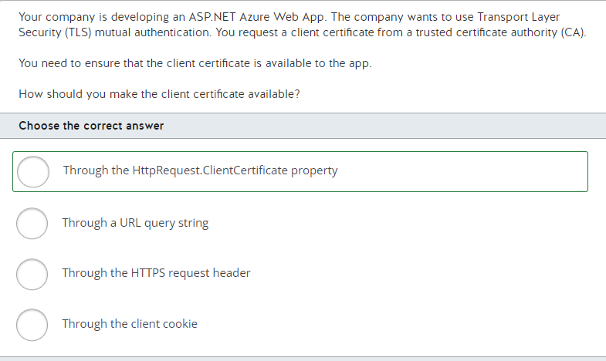

When configuring TLS mutual authentication for an ASP.NET app, the certificate is available through the HttpRequest.ClientCertificate property. This is supported for ASP.NET applications only.  
  
You should not make the certificate available through the HTTPS request header. For other application types, such as Node.JS apps, the certificate is passed through the HTTPS request header as a base64-encoded X-ARR-ClientCert header. The apps would then convert the base64-encoded PEM string into a certificate object for evaluation.  
  
You should not make the certificate available to the app through the client cookie. A client cookie contains information passed to the client for local storage.  
  
You should not make the certificate available to the app through a URL query string. Apps can be written to evaluate URL query strings, but this is not a valid method for passing a certificate.  
  
**References**  
  
[Configure TLS mutual authentication for Azure App Service](https://docs.microsoft.com/en-us/azure/app-service/app-service-web-configure-tls-mutual-auth)  
  
[certreq](https://docs.microsoft.com/en-us/windows-server/administration/windows-commands/certreq_1)

**PREGUNTA 26**

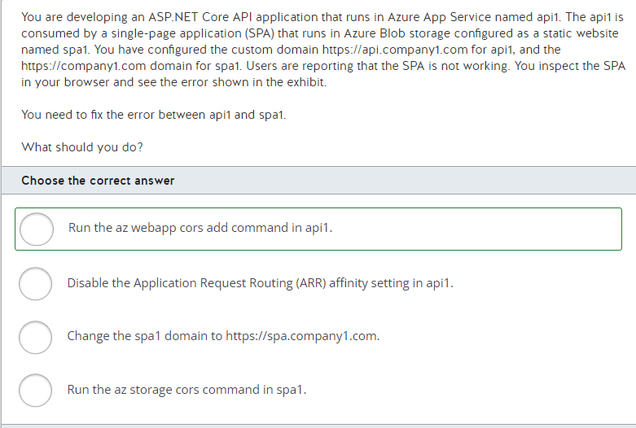

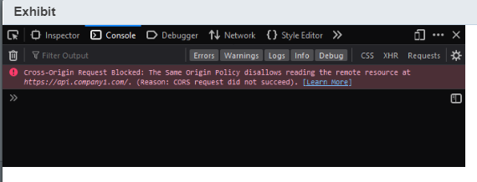

You should run the az webapp cors add command in api1. You should run this command with the --allowed-origins parameter as https://company1.com to add a Cross-Origin Resource Sharing (CORS) rule. This allows all requests from the SPA domain origin to work without errors.  
  
You should not run the az storage cors command in spa1. You should run this command to add a CORS rule for domains that send requests to spa1. The CORS rule must be configured in the destination, not in the origin.  
  
You should not disable the Application Request Routing (ARR) affinity setting in api1. You should disable the AAR affinity for stateless applications that do not require the client to use the same App Service instance for the life of the session. Disabling AAR affinity does not affect CORS configuration.  
  
You should not change the spa1 domain to https://spa.company1.com. You can avoid CORS errors if both origins follow the same-origin policy. Origin is the combination of protocol, port (if specified), and host for a given URL. If two URLs share the same origin, you will not have CORS errors. In this case, changing the spa1 domain results in CORS errors because https://spa.company1.com and https://api.company1.com do not have the same origin: the protocol and port are the same, but the host is different.  
  
**References**  
  
[Tutorial: Host a RESTful API with CORS in Azure App Service](https://docs.microsoft.com/en-us/azure/app-service/app-service-web-tutorial-rest-api)  
  
[Cross-Origin Resource Sharing (CORS)](https://developer.mozilla.org/en-US/docs/Web/HTTP/CORS)  
  
[az storage cors](https://docs.microsoft.com/en-us/cli/azure/storage/cors?view=azure-cli-latest)  
  
[Configure an App Service app](https://docs.microsoft.com/en-us/azure/app-service/configure-common)  
  
[Choose Between Traditional Web Apps and Single Page Apps (SPAs)](https://docs.microsoft.com/en-us/dotnet/architecture/modern-web-apps-azure/choose-between-traditional-web-and-single-page-apps)  
  
[Using the Application Request Routing Module](https://docs.microsoft.com/en-us/iis/extensions/planning-for-arr/using-the-application-request-routing-module)

**PREGUNTA 27**

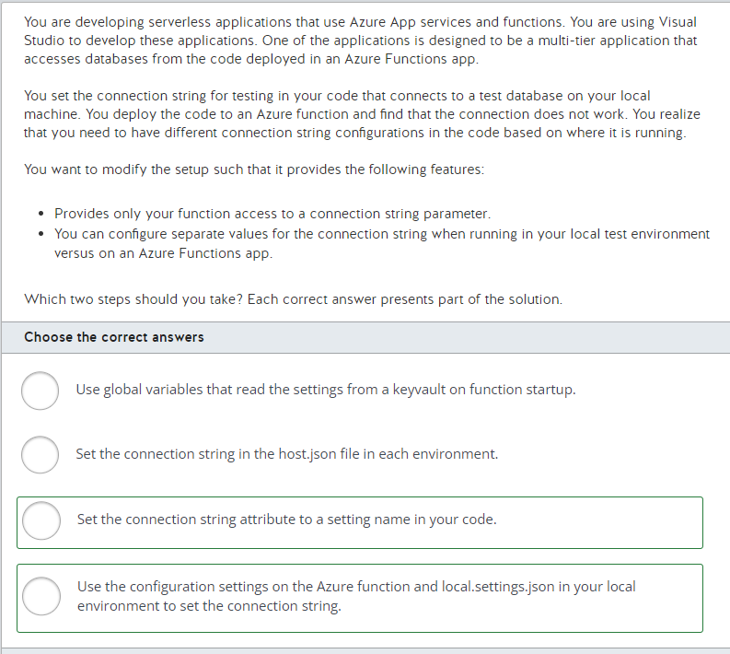

You should first change your code to use the connection string attribute in the Run method. The attribute with the functions framework is bound with properties set in the configuration section of the function or a value in the local.settings.json file. The framework provides the DbConfigurationType attribute to set the connection string.  
  
Next, you would need to set those values based on environments in the configuration settings portal user interface, and the file in local.settings.json file. When the code is executed in your machine, it will read the local.settings.json file. When it is run on Azure, the configuration is picked up from the values set in the configuration settings section of the function.  
  
You should not set the value in the host.json file. This file is also specific by environment, but the host file has configurations that define how your execution environment is configured. These configurations are used by the platform at runtime and not read by the application.  
  
Using a global variable in the function startup code would work, but this also would make the connection string available to all functions being deployed in that serverless instance. In this case, the requirement is to ensure that no other functions can get access to this connection string.  
  
**References**  
  
[DbConfigurationTypeAttribute Class](https://docs.microsoft.com/en-us/dotnet/api/system.data.entity.dbconfigurationtypeattribute?view=entity-framework-6.2.0)  
  
[How to specify EntityFramework ProviderName in an Azure Function](https://stackoverflow.com/questions/39916981/how-to-specify-entityframework-providername-in-an-azure-function)

**PREGUNTA 28**

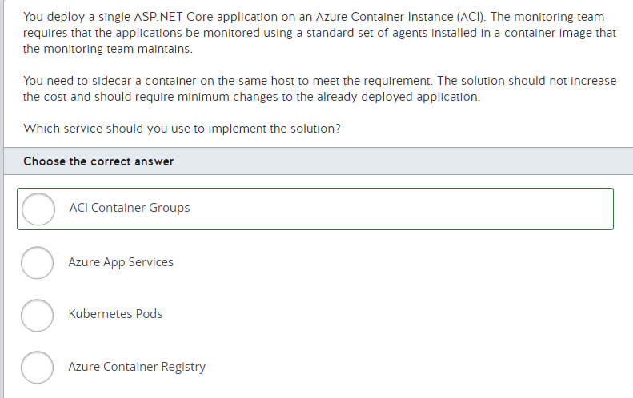

You should use ACI Container Groups. ACI Container Groups provide the capability to host a set of containers on the same host machine. You can have two separate container images, maintained by different teams, deployed together. Each deployed container instance will share the resources of the host and are able to communicate which each other. In this scenario, the ASP.NET core application will be monitored by the agents installed on a separate container instance.  
  
You should not use Azure Container Registry. Azure Container Registry is where multiple container images would be hosted. Azure Container Registry does not provide a hosting environment for executing container instances.  
  
You should not use Kubernetes Pods. Kubernetes Pods provide the capability to sidecar container instances similar to ACI Container Groups. Since the infrastructure for ACI is already created and the application is running on it, using Kubernetes would add additional steps for configuring new infrastructure. This would also increase cost.  
  
You should not use Azure App Services. Azure App Services provides platforms to host container images. Since the infrastructure for ACI is already created and the application is running on it, using App Service would add additional steps for configuring new infrastructure. This would also increase cost.  
  
**References**  
  
[Container groups in Azure Container Instances](https://docs.microsoft.com/en-us/azure/container-instances/container-instances-container-groups)  
  
[Pods](https://kubernetes.io/docs/concepts/workloads/pods/pod/)  
  
[Tutorial: Deploy a multi-container group using a Resource Manager template](https://docs.microsoft.com/en-us/azure/container-instances/container-instances-multi-container-group)  
  
[Introduction to private Docker container registries in Azure](https://docs.microsoft.com/en-us/azure/container-registry/container-registry-intro)

**PREGUNTA 29**

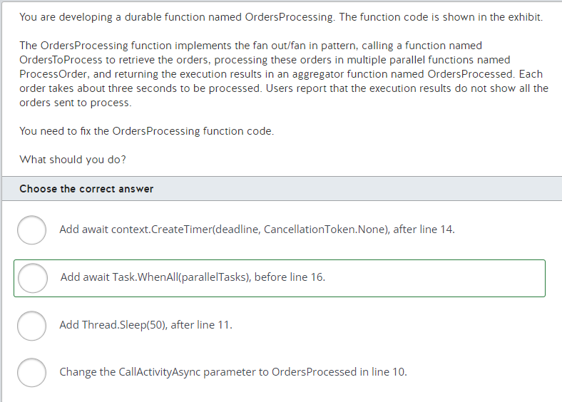

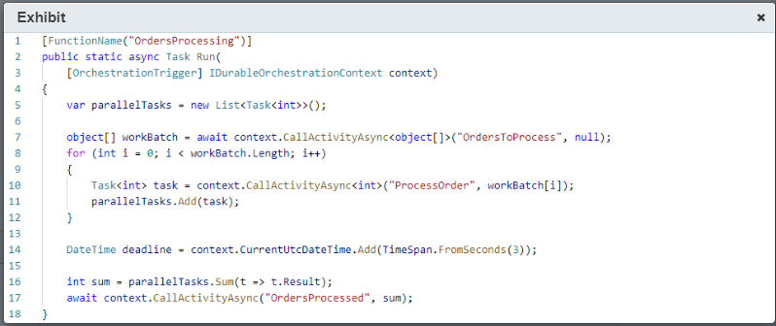

You should add await Task.WhenAll(parallelTasks), before line 16, to ensure that all orders are processed before summarizing the ProcessOrder tasks results.  
  
You should not change the CallActivityAsync parameter to OrdersProcessed in line 10. Modifying this line will cause the wrong function to be used to process each order.  
  
You should not add Thread.Sleep(50), after line 11. Including this line will pause the function execution in 50 milliseconds for each order. This does not ensure that all orders are processed before sending the results to the OrdersProcessed function. You should use a durable timer instead.  
  
You should not add await context.CreateTimer(deadline, CancellationToken.None), after line 14. Adding this line will pause the durable function execution for three seconds after all orders are sent to be processed. This also does not ensure that all orders are processed before sending the results to the OrdersProcessed function.  
  
**References**  
  
[What are Durable Functions?](https://docs.microsoft.com/en-us/azure/azure-functions/durable/durable-functions-overview?tabs=csharp)  
  
[Timers in Durable Functions (Azure Functions)](https://docs.microsoft.com/en-us/azure/azure-functions/durable/durable-functions-timers?tabs=csharp)

**PREGUNTA 30**

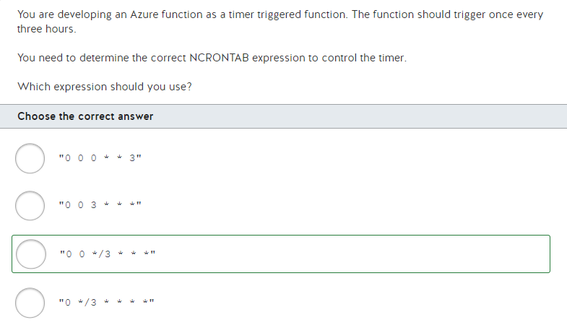

You should use the following expression:  
  
"0 0 */3 * * *"  
  
For example, you could create a time C# function like the following to test:  
  
[FunctionName("TriggerTest")]  
public static void Run([TimerTrigger("0 0 */3 * * *")]TimerInfo myTimer, ILogger log)  
{  
    if (myTimer.IsPastDue)  
    {  
        log.LogInformation("Timer is running late!");  
    }  
    log.LogInformation($"Trigger function executed at: {DateTime.Now}");  
}  
  
Fields in the NCRONTAB expressions are defined as:  
  
{second} {minute} {hour} {day} {month} {day-of-week}  
  
The expression sets the time at 0 second and 0 minutes every third hour.  
  
NCRONTAB is also used when setting timer schedules for functions through the Azure portal.  
  
You should not use the following expression:  
  
"0 */3 * * * *"  
  
This would have the trigger fire every three minutes.  
  
You should not use the following expression:  
  
"0 0 3 * * *"  
  
This would have the trigger fire once a day at 3 AM.  
  
You should not use the following expression:  
  
"0 0 0 * * 3"  
  
This would have the trigger fire at midnight each Wednesday.  
  
**References**  
  
[Create a function in the Azure portal that runs on a schedule](https://docs.microsoft.com/en-us/azure/azure-functions/functions-create-scheduled-function)  
  
[Timer trigger for Azure Functions](https://docs.microsoft.com/en-us/azure/azure-functions/functions-bindings-timer?tabs=csharp)

**PREGUNTA 31**

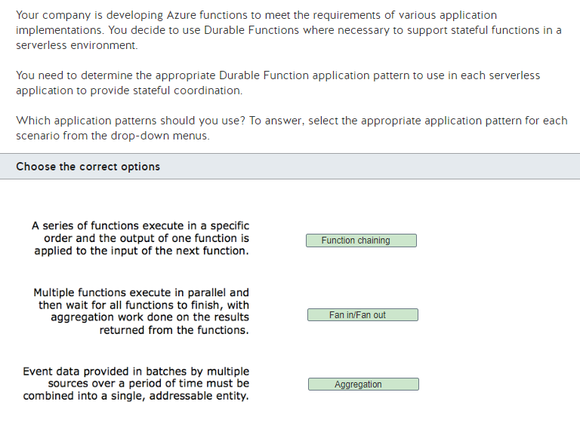

When you have a series of functions that execute in a specific order and the output of one function is applied to the input of the next function, you need to use the function chaining application pattern. This is implemented as a set of orchestrator functions that orchestrate the execution of other durable functions within a function app.  
  
When you have multiple functions that execute in parallel and then wait for all functions to finish with aggregation work done on the results that are returned from the functions, you would use the fan out/fan in application pattern. This is also implemented as orchestrator functions that can call other durable functions with output from called functions saved to local variables.  
  
When you have event data provided in batches by multiple sources over a period of time that must be combined into a single, addressable entity, you should use the aggregation application pattern. This pattern uses stateful entities for data aggregation into a single, addressable entity. Entity functions act like small services that communicate via messages.  
  
None of the scenarios is appropriate for the Async HTTP APIs application pattern. This pattern is used when coordinating the state of long-running operations with external clients.  
  
None of the scenarios is appropriate for the monitoring application pattern. This pattern is used to support to a flexible, recurring process in a workflow, often with a Timer trigger.  
  
**References**  
  
[What are Durable Functions?](https://docs.microsoft.com/en-us/azure/azure-functions/durable/durable-functions-overview?tabs=csharp)  
  
[Durable Functions types and features](https://docs.microsoft.com/en-us/azure/azure-functions/durable/durable-functions-types-features-overview)  
  
[Durable Orchestrations](https://docs.microsoft.com/en-us/azure/azure-functions/durable/durable-functions-orchestrations?tabs=csharp)  
  
[Entity functions](https://docs.microsoft.com/en-us/azure/azure-functions/durable/durable-functions-entities?tabs=csharp)

**PREGUNTA 32**

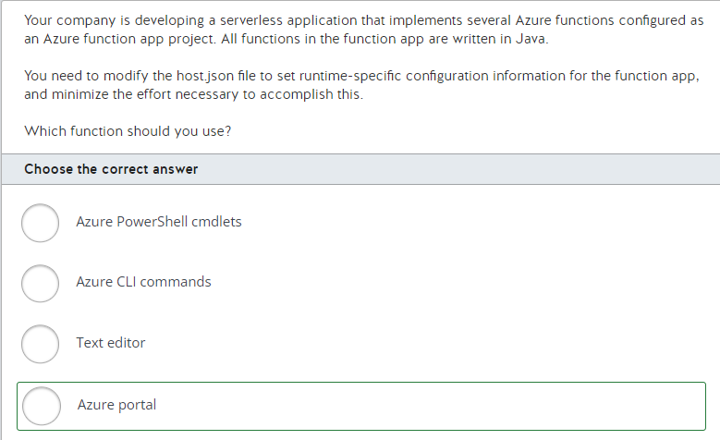

You should use the Azure portal to modify the host.json file. This is done through the function editor that is accessible through the Azure portal.  
  
The code for a function app and its functions are located in a root project folder following the general structure:  
  
FunctionApp  
  - host.json  
  - MyFirstFunction  
   - function.json  
   - ...   
  - MySecondFunction  
   - function.json  
   - ...   
  - SharedCode  
  - bin  
  
The host.json file contains runtime-specific configurations that apply to the function app as a whole. Each function.json file contains configurations for that function. The SharedCode folder is used to store shared code. The bin folder contains packages and library files that the function app requires. You can also use the Azure portal function editor to modify any of the function.json files in the function app.  
  
You should not use Azure PowerShell cmdlets or Azure CLI commands. They do not include the necessary commands to modify or update the host.json file.  
  
You should not edit the host.json file with a text editor. You need to make the edits specifically through the function editor.  
  
**References**  
  
[Introduction to Azure Functions](https://docs.microsoft.com/en-us/azure/azure-functions/functions-overview)  
  
[Azure Functions developer guide](https://docs.microsoft.com/en-us/azure/azure-functions/functions-reference)  
  
[Azure Functions Java developer guide](https://docs.microsoft.com/en-us/azure/azure-functions/functions-reference-java?tabs=consumption)

**PREGUNTA 33**

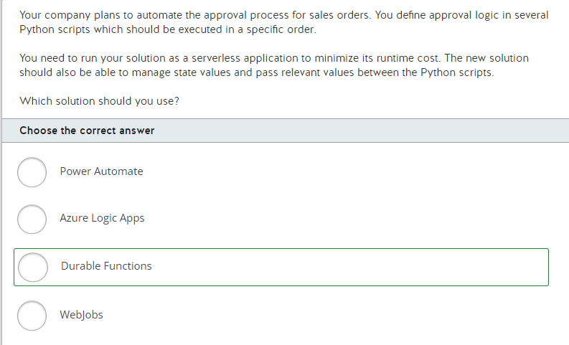

You should use Durable Functions. Durable Functions is an extension of Azure Function that allows you to write and execute stateful functions in a serverless environment. Durable Functions supports Python, C#, F#, JavaScript and PowerShell. It also supports function chaining as an application pattern so that you can run your functions in a specific order.  
  
You should not use Azure Logic Apps. Azure Logic Apps is a workflow designer that provides a visual interface to automate and orchestrate your business processes and tasks. You do not write your Python code in Logic Apps, although you can write it in Azure Functions and then execute it from Logic App.  
  
You should not use Power Automate. Built on top of Logic Apps, it is a similar platform with no or low code that office workers can use to perform simple integrations.  
  
You should not use WebJobs. WebJobs is not a serverless platform. Instead, it is a feature of Azure App Service that shares allocated compute capacity with its web app, API app or mobile app.  
  
**References**  
  
[What are Durable Functions?](https://docs.microsoft.com/en-us/azure/azure-functions/durable/durable-functions-overview?tabs=csharp)  
  
[Choose the right integration and automation services in Azure](https://docs.microsoft.com/en-us/azure/azure-functions/functions-compare-logic-apps-ms-flow-webjobs?toc=/azure/azure-functions/durable/toc.json)  
  
[What is Azure Logic Apps](https://docs.microsoft.com/en-gb/azure/logic-apps/logic-apps-overview)  
  
[Get started with Power Automate](https://docs.microsoft.com/en-us/power-automate/getting-started)  
  
[Run background tasks with WebJobs in Azure App Service](https://docs.microsoft.com/en-us/azure/app-service/webjobs-create)

**PREGUNTA 34**

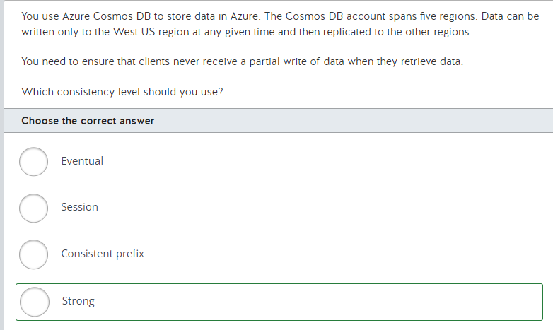

You should use the strong consistency level. This level ensures that clients never receive a partial write or uncommitted data during a read operation.  
  
You should not use the consistent prefix consistency level. This level ensures that reads never see out-of-order writes, but it does not prevent reads from seeing partial writes.  
  
You should not use the eventual consistency level. There is no read guarantee. Clients can potentially receive a partial write or uncommitted data during a read operation.  
  
You should not use the session consistency level. Reads honor the consistent prefix level. This level does not prevent a client from receiving partial writes.  
  
**References**[Consistency levels in Azure Cosmos DB](https://docs.microsoft.com/en-us/azure/cosmos-db/consistency-levels)

**PREGUNTA 35**

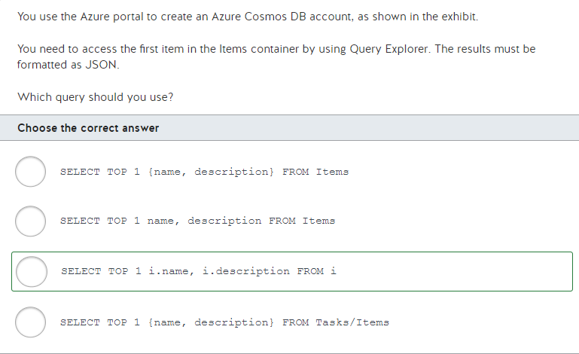

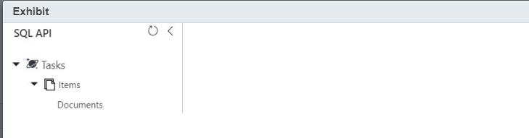

You should use the following query:  
  
SELECT TOP 1 i.name, i.description FROM i  
  
The Cosmos DB account in this scenario uses the SQL API. This allows you to use SQL syntax for querying documents. The FROM clause in SQL specifies the name of a table or result set from which to query data. In Cosmos DB, queries are executed in the container context, and the FROM clause can specify any name. Regardless of which name you specify, the query retrieves data from the collection you are querying. The results are always formatted as JSON.  
  
All of the other queries have syntax errors that would prevent you from retrieving the documents.  
  
**References**[Getting started with SQL queries](https://docs.microsoft.com/en-us/azure/cosmos-db/how-to-sql-query)[FROM clause in Azure Cosmos DB](https://docs.microsoft.com/en-us/azure/cosmos-db/sql-query-from)

**PREGUNTA 36**

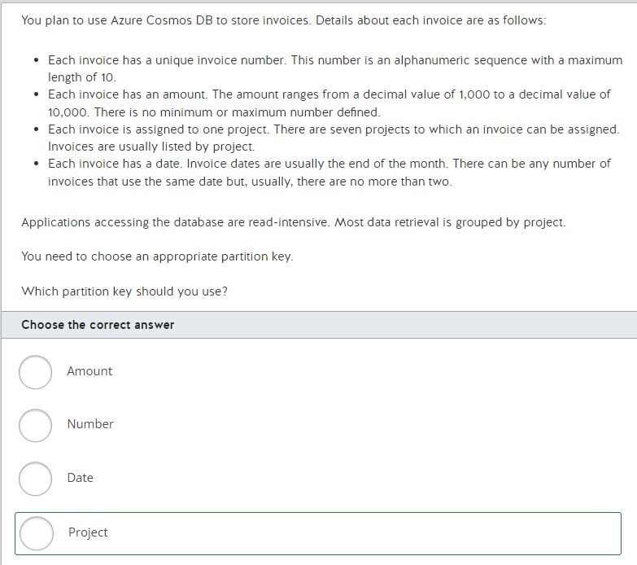

You should use the project partition key. By choosing project, you ensure that all invoices that are assigned to the same project are part of the same partition which allows you to write highly performant (i.e., low latency) and cost-efficient in-partition queries. When you are choosing a partition key for an Azure Cosmos DB container, there are a few key considerations. Understanding the query patterns for the given use-case is extremely vital, since it allows you to predict to a certain degree of preciseness, what kind of data insert, update, and retrieval will take place during majority of the time. In the scenario it is mentioned that most data retrieval will be grouped by project, which means that the majority of the queries for a given container across items will be using the project property value in their queries as a filter. In addition to this, a partition key should have properties of high cardinality, since this allows for a large range of values across this property allowing you to group items (or documents) into a large range of logical partitions (since all items, or documents, having the same partition key share the same logical partition). The key point to note here is that although high cardinality plays an important role in determining a partition key, it is always secondary to being able to choose a most commonly queried filter (project in this scenario).

You should not set the partition key to amount. The fundamental reason why amount, though it can have high cardinality with a large range of values that it can hold, will not make a good partition key in this scenario, is that we are aware that the majority of the data retrieval (i.e., queries) will be grouped by project. Amount being one of the properties in a project, chances are, there will be a very minimal number of queries which will be filtered (or searched) against amount. Hence, amount will not make an appropriate partition key for our Azure Cosmos DB container for this scenario.

You should not set the partition key to number. This value is unique. This would create as many partitions as there are invoices.

You should not set the partition key to date. Due to the fact that there are usually no more than two invoices per date, this would create about half the number of partitions as there are invoices.  
  
**References**[Partitioning and horizontal scaling in Azure Cosmos DB](https://docs.microsoft.com/en-us/azure/cosmos-db/partitioning-overview)

**PREGUNTA 37**

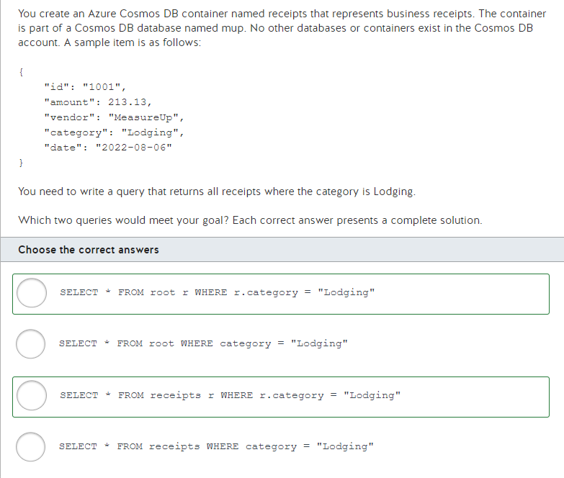

You should use either of the following queries:  
  
SELECT * FROM root r WHERE r.category = "Lodging"  
SELECT * FROM receipts r WHERE r.category = "Lodging"  
  
The first one uses the keyword root to select items from the default container. Because only one container exists, the default container is receipts. The second query specifies the name of the container, which is named receipts. Both of these queries use a table alias named r.  
  
You should not use either of the following queries:  
  
SELECT * FROM root WHERE category = "Lodging"  
SELECT * FROM receipts WHERE category = "Lodging"  
  
These queries do not specify container aliases, which are required when column names are directly referenced in other SQL clauses, including SELECT, WHERE, ORDER BY, and GROUP BY.  
  
**References**[Getting started with SQL queries](https://docs.microsoft.com/en-us/azure/cosmos-db/sql-query-getting-started)

**PREGUNTA 38**

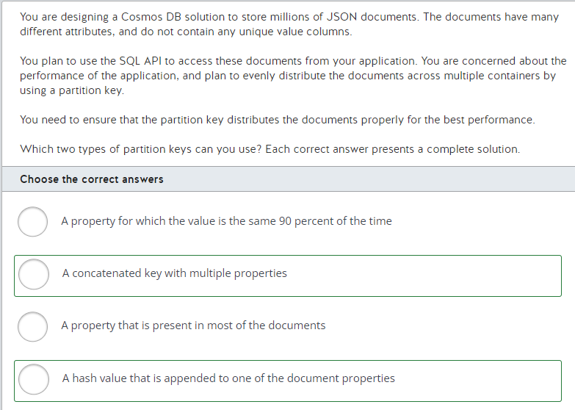

You can create the partition key by concatenating multiple properties. This type of key is called a synthetic key. Because the keys are not consistent, such a concatenated key will create randomness to enable proper distribution across various containers.  
  
You could also create a hash value appended to a document property value to generate the partition key. In this case, the hash value will generate randomness to properly distribute the document since the documents themselves do not have a unique identifier.  
  
You should not use a property present in most documents. In this scenario, if a large number of documents have the same value in that property, most of the documents will end up in just one of the containers. This will not provide optimal performance.  
  
You should not use a property for which the value is the same 90 percent of the time. In this scenario as well, you would end up with a container that has 90 percent of the documents. In order to achieve optimal performance, you want your documents to be distributed across multiple containers.  
  
**References**  
  
[Partitioning and horizontal scaling in Azure Cosmos DB](https://docs.microsoft.com/en-us/azure/cosmos-db/partitioning-overview)[Create a synthetic partition key](https://docs.microsoft.com/en-us/azure/cosmos-db/synthetic-partition-keys)

**PREGUNTA 39**

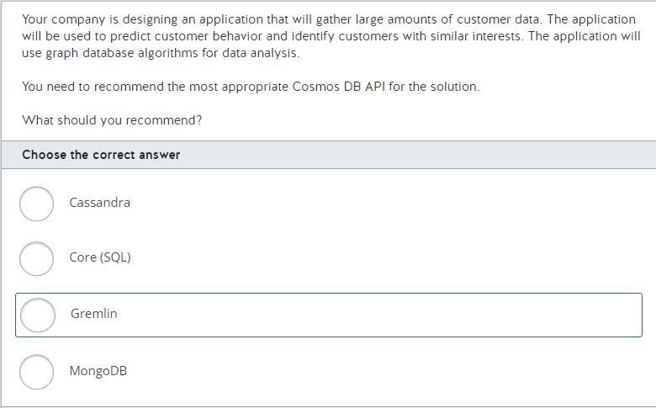

You should use the Gremlin API as your data solution. Gremlin is specifically designed as a fully-managed data-based solution for graph data. It provides native graph support and it is widely used in scenarios in which you need to work with large amounts of interrelated data.  
  
You should not use the Cassandra API. The Cassandra API is not designed or optimized to support graph data. Cassandra API is used for data storage for apps written for Apache Cassandra and for interacting with Cassandra-based tools. One of the Cassandra API's most common uses is porting existing Cassandra data to Azure.  
  
You should not use the MongoDB API. MongoDB is used for document, key-value, graph, and columnar data models.  
  
You should not use the Core (SQL) API. The Core (SQL) API uses an industry-standard relational database model. This API does not support the graph data storage model.  
  
**References**  
  
[Introduction to Gremlin API in Azure Cosmos DB](https://docs.microsoft.com/en-us/azure/cosmos-db/graph-introduction)  
  
[Understanding the differences between NoSQL and relational databases](https://docs.microsoft.com/en-us/azure/cosmos-db/relational-nosql)  
  
[Analyze the decision criteria](https://docs.microsoft.com/en-us/learn/modules/choose-api-for-cosmos-db/3-analyze-the-decision-criteria)

**PREGUNTA 40**

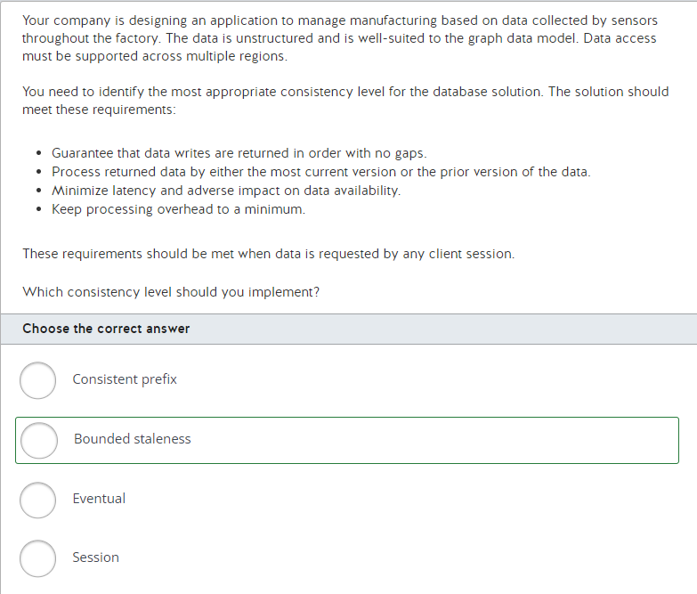

You should implement the bounded staleness consistency level. This consistency level includes the implementation of consistent prefix, which guarantees that data writes are returned in order. You can configure staleness, which determines the data version returned, based on either the number of versions or on time delay.  
  
You should not implement the consistent prefix consistency level. This level ensures that data is never returned out-of-order, but it does not let you configure staleness requirements for data.  
  
You should not implement the session consistency level. This level ensures that data is returned in order, but it only supports a single client session. This level also does not let you configure staleness.  
  
You should not use the eventual consistency level. This level does not let you configure staleness and does not guarantee that data is returned in order.  
  
**References**  
  
[Consistency levels in Azure Cosmos DB](https://docs.microsoft.com/en-us/azure/cosmos-db/consistency-levels)

**PREGUNTA 41**

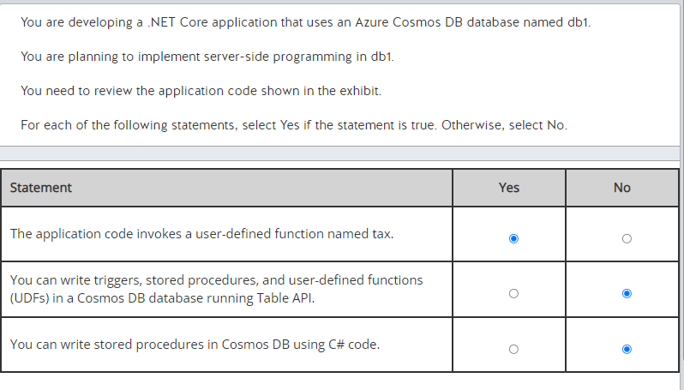

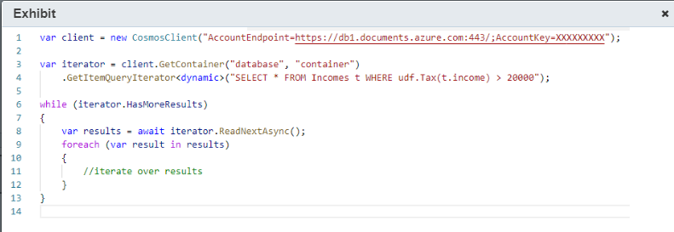

The application code invokes a user-defined function named tax. You can see the user-defined function tax function invoked in line 4 of the code. You can use a user-defined function to extend the SQL API query language syntax, and implement custom business logic directly in Cosmos DB.  
  
You cannot write triggers, stored procedures, and user-defined functions (UDFs) in a Cosmos DB database running Table API. You can write code with custom business logic in Javascript that is executed inside the database engine using the SQL API only. Other Cosmos DB APIs do not support triggers, stored procedures, and UDFs.  
  
You cannot write stored procedures in Cosmos DB using C# code. Cosmos DB only supports stored procedures, triggers, and UDFs written in Javascript. You can register and use Cosmos DB server-side programming custom logic with supported SDKs, including C#, Java, Javascript, and Python, but the code that is executed by the database engine must be written in Javascript.  
  
**References**  
  
[Stored procedures, triggers, and user-defined functions](https://docs.microsoft.com/en-us/azure/cosmos-db/stored-procedures-triggers-udfs)  
  
[How to register and use stored procedures, triggers, and user-defined functions in Azure Cosmos DB](https://docs.microsoft.com/en-us/azure/cosmos-db/how-to-use-stored-procedures-triggers-udfs)  
  
[JavaScript query API in Azure Cosmos DB](https://docs.microsoft.com/en-us/azure/cosmos-db/javascript-query-api)

**PREGUNTA 42**

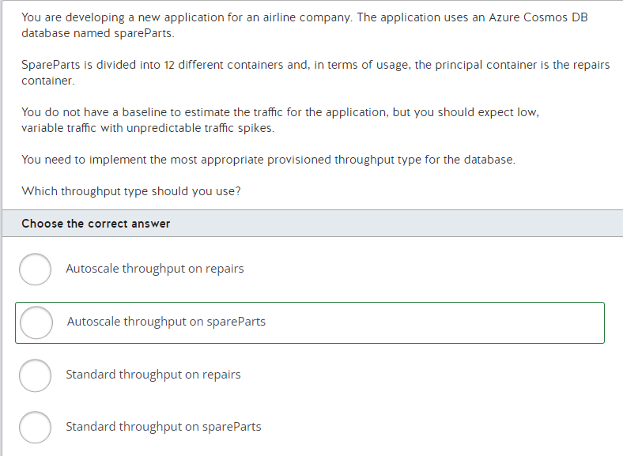

You should use autoscale throughput on spareParts. You can use the autoscale throughput on a database in scenarios in which you do not know yet the traffic pattern for the application, but you want to prepare the application to scale in unpredictable traffic spikes. You can scale spareParts between 400 to 4000 request units per second (RU/s) with autoscale throughput.  
  
You should not use autoscale throughput on repairs. You can provision a dedicated throughput for a container if you have specific throughput and performance requirements. In this case, since you expect low traffic with the application, you do not need dedicated provisioned throughput for repairs.  
  
You should not use standard throughput on spareParts or repairs. You can use standard throughput for an application that has known steady traffic. For scenarios like this one in which you have variable and unpredictable traffic, autoscale throughput is more recommendable.  
  
**References**  
  
[Introduction to provisioned throughput in Azure Cosmos DB](https://docs.microsoft.com/en-us/azure/cosmos-db/set-throughput)  
  
[Create Azure Cosmos containers and databases with autoscale throughput](https://docs.microsoft.com/en-us/azure/cosmos-db/provision-throughput-autoscale)  
  
[How to choose between standard (manual) and autoscale provisioned throughput](https://docs.microsoft.com/en-us/azure/cosmos-db/how-to-choose-offer)

**PREGUNTA 43**

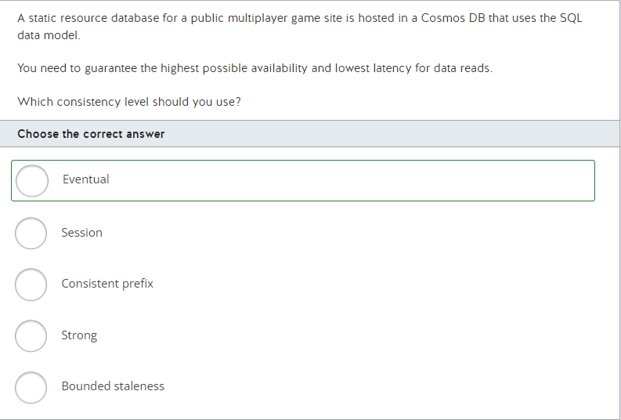

You should use the eventual consistency level. This level provides the lowest latency and higher availability for data reads because it does not guarantee the ordering of reads, but this lack of ordering is not an issue for a static database that will not be receiving new data writes.  
  
You should not use the consistent prefix consistency level. This level ensures that reads never see out-of-order writes. However, this level has more latency and less availability than the eventual consistency level.  
  
You should not use the session consistency level. This level ensures that reads honor consistency guarantees including the consistent-prefix, monotonic reads, monotonic writes, read-your-writes, and write-follows-reads. However, this level has more latency and less availability than the consistent prefix consistency level.  
  
You should not use the bounded staleness consistency level. Reads on this level might lag behind writes based on configured update versions (K) or time (t) and have more latency and less availability than the session consistency level.

You should not use the strong consistency level. Reads on this level always return the most recent committed version of an item. However, this level has more latency and less availability than the bounded staleness consistency level.

**References**  
  
[Consistency levels in Azure Cosmos DB](https://docs.microsoft.com/en-us/azure/cosmos-db/consistency-levels)

**PREGUNTA 44**

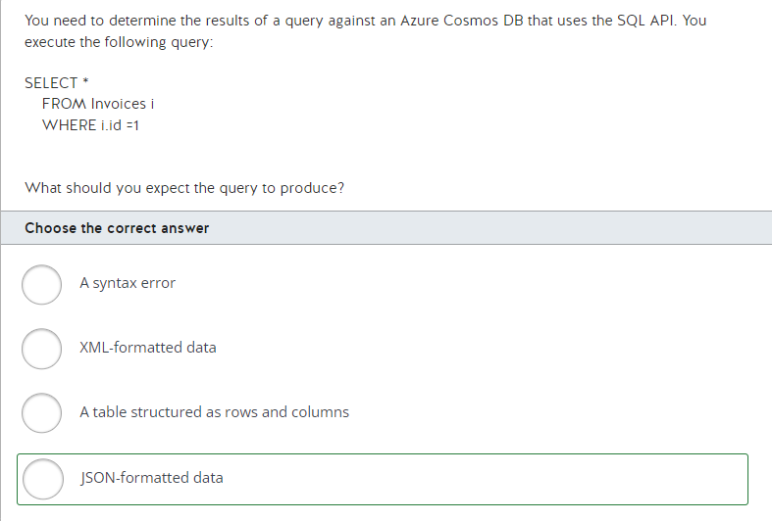

You should expect JSON-formatted data. SELECT queries against a Cosmos SQL database using the SQL API return data in a JSON format.  
  
You should not expect XML-formatted data. None of the APIs supported by Cosmos DB default returns data formatted as XML.  
  
You should not expect a table structured as rows and columns. You would expect this result when using the Table API.  
  
You should not expect a syntax error. The SQL API uses standard SQL syntax, and the query does not include any syntax errors.  
  
**References**  
  
[Getting started with SQL queries](https://docs.microsoft.com/en-us/azure/cosmos-db/sql-query-getting-started)  
  
[Azure Cosmos DB: Designing your data structure](https://social.technet.microsoft.com/wiki/contents/articles/39421.azure-cosmos-db-designing-your-data-structure.aspx)  
  
[Tutorial: Query Azure Cosmos DB by using the Table API](https://docs.microsoft.com/en-us/azure/cosmos-db/tutorial-query-table)  
  
[Introduction to Azure Cosmos DB database and the SQL API](https://www.mssqltips.com/sqlservertip/5331/introduction-to-azure-cosmos-db-database-and-the-sql-api/)

**PREGUNTA 45**

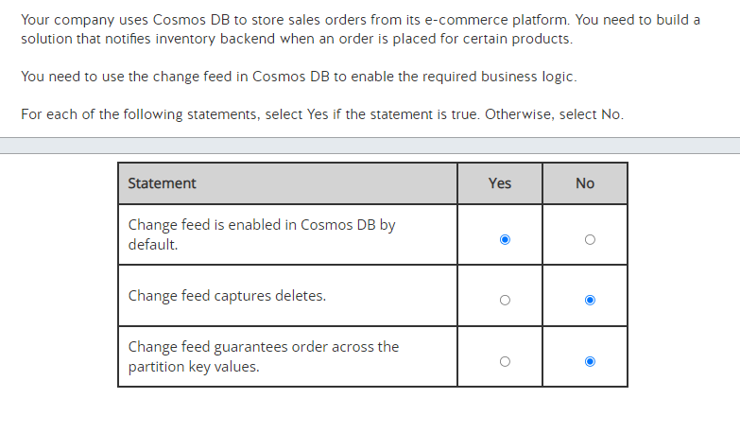

Change feed is enabled in Cosmos DB by default. You do not need to activate anything additionally; this functionality is enabled for all Cosmos DB accounts automatically.  
  
Change feed does not capture deletes, it captures inserts and updates. To capture deletes, you can set up an additional property in your Cosmos DB items as a marker, and update it at the time of deletion. This option would enable logging of the document updates in the change feed.  
  
Change feed does not guarantee order across the partition key values. In the change feed, order is guaranteed within each logical partition key value, but not across them.  
  
**References**  
  
[Change feed in Azure Cosmos DB](https://docs.microsoft.com/en-us/azure/cosmos-db/change-feed)  
  
[Change feed design patterns in Azure Cosmos DB](https://docs.microsoft.com/en-us/azure/cosmos-db/change-feed-design-patterns)  
  
[Reading Azure Cosmos DB change feed](https://docs.microsoft.com/en-us/azure/cosmos-db/read-change-feed)

**PREGUNTA 46**

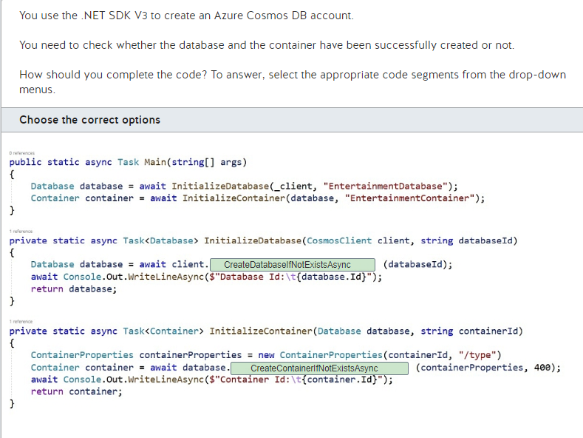

You should use CreateDatabaseIfNotExistsAsync and CreateContainerIfNotExistsAsync to complete the code.  
  
The CreateDatabaseIfNotExistsAsync(String, Nullable<Int32>, RequestOptions, CancellationToken) method should be used to check if a database exists, and if it does not, create it. Only the database id is used to verify if there is an existing database.  
  
You should not use CreateDatabaseAsync method. This method simply sends a request for creating an Azure Cosmos DB database and does not check if a database exists or not.  
  
You should not use CreateDatabaseStreamAsync method. This method simply sends a request for creating an Azure Cosmos DB database and does not check if a database exists or not. The key difference between CreateDatabaseAsync and CreateDatabaseStreamAsync methods lie in the parameters. CreateDatabaseAsync takes id, throughputProperties, requestOptions and cancellationToken as parameters, while CreateDatabaseStreamAsync takes databaseProperties (e.g., ETag, Id, LastModified, SelfLink), throughput, requestOptions and cancellationToken as parameters.  
  
The CreateContainerIfNotExistsAsync(String, String, Nullable<Int32>, RequestOptions, CancellationToken) method checks if a container exists, and if it does not, creates it. This will make a read operation, and if the container is not found it will do a create operation.  
  
You should not use the CreateContainerAsync method. This method simply creates a container as an asynchronous operation in the Azure Cosmos service. It does not check if the container exists or not.  
  
You should not use the CreateContainerStreamAsync method. This method simply creates a container as an asynchronous operation in the Azure Cosmos service. It does not check if the container exists or not. The key difference between CreateContainerAsync and CreateContainerStreamAsync methods lie in the parameters.  
  
**References**  
  
[CosmosClient.CreateDatabaseIfNotExistsAsync Method](https://docs.microsoft.com/en-us/dotnet/api/microsoft.azure.cosmos.cosmosclient.createdatabaseifnotexistsasync?view=azure-dotnet)  
  
[CosmosClient.CreateDatabaseAsync Method](https://docs.microsoft.com/en-us/dotnet/api/microsoft.azure.cosmos.cosmosclient.createdatabaseasync?view=azure-dotnet)  
  
[CosmosClient.CreateDatabaseStreamAsync Method](https://docs.microsoft.com/en-us/dotnet/api/microsoft.azure.cosmos.cosmosclient.createdatabasestreamasync?view=azure-dotnet)  
  
[Database.CreateContainerIfNotExistsAsync Method](https://docs.microsoft.com/en-us/dotnet/api/microsoft.azure.cosmos.database.createcontainerifnotexistsasync?view=azure-dotnet)  
  
[Database.CreateContainerAsync Method](https://docs.microsoft.com/en-us/dotnet/api/microsoft.azure.cosmos.database.createcontainerasync?view=azure-dotnet)  
  
[Database.CreateContainerStreamAsync Method](https://docs.microsoft.com/en-us/dotnet/api/microsoft.azure.cosmos.database.createcontainerstreamasync?view=azure-dotnet)

**PREGUNTA 47**

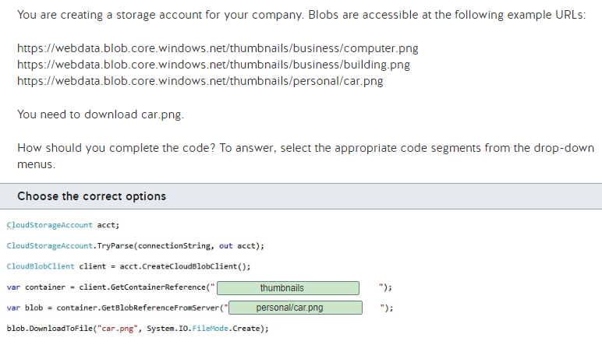

Blob storage account URLs have the following format:  
  
https://{account name}.blob.core.windows.net/{container}/{blob}  
  
The {account name} placeholder represents the account name.  
  
The {container} placeholder represents a blob container. Therefore, the name of the container for all three blobs is thumbnails.  
  
The {blob} placeholder represents a blob. A blob can have any combination of characters, including the / symbol. In this scenario, business/computer.png, business/building.png, and personal/car.png all represent the names of blobs.  
  
Therefore, you should use the following code:  
  
CloudStorageAccount acct;  
CloudStorageAccount.TryParse(connectionString, out acct);  
CloudBlobClient client = acct.CreateCloudBlobClient();  
var container = client.GetContainerReference("thumbnails");  
var blob = container.GetBlobReferenceFromServer("personal/car.png");  
blob.DownloadToFile("car.png", System.IO.FileMode.Create);  
  
You should not specify webdata or thumbnails/personal as the parameter to the GetContainerReference method. The name of the container is thumbnails for all three blobs.  
  
You should not specify thumbnails/personal/car.png or car.png as the parameter to the GetBlobReferenceFromServer method. The name of the blob is personal/car.png.  
  
**References**[Naming and Referencing Containers, Blobs, and Metadata](https://docs.microsoft.com/en-us/rest/api/storageservices/naming-and-referencing-containers--blobs--and-metadata)[Quickstart: Azure Blob Storage client library v12 for .NET](https://docs.microsoft.com/en-us/azure/storage/blobs/storage-quickstart-blobs-dotnet)

**PREGUNTA 48**

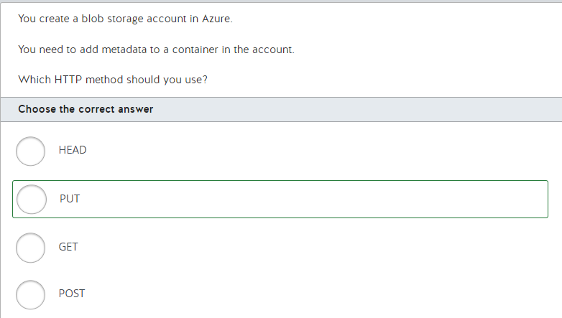

You should use the PUT method. This method allows you to add metadata to containers and blobs. The following example adds custom metadata to identify a blob named logo.png as an image:  
  
PUT https://webdata.blob.core.windows.net/home/logo.png?comp=metadata HTTP/1.1  
  
x-ms-version: 2018-03-28  
x-ms-date: Tue, 12 Mar 2019 09:12:57 GMT  
x-ms-meta-Category: Images  
Authorization: SharedKey webdata:S5013xY2DesKNh0ONtksNc9naXScqLHueE00JdjidOQ=  
  
The name of the custom metadata attribute is xs-ms-meta-Category, and its value is Images. The other metadata attributes are required.  
  
You should not use GET or HEAD. Both GET and HEAD allow you to retrieve metadata attributes. They do not allow you to set them. In general, GET is used to request data from a web server in a response body, and HEAD is used to determine whether a page exists, without returning a response body.  
  
You should not use POST. POST does not allow you to retrieve or set metadata attributes. POST is used to send data to a web server in the body of a request. The difference between PUT and POST is that PUT requests always produce the same result, whereas POST can produce different results.  
  
**References**[Setting and retrieving properties and metadata for Blob service resources](https://docs.microsoft.com/en-us/rest/api/storageservices/setting-and-retrieving-properties-and-metadata-for-blob-resources)[Set Container Metadata](https://docs.microsoft.com/en-us/rest/api/storageservices/set-container-metadata)[Authorize requests to Azure Storage](https://docs.microsoft.com/en-us/rest/api/storageservices/authorization-for-the-azure-storage-services)[HTTP Request Methods](https://www.w3schools.com/tags/ref_httpmethods.asp)

**PREGUNTA 48**

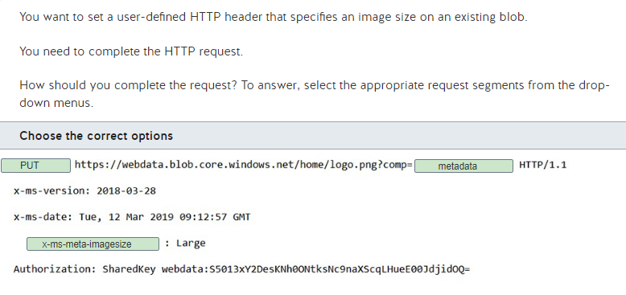

You should use the following request:  
  
PUT https://webdata.blob.core.windows.net/home/logo.png?comp=metadata HTTP/1.1  
  
x-ms-version: 2018-03-28  
x-ms-date: Tue, 12 Mar 2019 09:12:57 GMT  
x-ms-meta-imagesize: Large  
Authorization: SharedKey webdata:S5013xY2DesKNh0ONtksNc9naXScqLHueE00JdjidOQ=  
  
The PUT method allows you to add metadata and properties to containers and blobs. Metadata and properties are represented as HTTP headers. Properties are referred to as system properties. Only certain HTTP headers can be present when you set properties. User-defined HTTP headers are referred to as metadata. To use custom metadata, you must specify the HTTP header in the format x-ms-meta-{user-defined name}. Therefore, you should use x-ms-meta-imagesize as the name of the HTTP header to represent custom metadata. The comp query string in the request URL specifies whether you are setting metadata as system properties. To set custom metadata, you specify comp=metadata.  
  
You should not use GET or HEAD as the request method. Both GET and HEAD allow you to retrieve metadata attributes and properties. They do not allow you to set them. In general, GET is used to request data from a web server in a response body, and HEAD is used to determine whether a page exists, without returning a response body.  
  
You should not use POST as the request method. POST does not allow you to retrieve or set metadata attributes and properties. POST is used to send data to a web server in the body of a request. The difference between PUT and POST is that PUT requests always produce the same result, whereas POST can produce different results.  
  
You should not specify comp=properties in the query string. This query string indicates that you are setting system properties.  
  
You should not specify Image-Size as the HTTP header. To use custom metadata, you must specify the HTTP header in the format x-ms-meta-{user-defined name}. Therefore, you should use x-ms-meta-imagesize as the name of the HTTP header to represent custom metadata.  
  
**References**[Setting and retrieving properties and metadata for Blob service resources](https://docs.microsoft.com/en-us/rest/api/storageservices/setting-and-retrieving-properties-and-metadata-for-blob-resources)  
  
[Set Blob Metadata](https://docs.microsoft.com/en-us/rest/api/storageservices/set-blob-metadata)[Set Container Metadata](https://docs.microsoft.com/en-us/rest/api/storageservices/set-container-metadata)[Set Blob Properties](https://docs.microsoft.com/en-us/rest/api/storageservices/set-blob-properties)[HTTP Request Methods](https://www.w3schools.com/tags/ref_httpmethods.asp)

**PREGUNTA 50**

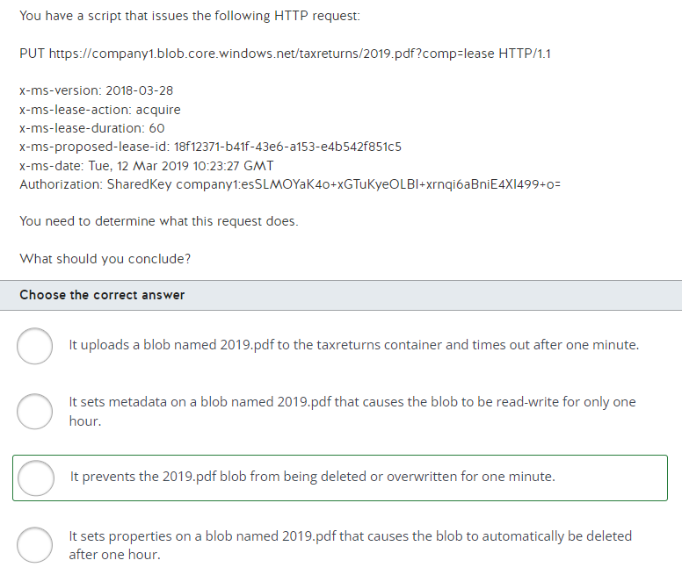

The request prevents the 2019.pdf blob from being deleted or overwritten for one minute. This is referred to as blob leasing. The comp query string of the PUT request URL is set to lease, which represents a blob lease request. Setting the x-ms-lease-action header to acquire causes a new lease to be requested or an existing lease to be extended. To extend an existing lease if it has not already expired, the x-ms-proposed-lease-id header is set to the existing lease ID, which is 18f12371-b41f-43e6-a153-e4b542f851c5. The x-ms-lease-duration header is set to 60, which leases the blob for 60 seconds (one minute).  
  
The request does not set properties on a blob named 2019.pdf that causes the blob to automatically be deleted after one hour. You must write custom code to delete blobs after certain time periods.  
  
The request does not upload a blob named 2019.pdf to the taxreturns container and time out after one minute. To upload a blob, you must specify content in the request body. In this scenario, no request body is present.  
  
The request does not set metadata on a blob named 2019.pdf that causes the blob to be read-write for only one hour. You must write custom code to cause a blob to be modifiable for a specific time period.  
  
**References**[Lease Blob](https://docs.microsoft.com/en-us/rest/api/storageservices/lease-blob)[Put Blob](https://docs.microsoft.com/en-us/rest/api/storageservices/put-blob)[Set Blob Properties](https://docs.microsoft.com/en-us/rest/api/storageservices/set-blob-properties)[Set Blob Metadata](https://docs.microsoft.com/en-us/rest/api/storageservices/set-blob-metadata)

**PREGUNTA 51**

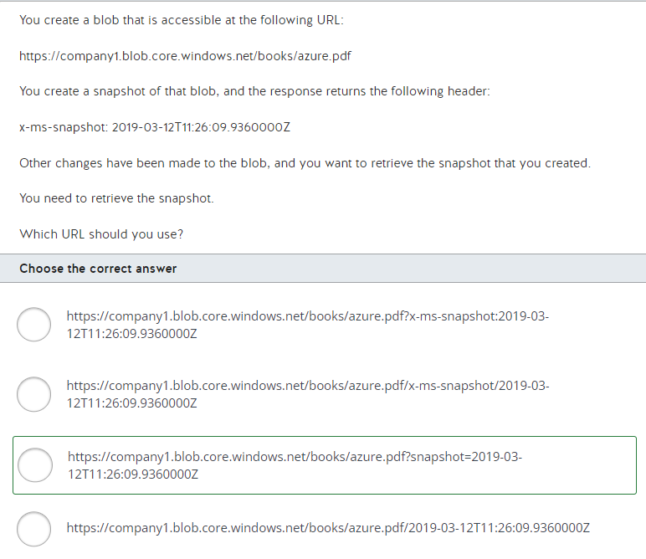

Blob storage account URLs have the following format:  
  
https://{account name}.blob.core.windows.net/{container}/{blob}  
  
The {account name} placeholder represents the account name. The {container} placeholder represents a blob container. The {blob} placeholder represents a blob. A blob can have any combination of characters, including the / symbol.  
  
You should use the following URL:  
  
https://company1.blob.core.windows.net/books/azure.pdf?snapshot=2019-03-12T11:26:09.9360000Z  
  
The snapshot query string specifies the date-time stamp of the snapshot, which is always a unique value when creating snapshots. This URL represents a snapshot taken on March 12, 2019 at 11:26 AM of a blob named azure.pdf in the books container of the company1 storage account.  
  
You should not use the following URL:  
  
https://company1.blob.core.windows.net/books/azure.pdf/2019-03-12T11:26:09.9360000Z  
  
This URL represents a blob named azure.pdf/2019-03-12T11:26:09.9360000Z in the books container of the company1 storage account.  
  
You should not use the following URL:  
  
https://company1.blob.core.windows.net/books/azure.pdf/x-ms-snapshot/2019-03-12T11:26:09.9360000Z  
  
This URL represents a blob named azure.pdf/x-ms-snapshot/2019-03-12T11:26:09.9360000Z in the books container of the company1 storage account.  
  
You should not use the following URL:  
  
https://company1.blob.core.windows.net/books/azure.pdf?x-ms-snapshot:2019-03-12T11:26:09.9360000Z  
  
The query string is incorrect. Although the header that is returned from a snapshot is named x-ms-snapshot, you must use the snapshot query string to retrieve a snapshot.  
  
**References**[Snapshot Blob](https://docs.microsoft.com/en-us/rest/api/storageservices/snapshot-blob)[Blob snapshots](https://docs.microsoft.com/en-us/azure/storage/blobs/storage-blob-snapshots)

**PREGUNTA 52**

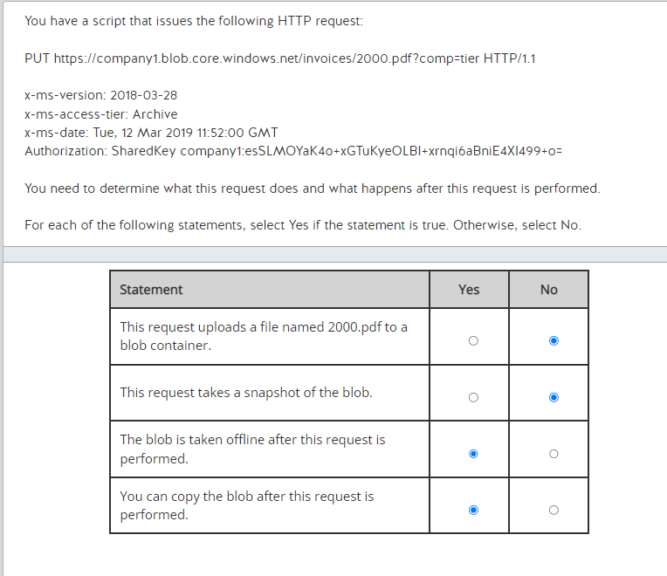

The request prevents the 2000.pdf blob from being read, modified, overwritten, or having snapshots taken. It places the blob in archive storage. The comp query string of the PUT request URL is set to tier, which represents a blob tier change request. The x-ms-access-tier header specifies the tier to which the blob should be changed. The Archive tier is intended for blobs that are rarely accessed. Scenarios include those where you would not access a blob for six months. The Hot tier is intended for blobs that are accessed frequently, and the Cool tier is intended for blobs that are accessed once a month.  
  
This request does not upload a blob named 2000.pdf to a blob container. To upload a blob, you must specify content in the request body. In this scenario, no request body is present.  
  
The request does not take a snapshot of the blob. A request sent to this endpoint with the comp=tier URL parameter is used to change the blob access tier. You should use comp=snapshot to take a blob snapshot instead.  
  
The blob is taken offline after this request is performed. The Archive tier causes a blob to be taken offline until it is needed. You need to wait for the rehydration process, which can take a few hours before you can read the blob contents.  
  
You can copy the blob after this request is performed. After a blob is moved to Archive tier, you can copy this blob to a new blob with the Hot or Cool tier. However, you still need to wait for the rehydration process before you can read the copied blob contents.  
  
**References**[Snapshot Blob](https://docs.microsoft.com/en-us/rest/api/storageservices/snapshot-blob)  
  
[Set Blob Tier](https://docs.microsoft.com/en-us/rest/api/storageservices/set-blob-tier)[Hot, Cool, and Archive access tiers for blob data](https://docs.microsoft.com/en-us/azure/storage/blobs/storage-blob-storage-tiers)  
  
[Blob rehydration from the Archive tier](https://docs.microsoft.com/en-us/azure/storage/blobs/storage-blob-rehydration)

**PREGUNTA 53**

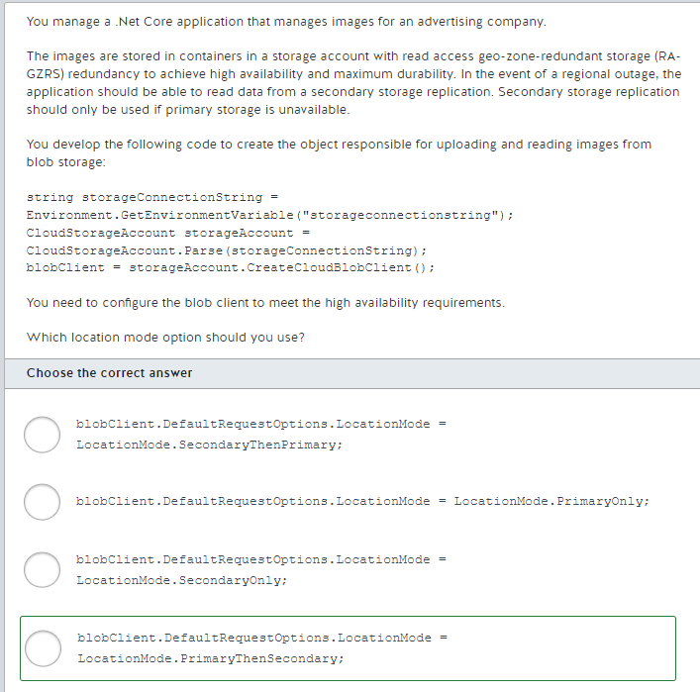

You should configure the blob client default request option for the location mode as PrimaryThenSecondary. In this mode, in the event of a regional outage affecting primary storage, the application reads the images replicated to another region as a fallback until primary storage is available again.  
  
You should not configure the blob client default request option for the location mode as PrimaryOnly. In this mode, only primary storage is used. In the case of a regional outage affecting primary storage, the application will fail to read images even if they are replicated to secondary storage. This is the default blob client mode.  
  
You should not configure the blob client default request option for the location mode as SecondaryOnly or SecondaryThenPrimary. With these modes, the blob client will first read the images from secondary storage. Secondary storage should only be used if primary storage is unavailable.  
  
**References**[Use geo-redundancy to design highly available applications](https://docs.microsoft.com/en-us/azure/storage/common/storage-designing-ha-apps-with-ragrs)  
[Using the Circuit Breaker pattern in your HA apps with RA-GRS Storage](https://github.com/Azure-Samples/storage-dotnet-circuit-breaker-ha-ra-grs)  
  
[Azure Storage redundancy](https://docs.microsoft.com/en-us/azure/storage/common/storage-redundancy)

**PREGUNTA 54**

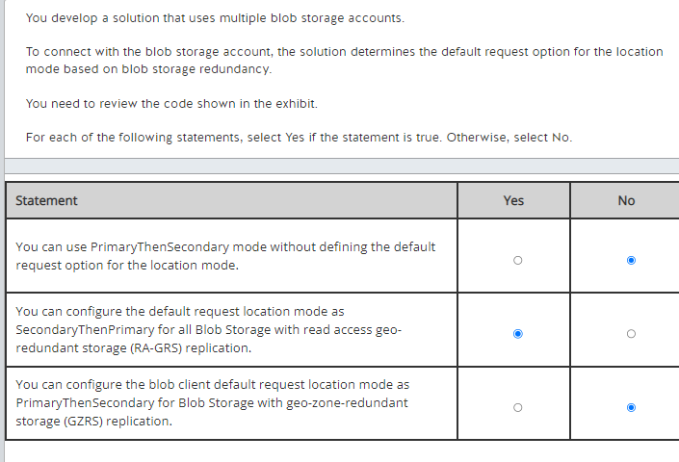

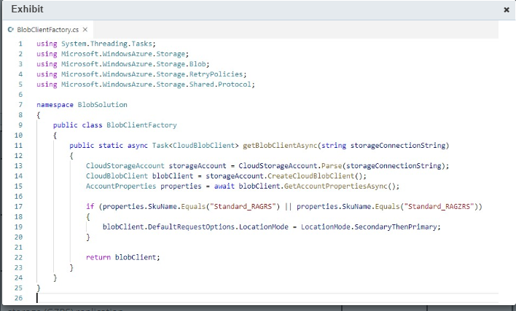

You need to define the default request option for the location mode in order for PrimaryThenSecondary mode to be used. If you omit the default request location mode, PrimaryOnly mode will be used. PrimaryOnly is the default blob client mode. The solution defines the default request location mode as SecondaryThenPrimary for all Blob Storage with RA-GRS replication. The code checks if the Blob Storage is RA-GRS or read access geo-zone-redundant storage (RA-GZRS) and configures the blob client default request location mode as SecondaryThenPrimary. You should use RA-GRS or RA-GZRS to enable read access to secondary storage.  
  
You cannot configure the blob client default request location mode as PrimaryThenSecondary for Blob Storage with GZRS. Secondary storage reading is only enabled in RA-GRS or RA-GZRS. Other redundancy options like geo-zone-redundant (GRS) redundancy can only use the default PrimaryOnly location mode.  
  
**References**  
[Use geo-redundancy to design highly available applications](https://docs.microsoft.com/en-us/azure/storage/common/storage-designing-ha-apps-with-ragrs)[Azure Storage redundancy](https://docs.microsoft.com/en-us/azure/storage/common/storage-redundancy)  
  
[Get storage account configuration information](https://docs.microsoft.com/en-us/azure/storage/common/storage-account-get-info)  
  
[Using the Circuit Breaker pattern in your HA apps with RA-GRS Storage](https://github.com/Azure-Samples/storage-dotnet-circuit-breaker-ha-ra-grs)

**PREGUNTA 55**

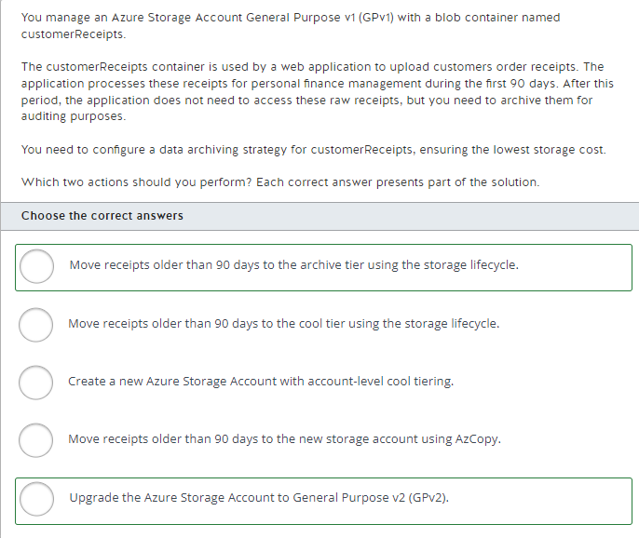

You should upgrade the Azure Storage Account to General Purpose v2 (GPv2). The most efficient way to implement data archiving in Azure Blob Storage is by using the Blob storage lifecycle and access tiers. To implement access tiering, you need to upgrade the Azure Storage Account from GPv1 to GPv2. You can convert an existing GPv1 account to a GPv2 account through the Azure portal.  
  
You should also move receipts older than 90 days to the archive tier using the storage lifecycle. After you upgrade the storage account to GPv2, you can implement a storage lifecycle to move receipts older than 90 days to the archive tier. The archive tier has the lowest storage cost because it uses offline storage to persist the data. You can use a storage lifecycle to automatically move receipts older than 90 days to the archive tier.  
  
You should not move receipts older than 90 days to the cool tier. The cool tier offers more storage space than the archive tier and with the cool tier, you would still have online access to the data with lower storage costs than the hot tier; however, the cool tier costs more than the archive tier. You would use the cool tier if you needed to provide infrequent access to the data.  
  
You should not create a new Azure Storage Account with account-level cool tiering. You can use the same Storage Account and implement a storage lifecycle that archives the customerReceipts blobs. Using the archive tier would incur lower storage costs; however, you cannot configure account-level archive tiering for a Storage Account.  
  
You should not move receipts older than 90 days to the new storage account using AzCopy. Moving files using AzCopy is a one-time action, and to archive all receipts correctly, you would need to run it every day.  
  
**References**  
  
[Hot, Cool, and Archive access tiers for blob data](https://docs.microsoft.com/en-us/azure/storage/blobs/storage-blob-storage-tiers)  
  
[Optimize costs by automatically managing the data lifecycle](https://docs.microsoft.com/en-us/azure/storage/blobs/storage-lifecycle-management-concepts)  
  
[Get started with AzCopy](https://docs.microsoft.com/en-us/azure/storage/common/storage-use-azcopy-v10)

**PREGUNTA 56**

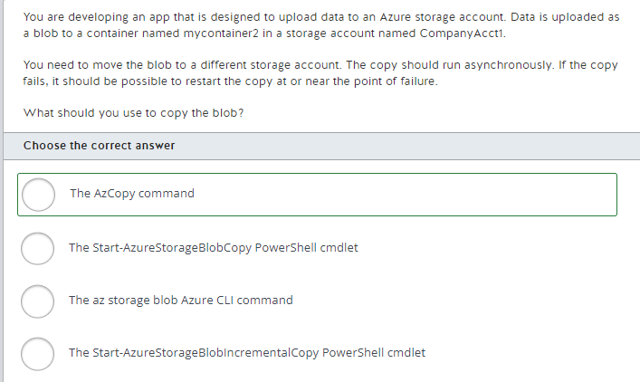

You should use the AzCopy command to copy the blob. This is a command-line tool you can use to move data into and out of storage in Azure. The AzCopy command includes the ability to copy between blob storage accounts. You would specify the source and destination accounts when you run the command. AzCopy copies the blob, but it leaves the original blob in place. When moving a blob, you would delete the source blob after the copy is complete.  
  
You should not use the az storage blob command to copy the blob. This supports synchronous copy, but it does not support restart at the point of failure if a copy operation fails.  
  
You should not use the Start-AzureStorageBlobCopy PowerShell cmdlet. This cmdlet can be used to copy a blob between containers but not between storage accounts.  
  
You should not use the Start-AzureStorageBlobIncrementalCopy PowerShell cmdlet. This cmdlet is used to copy data from a Page blob snapshot to a specified destination Page blob.  
  
**References**  
  
[Start-AzureStorageBlobCopy](https://docs.microsoft.com/en-us/powershell/module/azure.storage/start-azurestorageblobcopy?view=azurermps-6.13.0)  
  
[Start-AzureStorageBlobIncrementalCopy](https://docs.microsoft.com/en-us/powershell/module/azure.storage/start-azurestorageblobincrementalcopy?view=azurermps-6.13.0)  
  
[azcopy](https://docs.microsoft.com/en-us/azure/storage/common/storage-ref-azcopy)  
  
[Get started with AzCopy](https://docs.microsoft.com/en-us/azure/storage/common/storage-use-azcopy-v10)  
  
[Choose a tool and strategy to copy blobs](https://docs.microsoft.com/en-us/learn/modules/copy-blobs-from-command-line-and-code/2-choosing-a-tool-and-strategy)  
  
[Move Azure storage blobs from the command line with the Azure CLI](https://docs.microsoft.com/en-us/learn/modules/copy-blobs-from-command-line-and-code/3-move-blobs-using-cli)

**PREGUNTA 57**

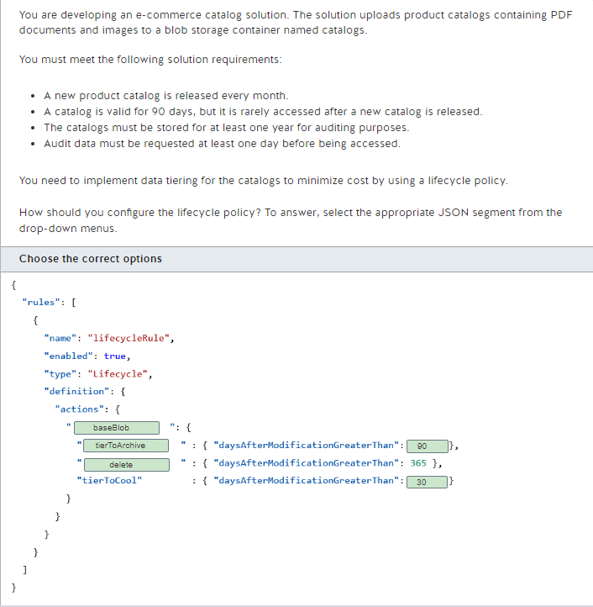

You should configure the lifecycle policy as shown below:  
  
{  
  "rules": [  
    {  
      "name": "lifecycleRule",  
      "enabled": true,  
      "type": "Lifecycle",  
      "definition": {  
        "actions": {  
          "baseBlob": {  
            "tierToArchive" : { "daysAfterModificationGreaterThan": 90 },  
            "delete" : { "daysAfterModificationGreaterThan": 365 },  
            "tierToCool" : { "daysAfterModificationGreaterThan": 30 }  
          }  
        }  
      }  
    }  
  ]  
}  
  
You should configure the baseBlob to manage the blob storage life cycle. This JSON object contains the rules that you need to enforce in your data storage.  
  
You should configure the tierToArchive action and set it to 90 days. This moves data from expired catalogs to the archive tier. In the archive tier, you cannot access data directly because it is stored in offline storage. This tier requires a rehydration process to a cool or hot tier before you could access the data. This process takes a few hours to complete. Given that audit data should be requested at least one day before, you have enough time to wait for the rehydration process.  
  
You should configure the delete action and set it to 365 days. Catalog data must be stored for at least one year for auditing. Catalogs older than a year should be deleted to minimize storage costs.  
  
You should configure the tierToCool action and set it to 30 days. This rule moves data to a cooler tier after 30 days, which is appropriate seeing as catalogs older than a month are accessed infrequently. This minimizes storage costs.  
  
You should not configure a snapshot segment. If versioning is enabled in a blob container, each time a blob is modified, a new snapshot version is created. Snapshot data retention for this solution is not applicable.  
  
**References**  
  
[Optimize costs by automatically managing the data lifecycle](https://docs.microsoft.com/en-us/azure/storage/blobs/storage-lifecycle-management-concepts?tabs=azure-portal)  
  
[Blob rehydration from the Archive tier](https://docs.microsoft.com/en-us/azure/storage/blobs/storage-blob-rehydration?tabs=azure-portal)

**PREGUNTA 58**

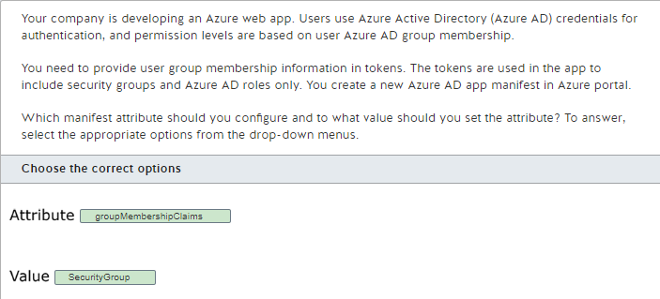

You should configure the groupMembershipClaims attribute with a value of SecurityGroup. The groupMembershipClaims attribute set at this value will retrieve group membership and Azure AD roles for the group claim. A value of None returns no user security claims. A value of All includes distribution groups along with group membership and Azure AD roles.  
  
You should not set the appRoles attribute. This attribute is used to specify a collection of roles that an app may declare.  
  
You should not set the signInAudience attribute. This attribute is used to identify Microsoft accounts that are supported for the app.  
  
**References**  
  
[Azure Active Directory app manifest](https://docs.microsoft.com/en-us/azure/active-directory/develop/reference-app-manifest)  
  
[Configure group claims for applications with Azure Active Directory](https://docs.microsoft.com/en-us/azure/active-directory/hybrid/how-to-connect-fed-group-claims)

**PREGUNTA 59**

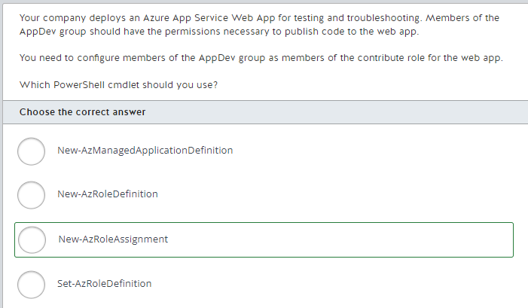

You should use the New-AzRoleAssignment cmdlet. This cmdlet lets you grant access based on role-based access control (RBAC) to a security principal, including a user or group. You can also use the Azure CLI az role assignment create command to assign the RBAC role as an alternate solution.  
  
You should not use the New-AzRoleDefinition cmdlet. This is used to create a new RBAC role definition, not to control access to the role.  
  
You should not use the Set-AzRoleDefinition cmdlet. This cmdlet lets you configure an existing RBAC role, but it does not provide any way of setting the security principals to which the role is assigned.  
  
You should not use the New-AzManagedApplicationDefinition cmdlet. This cmdlet does not apply in this scenario. Managed applications provide a way to offer cloud solutions that are easy for consumers to deploy and operate by publishing the applications in Azure Marketplace.  
  
**References**  
  
[New-AzRoleAssignment](https://docs.microsoft.com/en-us/powershell/module/az.Resources/New-azRoleAssignment?view=azps-4.2.0)  
  
[New-AzRoleDefinition](https://docs.microsoft.com/en-us/powershell/module/az.resources/new-azroledefinition?view=azps-4.2.0)  
  
[Set-AzRoleDefinition](https://docs.microsoft.com/en-us/powershell/module/az.resources/set-azroledefinition?view=azps-4.2.0)  
  
[New-AzManagedApplicationDefinition](https://docs.microsoft.com/en-us/powershell/module/az.resources/new-azmanagedapplicationdefinition?view=azps-4.2.0)  
  
[az role assignment](https://docs.microsoft.com/en-us/cli/azure/role/assignment?view=azure-cli-latest#az-roleassignment-create)  
  
[Azure managed applications overview](https://docs.microsoft.com/en-us/azure/azure-resource-manager/managed-applications/overview)

**PREGUNTA 60**

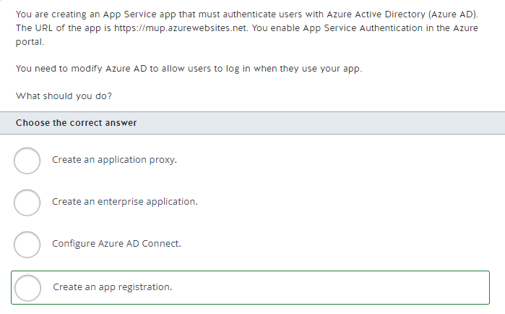

You should create an app registration. This is similar to creating an app registration with other identity providers such as Google, Facebook, or Microsoft. The app registration allows you to define the app that is allowed to authenticate against Azure AD.  
  
You should not create an application proxy. An application proxy allows users to access an on-premises application securely through Azure AD.  
  
You should not configure Azure AD Connect. AD Connect allows you to synchronize an AD tenant with an on-premises AD domain.  
  
You should not create an enterprise application. Enterprise applications allow you to integrate other applications with Azure AD, including your own apps.  
  
**References**[Configure your App Service or Azure Functions app to use Azure AD login](https://docs.microsoft.com/en-us/azure/app-service/configure-authentication-provider-aad)[Remote access to on-premises applications through Azure AD Application Proxy](https://docs.microsoft.com/en-us/azure/active-directory/manage-apps/application-proxy)[What is hybrid identity with Azure Active Directory?](https://docs.microsoft.com/en-us/azure/active-directory/hybrid/whatis-hybrid-identity)[Quickstart: Add an enterprise application](https://docs.microsoft.com/en-us/azure/active-directory/manage-apps/add-application-portal)[Tutorial: Azure AD SSO integration with Google Cloud / G Suite Connector by Microsoft](https://docs.microsoft.com/en-us/azure/active-directory/saas-apps/google-apps-tutorial)

**PREGUNTA 61**

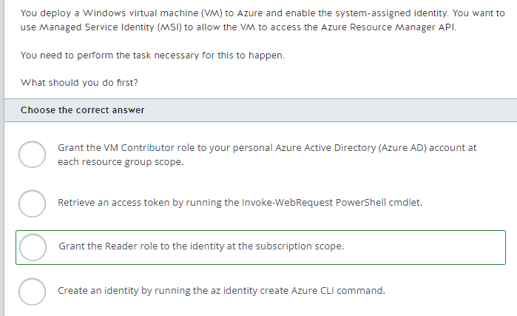

You should grant the Reader role to the identity at the subscription scope. This applies to all resource groups in the subscription, which ensures that the VM can access resources in all resource groups. This is necessary to access the Resource Manager API.  
  
You should not grant the VM Contributor role to your personal Azure AD account at each resource group scope. Although this role is required to create a VM with the system-assigned identity enabled, your account already has the required permissions because you already created the VM.  
  
You should not create an identity by running the az identity create Azure CLI command. You should run this command to set the name of a user identity, not a system identity.  
  
You should not retrieve an access token by running the Invoke-WebRequest PowerShell cmdlet. You should perform this step after granting the Reader role to the VM. You cannot retrieve an access token without granting the Reader role to the VM.  
  
**References**  
  
[What are managed identities for Azure resources?](https://docs.microsoft.com/en-us/azure/active-directory/managed-identities-azure-resources/overview)  
  
[Use a Windows VM system-assigned managed identity to access Resource Manager](https://docs.microsoft.com/en-us/azure/active-directory/managed-identities-azure-resources/tutorial-windows-vm-access-arm)  
  
[Configure managed identities for Azure resources on an Azure VM using Azure CLI](https://docs.microsoft.com/en-us/azure/active-directory/managed-identities-azure-resources/qs-configure-cli-windows-vm)  
  
[Tutorial: Use a Windows VM system-assigned managed identity to access Azure Storage via a SAS credential](https://docs.microsoft.com/en-us/azure/active-directory/managed-identities-azure-resources/tutorial-windows-vm-access-storage-sas)

**PREGUNTA 62**

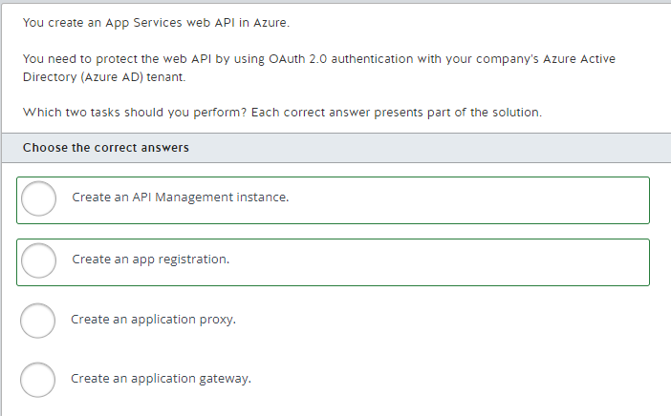

You should create an API Management instance. This allows a client application to use OAuth 2.0 authentication with an Azure AD tenant when accessing your web API.  
  
You should also create an app registration. This is similar to creating an app registration with other identity providers such as Google, Facebook, or Microsoft. The app registration allows you to define the app that is allowed to authenticate against Azure AD.  
  
You should not create an application proxy. Application Proxy allows users to access an on-premises application securely through Azure AD.  
  
You should not create an application gateway. Application Gateway allows you to use routing to create a load balancer to backend web applications.  
  
**References**[Protect an API in Azure API Management using OAuth 2.0 authorization with Azure Active Directory](https://docs.microsoft.com/en-us/azure/api-management/api-management-howto-protect-backend-with-aad)  
  
[What is Azure Application Gateway?](https://docs.microsoft.com/en-us/azure/application-gateway/overview)[Remote access to on-premises applications through Azure Active Directory's Application Proxy](https://docs.microsoft.com/en-us/azure/active-directory/manage-apps/application-proxy)[Configure your App Service or Azure Functions app to use Azure AD login](https://docs.microsoft.com/en-us/azure/app-service/configure-authentication-provider-aad)

**PREGUNTA 63**

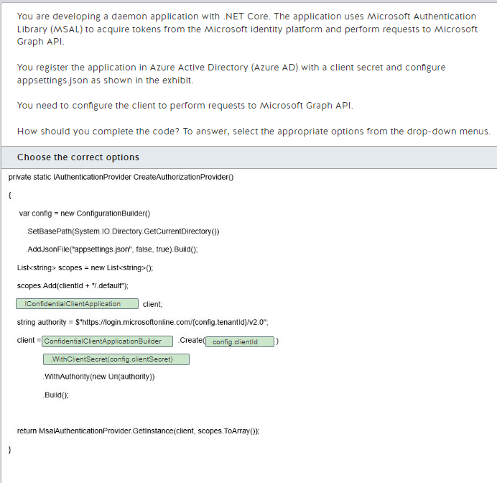

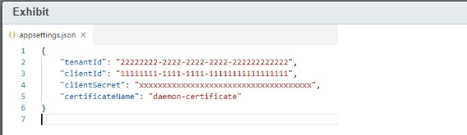

You should complete the code as shown below:  
  
private static IAuthenticationProvider CreateAuthorizationProvider()  
{  
    var config = new ConfigurationBuilder()  
        .SetBasePath(System.IO.Directory.GetCurrentDirectory())  
        .AddJsonFile("appsettings.json", false, true).Build();  
  
    List<string> scopes = new List<string>();  
    scopes.Add(clientId + "/.default");  
  
    IConfidentialClientApplication client;  
    string authority = $"https://login.microsoftonline.com/{config.tenantId}/v2.0";  
  
    client = ConfidentialClientApplicationBuilder.Create(config.clientId)  
                .WithClientSecret(config.clientSecret)  
                .WithAuthority(new Uri(authority))  
                .Build();  
  
    return MsalAuthenticationProvider.GetInstance(client, scopes.ToArray());  
}  
  
You should use a confidential client application with your daemon application. These applications run on servers and have the ability to securely store application secrets. A daemon application does not interact with users. To acquire tokens from the Microsoft identity platform and perform requests to Microsoft Graph API, it needs to use the OAuth 2.0 client credentials grant flow. This grant flow requires a confidential client.  
  
You should use the clientId to create the client. The clientId configures the application to use the previously registered Azure AD App registration.  
  
You should use .WithClientSecret(config.clientSecret) to reference the previously registered client secret in the Azure AD App registration. Without a client secret or a certificate, you cannot create a confidential client application.  
  
You should not use a public client application with your daemon application. Public client applications are not trusted to safely keep application secrets, so they can only access Microsoft Graph API on behalf of the user. A daemon application does not interact with users and needs to access Microsoft Graph API on behalf of itself.  
  
You should not use the client secret to create the client. This configuration is provided to ConfidentialClientApplicationBuilder using the WithClientSecret method.  
  
You should not use .WithCertificate(config.certificateName). A confidential client application can be configured with a client secret or a certificate. However, Azure AD App registration is configured only with a client secret in this case. To use a certificate, you should upload it first to the Azure AD App registration.  
  
**References**  
  
[Overview of Microsoft Authentication Library (MSAL)](https://docs.microsoft.com/en-us/azure/active-directory/develop/msal-overview)  
  
[Scenario: Daemon application that calls web APIs](https://docs.microsoft.com/en-us/azure/active-directory/develop/scenario-daemon-overview)  
  
[Microsoft identity platform and the OAuth 2.0 client credentials flow](https://docs.microsoft.com/en-us/azure/active-directory/develop/v2-oauth2-client-creds-grant-flow)  
  
[Public client and confidential client applications](https://docs.microsoft.com/en-us/azure/active-directory/develop/msal-client-applications)

**PREGUNTA 64**

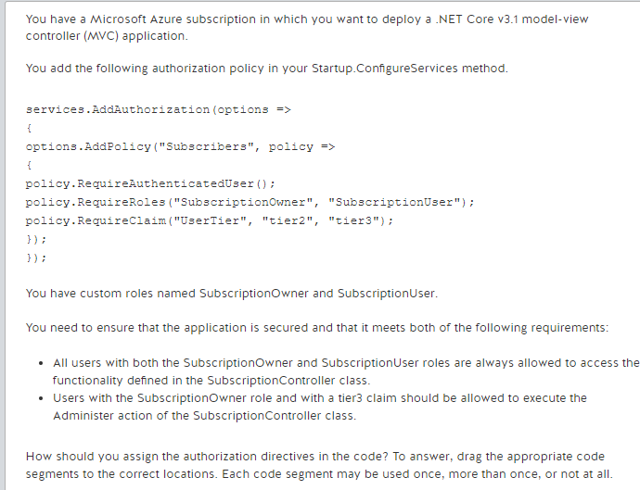

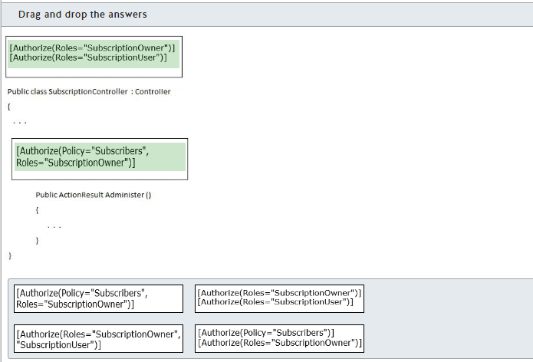

You should complete the code as follows:  
  
[Authorize(Roles="SubscriptionOwner")]  
[Authorize(Roles="SubscriptionUser")]  
Public class SubscriptionController  : Controller  
{

 .  .  .

[Authorize(Policy="Subscribers", Roles="SubscriptionOwner")]

Public ActionResult Administer ()

{

  .  .  .

}

}  
  
You should use the following to authorize any user that has the roles SubscriptionOwner and SubscriptionUser to access the SubscriptionController class:  
  
[Authorize(Roles="SubscriptionOwner")]  
[Authorize(Roles="SubscriptionUser")]  
  
Applying multiple Authorize attributes to the controller class ensures that only users that have both roles can execute actions present within the class.  
  
You should use the following to ensure that users with the SubscriptionOwner role and with a tier3 claim will be allowed to execute the Administer action of the SubscriptionController class:  
  
[Authorize(Policy="Subscribers", Roles="SubscriptionOwner")]  
  
This attribute ensures that user is validated against the policy defining the acceptable UserTier property to fall in either tier2 or tier3. You also ensure that the user should have a roles of SubscriptionOwner by specifying that in the Authorize attributes roles parameter.  
  
You should not use the following to authorize access to the SubscriptionController class:  
  
[Authorize(Roles="SubscriptionOwner", "SubscriptionUser")]  
  
This would allow any user with either SubscriptionOwner or SubscriptionUser to execute actions in the class. This will not force a user to have both roles.  
  
You should not use the following:  
  
[Authorize(Policy="Subscribers")]  
[Authorize(Roles="SubscriptionOwner")]  
  
Setting these attributes on the class would require the SubscriptionUser roles to meet all of the requirements of the Subscribers policy for access to either the class or the action in the class. In this case, you would allow users with SubscriptionUser roles to access the class even if they may not have the associated claims. The claims only need to be validated to execute the Administer action.  
  
**References**  
  
[Policy-based authorization in ASP.NET Core](https://docs.microsoft.com/en-us/aspnet/core/security/authorization/policies?view=aspnetcore-3.1)  
  
[Role-based authorization in ASP.NET Core](https://docs.microsoft.com/en-us/aspnet/core/security/authorization/roles?view=aspnetcore-3.1)  
  
[Claims-based authorization in ASP.NET Core](https://docs.microsoft.com/en-us/aspnet/core/security/authorization/claims?view=aspnetcore-3.1)

**PREGUNTA 65**

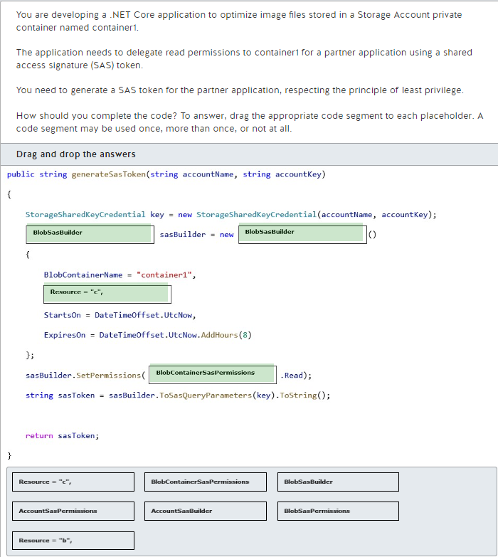

You should complete the code as follows:  
  
public string generateSasToken(string accountName, string accountKey)  
{  
    StorageSharedKeyCredential key = new StorageSharedKeyCredential(accountName, accountKey);  
    BlobSasBuilder sasBuilder = new BlobSasBuilder()  
    {  
        BlobContainerName = "container1",  
        Resource = "c",  
        StartsOn = DateTimeOffset.UtcNow,  
        ExpiresOn = DateTimeOffset.UtcNow.AddHours(8)  
    };  
    sasBuilder.SetPermissions(BlobContainerSasPermissions.Read);  
    string sasToken = sasBuilder.ToSasQueryParameters(key).ToString();  
  
    return sasToken;  
}  
  
You should generate a service SAS with read permission on container1 to delegate access to the partner application and respect the principle of least privilege. To generate a service SAS, you should use the BlobSasBuilder class and the BlobContainerSasPermissions.Read permission to scope the SAS token correctly.  
  
You should also set the sasBuilder Resource property as "c" to generate a SAS token scoped to Blob container level to delegate the necessary permissions to the partner application.  
  
You should not use the AccountSasBuilder class and and the AccountSasPermissions.Read permission to generate the SAS token. This would result in an account SAS that gives more permissions than necessary to the partner application.  
  
You should not set the sasBuild Resource property as "b" or use the BlobSasPermissions.Read permission. These code segments generate a SAS token scoped to a single blob. You would also need to set the sasBuilder BlobName property with a specific blob.  
  
**References**  
  
[Grant limited access to Azure Storage resources using shared access signatures (SAS)](https://docs.microsoft.com/en-us/azure/storage/common/storage-sas-overview)  
  
[Create an account SAS with .NET](https://docs.microsoft.com/en-us/azure/storage/common/storage-account-sas-create-dotnet)[BlobSasBuilder Class](https://docs.microsoft.com/en-us/dotnet/api/azure.storage.sas.blobsasbuilder?view=azure-dotnet)

**PREGUNTA 66**

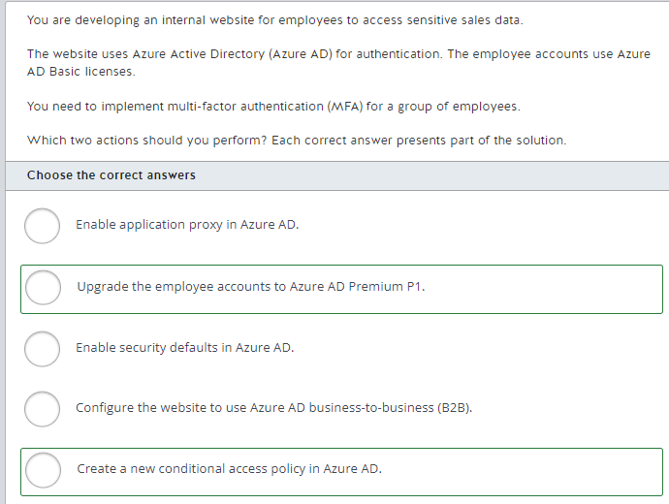

You should upgrade the employees accounts to Azure AD Premium P1. You need to use an Azure AD Premium license to implement MFA. Azure AD Premium P1 is the most cost-efficient license that includes MFA support for a group of accounts.  
  
You should also create a new conditional access policy in Azure AD. You can configure a conditional access policy to allow, deny, or require MFA authentication depending on specific conditions, such as user location, device, or application.  
  
You should not configure the website to use Azure AD business-to-business (B2B). You can use Azure AD B2B to share your applications with guest users from external organizations. In this scenario, you are developing an internal website for employees only.  
  
You should not enable application proxy in Azure AD. You can use the Azure AD application proxy to allow access to on-premises web applications externally. You do not need to enable Azure AD application proxy for an internal website or to configure MFA.  
  
You should not enable security defaults in Azure AD. You can use security defaults to protect your organization's users with a set of pre-configured security settings, which include enforcing all users to register for MFA. In this case, you need to enforce MFA for a group of users only.  
  
**References**  
  
[Tutorial: Secure user sign-in events with Azure Multi-Factor Authentication](https://docs.microsoft.com/en-us/azure/active-directory/authentication/tutorial-enable-azure-mfa)  
  
[Azure Active Directory pricing](https://azure.microsoft.com/en-us/pricing/details/active-directory/)  
  
[B2B collaboration overview](https://docs.microsoft.com/en-us/azure/active-directory/b2b/what-is-b2b)  
  
[Using Azure AD Application Proxy to publish on-premises apps for remote users](https://docs.microsoft.com/en-us/azure/active-directory/manage-apps/what-is-application-proxy)  
  
[Security defaults in Azure AD](https://docs.microsoft.com/en-us/azure/active-directory/fundamentals/concept-fundamentals-security-defaults)

**PREGUNTA 67**

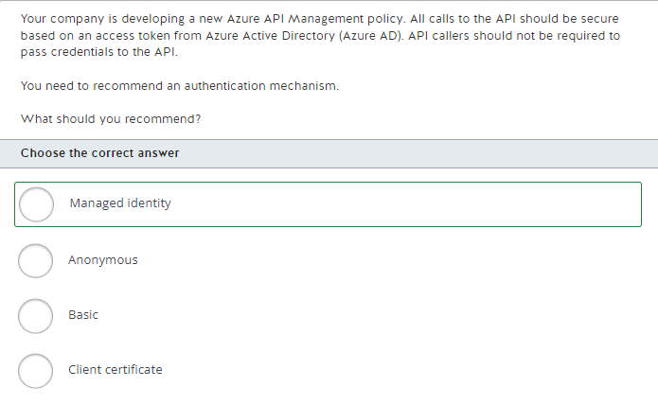

You should recommend managed identity as the authentication mechanism. Managed identity provides for the required secure access without passing credentials to the API. The API management service identity is used for authentication. This policy uses the managed identity to obtain an access token from Azure AD.  
  
You should not recommend basic as the authentication mechanism. This sets the HTTP Authorization header to the value corresponding to the credentials provided in the policy and does not involve Azure AD in the authentication process.  
  
You should not recommend a client certificate as the authentication mechanism. This method uses a certificate that has been installed in API Management for authentication.  
  
You should not use anonymous as the authentication mechanism. Azure AD supports anonymous access in some scenarios, but not as an API authentication mechanism policy.  
  
**References**  
  
[API Management authentication policies](https://docs.microsoft.com/en-us/azure/api-management/api-management-authentication-policies)  
  
[Anonymous Authentication <anonymousAuthentication>](https://docs.microsoft.com/en-us/iis/configuration/system.webserver/security/authentication/anonymousauthentication)  
  
[Authentication and authorization in Azure App Service and Azure Functions](https://docs.microsoft.com/en-us/azure/app-service/overview-authentication-authorization)

**PREGUNTA 68**

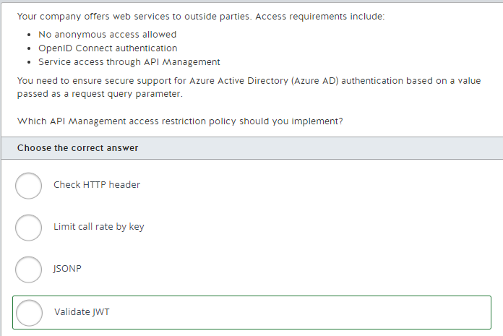

You should implement the Validate JWT API Management access restriction policy. You use this policy to enforce the existence and validity of a JSON Web Token (JWT) extracted from either a specified HTTP Header or a specified query parameter. You can apply the policy at the API level to secure the entire API through Azure AD authentication.  
  
You should not implement the Check HTTP header access restriction policy. This policy is used to enforce the existence of an HTTP header, the header value, or both.  
  
You should not implement the Limit call rate by key access restriction policy. This policy gives you a way to enforce a renewable or lifetime call volume and/or bandwidth quota, on a per-key basis. This policy limits access but does not provide for authentication.  
  
You should not implement JSONP. This is not an access restriction policy, and so it is not used to control access to the API. JSONP is used to add JSON with padding support to an operation or an API to allow cross-domain calls from JavaScript browser-based clients.  
  
**References**  
  
[API Management access restriction policies](https://docs.microsoft.com/en-us/azure/api-management/api-management-access-restriction-policies)  
  
[JSON Web Tokens](https://aadguide.azurewebsites.net/integration/jwts/)  
  
[API Management cross domain policies](https://docs.microsoft.com/en-us/azure/api-management/api-management-cross-domain-policies)

**PREGUNTA 69**

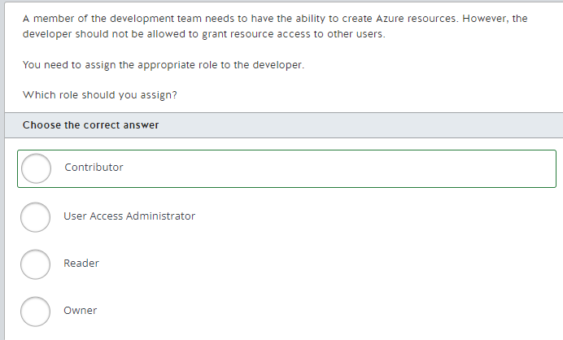

You should assign the Contributor role to the developer. This role allows the developer to create all types of Azure resources, without the ability to grant resource access to other users.  
  
You should not assign the Owner role. This role allows the developer to have full access to Azure, including granting resource access to other users.  
  
You should not assign the Reader role. This role only allows the developer to view resources, not create them.  
  
You should not assign the User Access Administrator role. This role allows the developer to grant resource access to other users.  
  
**References**  
  
[What is Azure role-based access control (Azure RBAC)?](https://docs.microsoft.com/en-us/azure/role-based-access-control/overview)

**PREGUNTA 70**

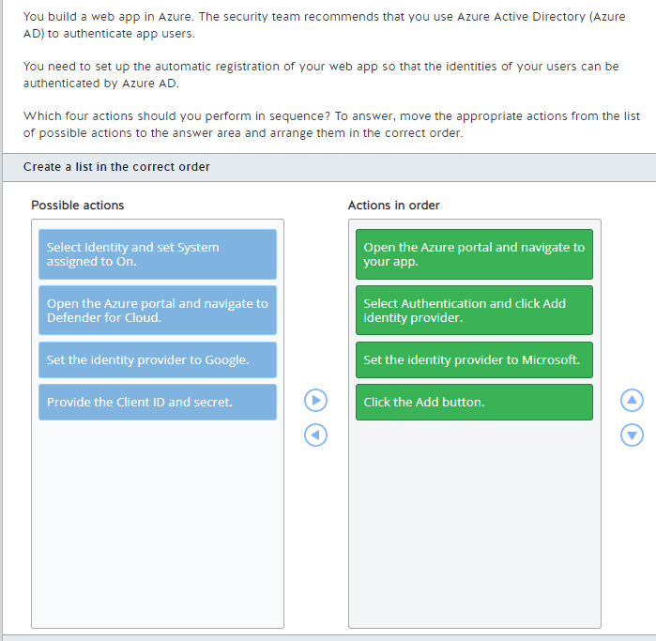

To register your app for automatic AAD authentication, you should perform the following steps in order:

1. Open the Azure portal and navigate to your app.
2. Select Authentication and click Add identity provider.
3. Set the identity provider to Microsoft.
4. Click the Add button.

Following the steps above will add a Microsoft identity provider (with Azure AD authentication) to the app’s authentication settings, from where you can update its configuration settings if required.  
  
You should not open the Azure portal and navigate to Defender for Cloud. Microsoft Defender for Cloud can help assess the security level of your Azure on-premises resources, generate threat prevention recommendations and alerts, and enforce relevant security policies to protect your workload. However, you cannot use Defender for Cloud to register your web app for Azure AD authentication.  
  
You should not select Identity and set System assigned to On. This configuration generates a system-enabled managed identity so that your web app can be authenticated to services that support Azure AD authentication, for example Azure storage, without having credentials in the app code. Managed identity is not designed to authenticate your web app end users.  
  
You should not set the identity provider to Google and provide the Client ID and secret. These two steps are required when you configure Google as an authentication provider. In the given scenario, you should set the identity provider to Microsoft to enable Azure AD authentication.  
  
**References**  
  
[Configure your App Service or Azure Functions app to use Azure AD login](https://docs.microsoft.com/en-us/azure/app-service/configure-authentication-provider-aad)  
  
[What is Microsoft Defender for Cloud?](https://docs.microsoft.com/en-us/azure/security-center/security-center-introduction)  
  
[What are managed identities for Azure resources?](https://docs.microsoft.com/en-gb/azure/active-directory/managed-identities-azure-resources/overview)  
  
[Configure your App Service or Azure Functions app to use Google login](https://docs.microsoft.com/en-us/azure/app-service/configure-authentication-provider-google)

**PREGUNTA 71**

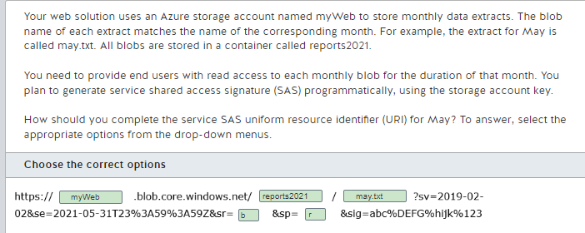

You should complete the URI as follows:  
  
https://myWeb.blob.core.windows.net/reports2021/may.txt?sv=2019-02-02&se=2021-05-31T23%3A59%3A59Z&sr=b&sp=r&sig=abc%DEFG%hijk%123  
  
You should use myWeb in the first string to specify the public endpoint of your blob storage.  
  
You should then use the container name, reports2021, followed by the blob name, may.txt.  
  
You should set the sr (Signed Resource) to b, to indicate that you grant access to the content and metadata of your may.txt blob.  
  
You should set the sp field (Signed Permission) to r, to indicate that the user permission is restricted to the read operation.  
  
You should not use value c. c is a parameter value for the sr field that grants access to the content and metadata of all the blobs in the container and that also allows to list the blobs.  
  
**References**  
  
[Grant limited access to Azure Storage resources using shared access signatures (SAS)](https://docs.microsoft.com/en-us/azure/storage/common/storage-sas-overview)  
  
[Create a service SAS](https://docs.microsoft.com/en-us/rest/api/storageservices/create-service-sas)

**PREGUNTA 72**

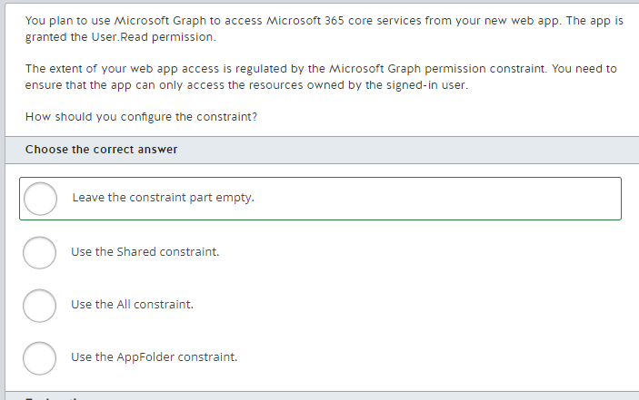

You should leave the constraint part empty. If you do not specify constraints in the Microsoft Graph permission name, using User.Read as is, the app can perform read operations only on the resources owned by the signed-in user.  
  
You should not use the All constraint. The All constraint enables operations on all resources of the specified type. For example, with the User.Read.All permission, your web app may be able to read the profiles of all users in Azure Active Directory (Azure AD).   
  
You should not use the AppFolder constraint. This file permission is used in the Files.ReadWrite.AppFolder permission to read, create, update, and delete files in the OneDrive application folder. It cannot be used with the User.Read permission.  
  
You should not use the Shared constraint. The Shared constraint grants the app permission to perform operations on the resources shared by other users with the signed-in user; to access contacts or calendars in other Outlook resources, for example.  
  
**References**  
  
[Microsoft Graph auth overview](https://docs.microsoft.com/en-us/graph/auth/)  
  
[Microsoft Graph permissions reference](https://docs.microsoft.com/en-us/graph/permissions-reference)

**PREGUNTA 73**

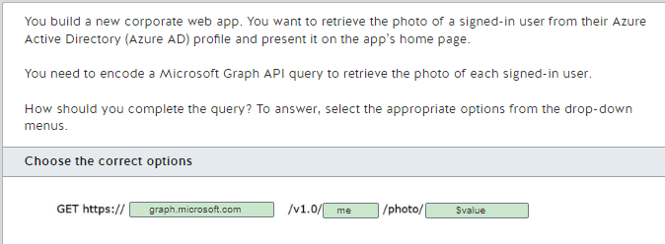

You should complete the query as follows:  
  
GET https://graph.microsoft.com/v1.0/me/photo/$value  
  
You should use graph.microsoft.com. This is the web address of the Microsoft Graph API service. You should then use the /me endpoint, because it uses the delegated permission of the signed-in user. You also should use the $value URL segment to retrieve the binary value of the user photo.  
  
You should not use portal.azure.com. This is the web address of the Azure portal that you can use to manage your Azure subscription and resources. This URL does not expose Microsoft Graph API endpoints.  
  
You should not use compliance.microsoft.com. This is the web address of the Microsoft Purview compliance portal. You can use it to manage the compliance needs of your company. It is not designed to expose the details of end user profiles via an API.  
  
You should not use the /users or /groups endpoints. These can provide you with access to the photos of specific users or groups, but you would need to provide additional parameters with an ID (or user Principal Name in the case of users). To use the delegated permission of the signed-in user, you should use the /me endpoint.  
  
You should not use the $format query option. This query option specifies the format in which the results should be returned, for example JSON or XML. For a photo, you need to retrieve the binary value and that is why you should use the $value URL segment.  
  
You should not use the $count query parameter. This query parameter provides the total count of matching resources.  
  
**References**  
  
[Get profilePhoto](https://docs.microsoft.com/en-us/graph/api/profilephoto-get?view=graph-rest-1.0)  
  
[Use the Microsoft Graph API](https://docs.microsoft.com/en-us/graph/use-the-api)  
  
[Get a user](https://docs.microsoft.com/en-us/graph/api/user-get?view=graph-rest-1.0&tabs=http)  
  
[Azure portal overview](https://docs.microsoft.com/en-us/azure/azure-portal/azure-portal-overview)  
  
[Microsoft Purview compliance portal](https://docs.microsoft.com/en-us/microsoft-365/compliance/microsoft-365-compliance-center?view=o365-worldwide)

**PREGUNTA 74**

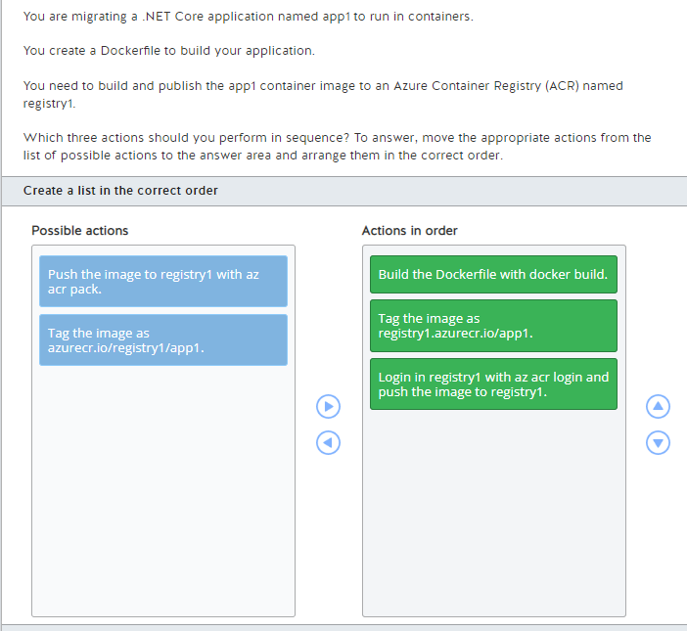

You should perform the following actions in order:

1. Build the Dockerfile with docker build.
2. Tag the image as registry1.azurecr.io/app1.
3. Login in registry1 with az acr login and push the image to registry1.

You should build the Dockerfile with docker build to create a new container image with the instructions in it.  
  
You should also tag the image as registry1.azurecr.io/app1. To push a container image to an Azure Container Registry (ACR) you need to tag the image following the convention <registry name>.azurecr.io/<image name>.  
  
Finally, you should login in registry1 with az acr login and push the image to registry1. Before pushing the image to registry1, you must login with the ACR using the az acr login. After the login, you can push the image to registry using the docker push command.  
  
You should not tag the image as azurecr.io/registry1/app1. This tag name does not follow the convention <registry name>.azurecr.io/<image name> to push a container image to ACR.  
  
You should not push the image to registry1 with az acr pack. You can use this command to build a container image that uses Cloud Native Buildpacks using ACR Tasks.  
  
**References**  
  
[Push your first image to a private Docker container registry using the Docker CLI](https://docs.microsoft.com/en-us/azure/container-registry/container-registry-get-started-docker-cli)  
  
[az acr pack](https://docs.microsoft.com/en-us/cli/azure/acr/pack?view=azure-cli-latest)

**PREGUNTA 75**

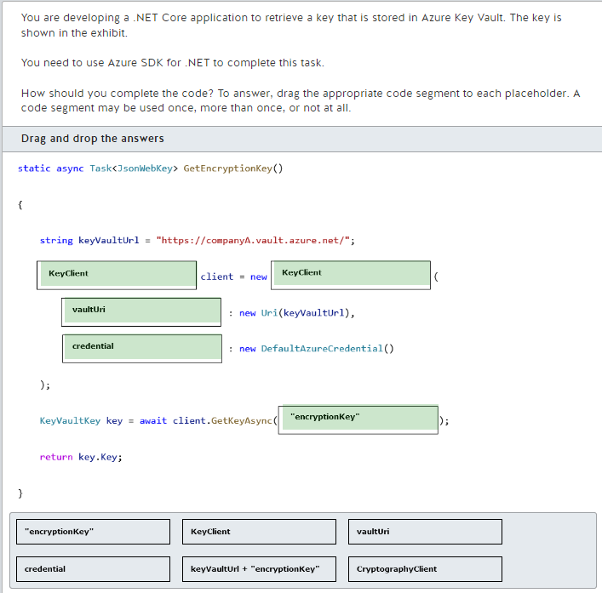

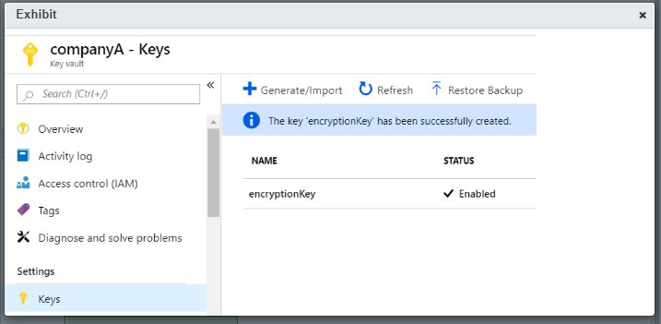

You should complete the code as follows:  
  
static async Task<JsonWebKey> GetEncryptionKey()  
{  
    string keyVaultUrl = "https://companyA.vault.azure.net/";  
    KeyClient client = new KeyClient(  
        vaultUri: new Uri(keyVaultUrl),   
        credential: new DefaultAzureCredential()  
    );  
  
    KeyVaultKey key = await client.GetKeyAsync("encryptionKey");  
  
    return key.Key;  
}  
  
You should use the KeyClient class to create the client. You need to pass the vaultUri argument with the Azure Key Vault URI and an authentication credential. The DefaultAzureCredential class uses the default credential from Azure.Identity using the environment variables AZURE_CLIENT_ID, AZURE_CLIENT_SECRET, and AZURE_TENANT_ID.  
  
You should specify "encryptionKey" as the parameter to the GetKeyAsync method of the KeyVaultClient class. The GetKeyAsync method of KeyVaultClient expects the key name only.  
  
You should not use the CryptographyClient class. This class is used to perform cryptographic operations with Azure Key Vault keys.  
  
You should not specify keyVaultUrl + "encryptionKey" in the GetKeyAsync method. The GetKeyAsync method of KeyVaultClient expects the key name only.  
  
**References**  
  
[Azure Key Vault key client library for .NET](https://github.com/Azure/azure-sdk-for-net/tree/master/sdk/keyvault/Azure.Security.KeyVault.Keys)  
  
[Azure Identity client library for .NET](https://github.com/Azure/azure-sdk-for-net/blob/master/sdk/identity/Azure.Identity/README.md)

**PREGUNTA 76**

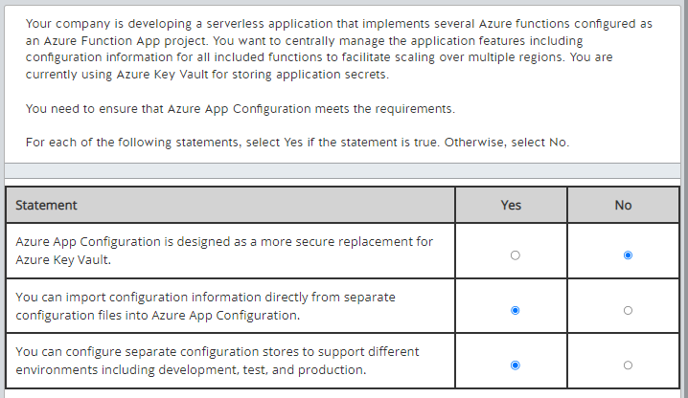

Azure App Configuration is not designed as a more secure replacement for Azure Key Vault. Azure App Configuration is designed to work with Azure Key Vault to provide a secure environment. Data is encrypted in Azure App Configuration, but Azure Key Vault uses a more secure storage environment through hardware-level encryption, granular access policies, and management operations.  
  
You can import configuration information directly from separate configuration files into Azure App Configuration. You can also export configuration information out from Azure App Configuration to separate configuration files.  
  
You can configure separate configuration stores to support different environments including development, test, and production. This gives you a way to manage applications throughout their lifecycle.  
  
**References**  
  
[What is Azure App Configuration?](https://docs.microsoft.com/en-us/azure/azure-app-configuration/overview)  
  
[Azure App Configuration FAQ](https://docs.microsoft.com/en-us/azure/azure-app-configuration/faq)

**PREGUNTA 77**

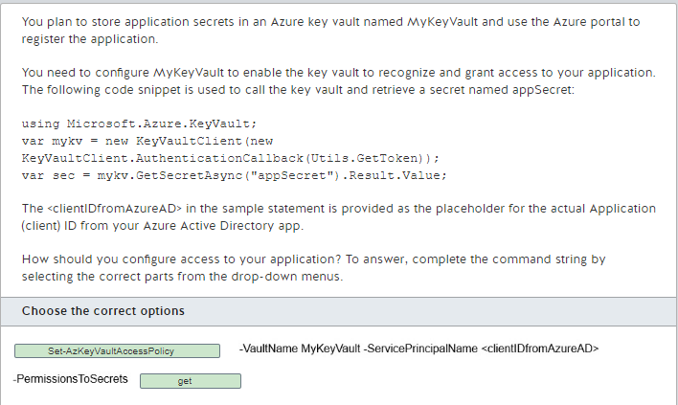

You should complete the command statement as follows:  
  
Set-AzKeyVaultAccessPolicy -VaultName MyKeyVault -ServicePrincipalName <clientIDfromAzureAD> -PermissionsToSecrets Get  
  
The Set-AzKeyVaultAccessPolicy PowerShell cmdlet grants or modifies permissions for a user, application, or security group to perform operations with a key vault. In this scenario, you need to grant the get permission to enable the application to access the key value.  
  
You should not use the New-AzKeyVaultNetworkRuleSetObject cmdlet. This cmdlet is used to create an object representing the network rule settings that can be used when creating a vault.  
  
You should not use the Set-AzKeyVaultSecret cmdlet. This cmdlet is used to modify an existing key vault secret and is not related to key vault access. An application can modify a key vault secret if the application is granted the set permission.  
  
You should not use the Update-AzKeyVaultKey cmdlet. This cmdlet is used to modify editable attributes of a key in a key vault.  
  
You should not assign the recover permission. This permission is required to recover a deleted secret.  
  
You should not assign the restore permission. This permission is required to restore a backed-up secret to a key vault.  
  
You should not assign the set permission. This permission is used to create or modify a secret.  
  
**References**  
  
[Automate the rotation of a secret for resources that have two sets of authentication credentials](https://docs.microsoft.com/en-us/azure/key-vault/secrets/key-rotation-log-monitoring)  
  
[About Azure Key Vault secrets](https://docs.microsoft.com/en-us/azure/key-vault/secrets/about-secrets)  
  
[Set-AzKeyVaultAccessPolicy](https://docs.microsoft.com/en-us/powershell/module/az.keyvault/Set-AzKeyVaultAccessPolicy?view=azps-4.2.0)  
  
[Set-AzKeyVaultSecret](https://docs.microsoft.com/en-us/powershell/module/az.keyvault/Set-AzKeyVaultSecret?view=azps-4.2.0)  
  
[Update-AzKeyVaultKey](https://docs.microsoft.com/en-us/powershell/module/az.keyvault/Update-AzKeyVaultKey?view=azps-4.2.0)  
  
[New-AzKeyVaultNetworkRuleSetObject](https://docs.microsoft.com/en-us/powershell/module/az.keyvault/New-AzKeyVaultNetworkRuleSetObject?view=azps-4.2.0)

**PREGUNTA 78**

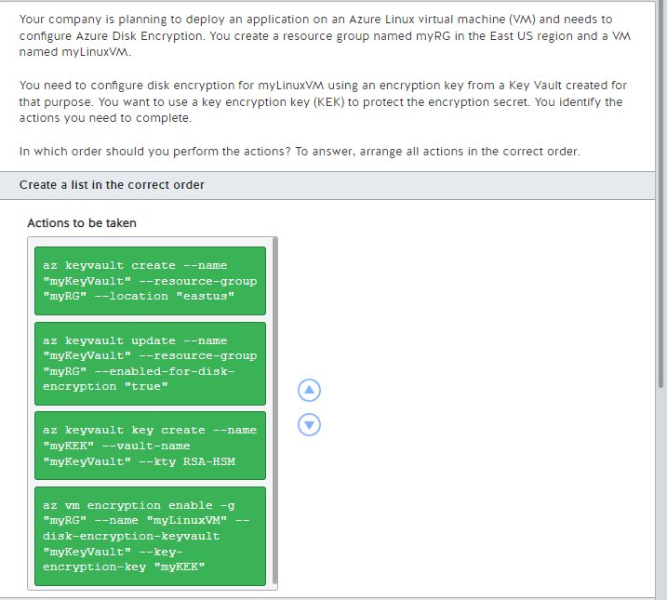

You should take the actions in the following order:  
  
  
1. az keyvault create --name "myKeyVault" --resource-group "myRG" --location "eastus"  
2. az keyvault update --name "myKeyVault" --resource-group "myRG" --enabled-for-disk-encryption "true"  
3. az keyvault key create --name "myKEK" --vault-name "myKeyValult" --kty RSA-HSM  
4. az vm encryption enable -g "myRG" --name "myLinuxVM" --disk-encryption-keyvault "myKeyVault" --key-encryption-key "myKEK"  
  
  
The first two statements create the key vault and enable it to support disk encryption. This could also have been done using the following single statement:  
  
az keyvault create --name "myKeyValue" --resource-group "myRG" --location "eastus" --enabled-for-disk-encryption  
  
The next step is to create a KEK. This provides an additional layer of security for encryption keys. When configuring for Azure disk encryption, you must specify an RSA key type. Other key type options are not supported.  
  
Finally, you need to add your KEK to your key vault.  
  
**References**  
  
[Creating and configuring a key vault for Azure Disk Encryption](https://docs.microsoft.com/en-us/azure/virtual-machines/linux/disk-encryption-key-vault)  
  
[Quickstart: Create and encrypt a Linux VM with the Azure CLI](https://docs.microsoft.com/en-us/azure/virtual-machines/linux/disk-encryption-cli-quickstart)

**PREGUNTA 79**

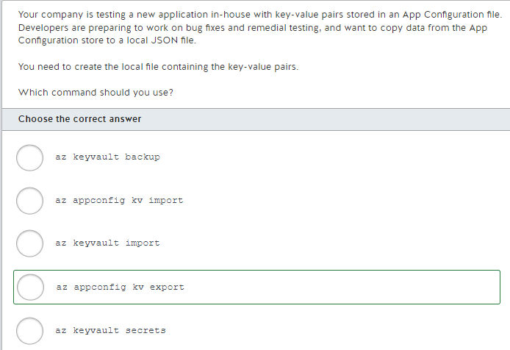

You should use the az appconfig kv export command. This copies key-value pairs from the specified App Configuration file to a local file, such as a JSON file, or to a different App Configuration store. You could run a command string similar to the following:  
  
az appconfig kv export --name myDevAppConfigStore --file ~/DevFix.json  
  
You should not use the az appconfig kv import command. This is used to copy from one or more sources into an App Configuration file. Sources can include multiple sources, such as other App Configuration files, or JSON, YAML, or properties files.  
  
You should not use any of the following commands:  
  
az keyvault key import  
az keyvault key backup  
az keyvault secret  
  
These are for configuring and managing Key Vault, not App Configuration files. You would use az keyvault key import to import a private key into a Key Vault. You would use az keyvault key backup to back up a private key that is downloaded to the client running the command. You would use az keyvault secret to manage Key Vault secrets, including backing up, restoring, and recovering secrets.  
  
**References**  
  
[az appconfig kv](https://docs.microsoft.com/en-us/cli/azure/appconfig/kv?view=azure-cli-latest)  
  
[az keyvault](https://docs.microsoft.com/en-us/cli/azure/keyvault?view=azure-cli-latest)  
  
[What is Azure App Configuration?](https://docs.microsoft.com/en-us/azure/azure-app-configuration/overview)

**PREGUNTA 80**

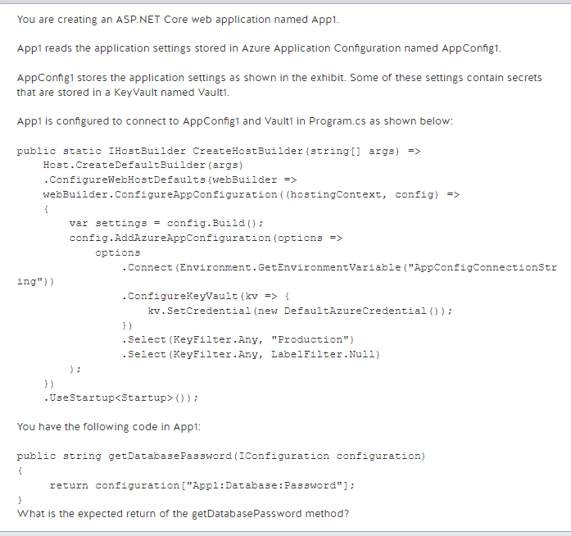

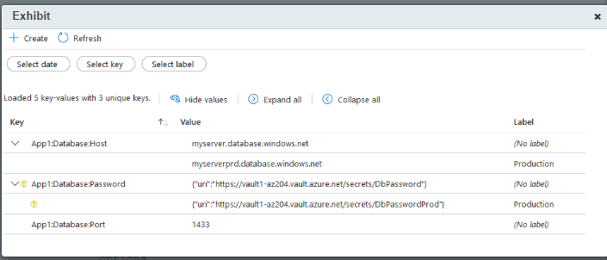

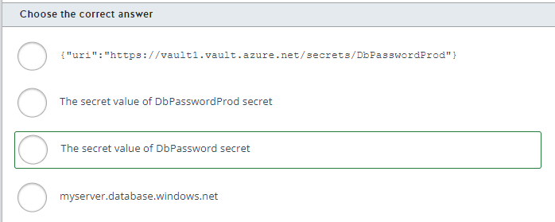

You should expect the secret value of DbPassword secret as the return when using this method. The App1:Database:Password configuration key has two values in AppConfig1 that reference Vault1 secrets. The value that is returned depends on how App1 filters the labels from AppConfig1. By default, config.AddAzureAppConfiguration selects all configurations without any label. However, App1 first selects all configurations with the label Production in .Select(KeyFilter.Any, "Production"), and then selects configurations without any labels with .Select(KeyFilter.Any, LabelFilter.Null). Because of this order, configuration keys without any labels overwrite the configurations with the label Production.  
  
You should not expect the secret value of DbPasswordProd secret as the return when using this method. App1 is configured to overwrite configurations with the label Production with configurations without any label. To return the secret value of DbPasswordProd secret, you should change the Program.cs to select the configurations without labels before the configurations with the Production label as shown below:  
  
config.AddAzureAppConfiguration(options =>  
    options  
        .Connect(Environment.GetEnvironmentVariable("AppConfigConnectionString"))  
        .ConfigureKeyVault(kv => {  
            kv.SetCredential(new DefaultAzureCredential());  
        })  
        .Select(KeyFilter.Any, LabelFilter.Null)  
        .Select(KeyFilter.Any, "Production")  
);  
  
You should not expect {"uri":"https://vault1.vault.azure.net/secrets/DbPasswordProd"} as the return when using this method. The App1:Database:Password configuration key references Vault1 secrets. The URI shown in the exhibit is the secret that will be referenced when App1 loads this configuration.  
  
You should not expect myserver.database.windows.net as the return when using this method. This is the return if you change the code to load the App1:Database:Host configuration key.  
  
**References**  
  
[Tutorial: Use Key Vault references in an ASP.NET Core app](https://docs.microsoft.com/en-us/azure/azure-app-configuration/use-key-vault-references-dotnet-core?tabs=bash%2Ccore3x)  
  
[Use labels to provide per-environment configuration values](https://docs.microsoft.com/en-us/azure/azure-app-configuration/howto-labels-aspnet-core)  
  
[Keys and values](https://docs.microsoft.com/en-us/azure/azure-app-configuration/concept-key-value)

**PREGUNTA 81**

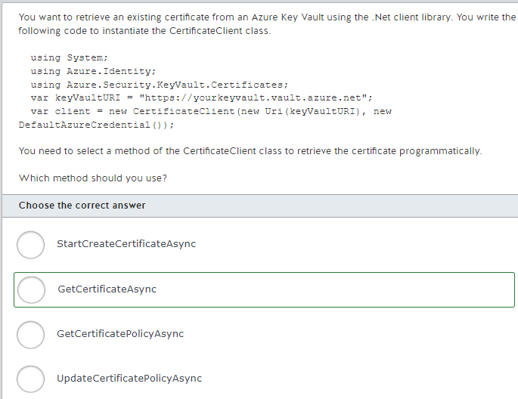

You should use the GetCertificateAsync method. This method accepts the name of the certificate as an input parameter and returns the latest version of that certificate from an Azure Key Vault. Additionally, it retrieves the current policy of the requested certificate.  
  
You should not use the GetCertificatePolicyAsync method. This method retrieves the current policy of the certificate, but not the certificate itself.  
  
You should not use the StartCreateCertificateAsync method. This method allows you to create a new certificate in an Azure Key Vault, not retrieve an existing one.  
  
You should not use the UpdateCertificatePolicyAsync method. This method is used to update the policy of the specified certificate. It is not intended for the retrieval of the certificate.  
  
**References**  
  
[Quickstart: Azure Key Vault certificate client library for .NET (SDK v4)](https://docs.microsoft.com/en-us/azure/key-vault/certificates/quick-create-net)  
  
[CertificateClient.GetCertificateAsync(String, CancellationToken) Method](https://docs.microsoft.com/en-us/dotnet/api/azure.security.keyvault.certificates.certificateclient.getcertificateasync?view=azure-dotnet)  
  
[CertificateClient.GetCertificatePolicyAsync(String, CancellationToken) Method](https://docs.microsoft.com/en-us/dotnet/api/azure.security.keyvault.certificates.certificateclient.getcertificatepolicyasync?view=azure-dotnet)  
  
[CertificateClient.StartCreateCertificateAsync(String, CertificatePolicy, Nullable<Boolean>, IDictionary<String,String>, CancellationToken) Method](https://docs.microsoft.com/en-us/dotnet/api/azure.security.keyvault.certificates.certificateclient.startcreatecertificateasync?view=azure-dotnet)  
  
[CertificateClient.UpdateCertificatePolicyAsync(String, CertificatePolicy, CancellationToken) Method](https://docs.microsoft.com/en-us/dotnet/api/azure.security.keyvault.certificates.certificateclient.updatecertificatepolicyasync?view=azure-dotnet)

**PREGUNTA 82**

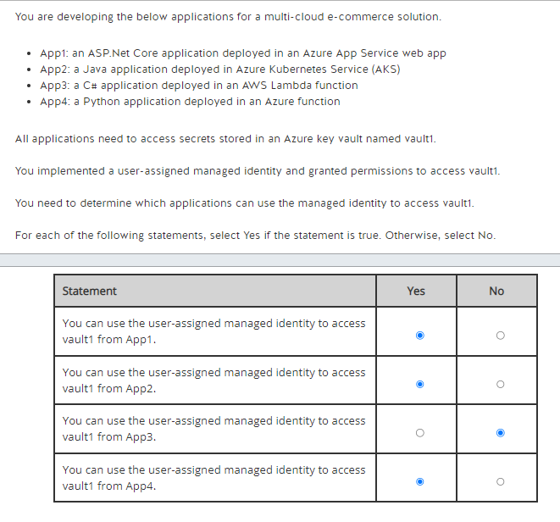

You can use the user-assigned managed identity to access vault1 from App1, App2, and App4. You can assign a user-assigned managed identity to multiple Azure services, including Azure App Service, Azure Kubernetes Services (AKS), Azure Functions, Azure Virtual Machines (VM), and others. You can also implement the Azure Identity client library to use managed identities in multiple application languages, including .NET, Java, Javascript, and Python.  
  
You cannot use the user-assigned managed identity to access vault1 from App3. User-assigned managed identities can be assigned only to resources hosted in the Azure cloud. You cannot assign a managed identity to instances of any AWS services.  
  
Managed identities in Azure provide an identity to your applications and they allow you to grant access to other Azure resources (like Azure Key Vault) without managing traditional credentials. Depending on your solution needs, you can use a system-assigned managed identity that is created together with the Azure resource hosting the application, or you can use a user-assigned managed identity that can be reused across multiple resources.  
  
**References**  
  
[What are managed identities for Azure resources?](https://docs.microsoft.com/en-us/azure/active-directory/managed-identities-azure-resources/overview)  
  
[Azure services that can use managed identities to access other services](https://docs.microsoft.com/en-us/azure/active-directory/managed-identities-azure-resources/managed-identities-status)

**PREGUNTA 83**

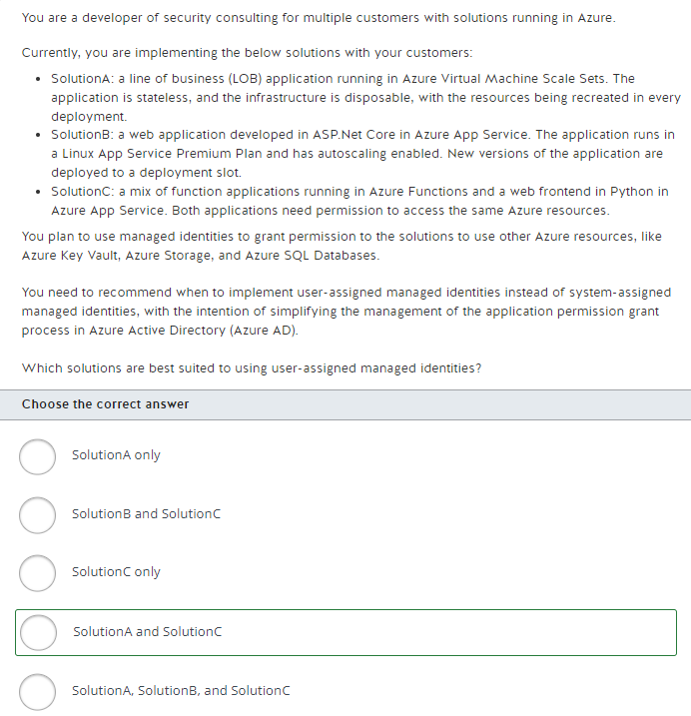

SolutionA and SolutionC are best suited to use user-assigned managed identities. You should use a user-assigned managed identity when you need to manage the identity provisioning in a different lifecycle than the resources themselves. You can also use a user-assigned managed identity if you need to share the same managed identity across multiple Azure resources.  
  
Because SolutionA uses a disposable infrastructure for every deployment, if you use a system-assigned managed identity, you need to go through the permission grant process in every deployment. If you use a user-assigned managed identity, you need to grant the permissions only once and assign the same managed identity in every deployment.  
  
SolutionC is composed of multiple Azure resources. If you use a system-assigned managed identity, you need to grant the same permission to every resource individually because a system-assigned managed identity is tightly linked to the Azure resource. If you use a user-assigned managed identity, you can reuse the same identity for all resources, simplifying the permission grant process.  
  
SolutionB can use both user-assigned or system-assigned managed identities. Considering that this solution is provisioned as a single resource and you do not need to share the same set of permissions across different resources, both user-assigned and system-assigned managed identities can satisfy this use case. The process to grant permission, in this case, will be the same if you use a user-assigned or a system-assigned managed identity.  
  
**References**  
  
[What are managed identities for Azure resources?](https://docs.microsoft.com/en-us/azure/active-directory/managed-identities-azure-resources/overview)  
  
[Azure services that can use managed identities to access other services](https://docs.microsoft.com/en-us/azure/active-directory/managed-identities-azure-resources/managed-identities-status)

**PREGUNTA 84**

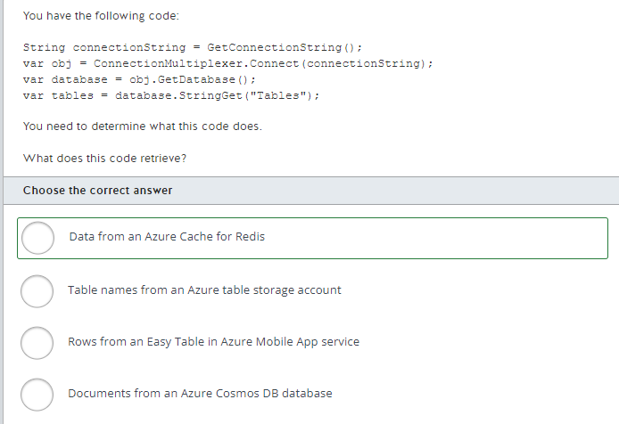

This code retrieves data from an Azure Cache for Redis. Azure cache for Redis allows you to store frequently accessed data in a cloud location close to your application. It stores the data in memory instead of in data storage.  
  
This code does not retrieve table names from an Azure table storage account. To retrieve rows from Azure table storage, you use the CloudTableClient class.  
  
This code does not retrieve rows from an Easy Table in Azure Mobile App service. To retrieve rows from an Azure Mobile Services Easy Table, you use the MobileServiceClient class.  
  
This code does not retrieve documents from an Azure Cosmos DB database. To retrieve data from an Azure Cosmos DB database, you use the CosmosClient class.  
  
**References**[Tutorial:Build a .NET console app to manage data in Azure Cosmos DB SQL API account](https://docs.microsoft.com/en-us/azure/cosmos-db/sql-api-dotnetcore-get-started)[Use Azure Easy Tables and the Mobile Apps SDK with Unity](https://docs.microsoft.com/en-us/sandbox/gamedev/unity/samples/azure-mobile-apps-unity-racer)[Quickstart: Use Azure Cache for Redis in .NET Core](https://docs.microsoft.com/en-us/azure/azure-cache-for-redis/cache-dotnet-core-quickstart) [Performance tips for Azure Cosmos DB and .NET](https://docs.microsoft.com/en-us/azure/cosmos-db/sql/performance-tips-dotnet-sdk-v3-sql?tabs=trace-net-core)

**PREGUNTA 85**

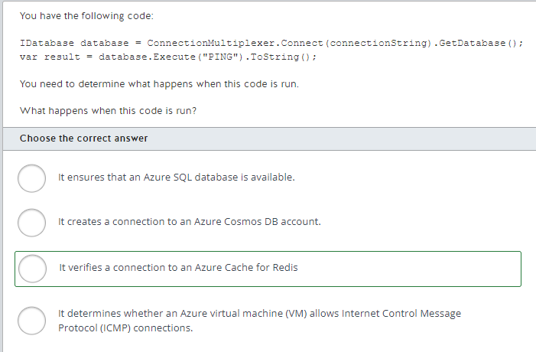

This code verifies a connection to an Azure Cache for Redis. When you execute the PING command, the value of result is PONG if the connection is valid.  
  
The code does not determine whether an Azure VM allows ICMP connections. The IDatabase interface represents a connection to an Azure cache for Redis, not a connection to a VM.  
  
The code neither ensures whether an Azure SQL database is available, nor creates a connection to an Azure Cosmos DB account. The code verifies a connection to an Azure cache for Redis.  
  
**References**[Quickstart: Use Azure Cache for Redis NET Core](https://docs.microsoft.com/en-us/azure/azure-cache-for-redis/cache-dotnet-core-quickstart)[Azure Cache for Redis libraries for .NET](https://docs.microsoft.com/en-us/dotnet/api/overview/azure/redis-cache?view=azure-dotnet)

**PREGUNTA 86**

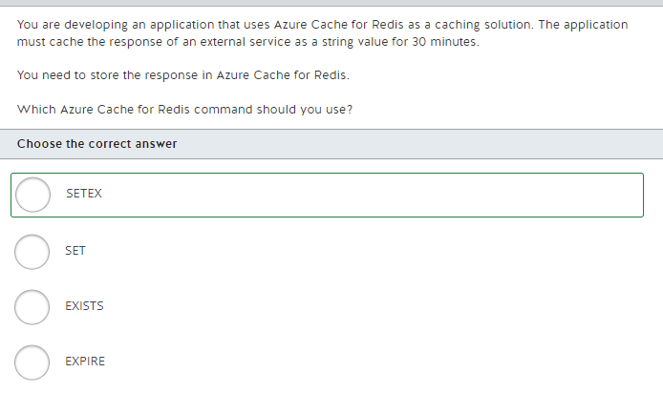

You should use the SETEX command. You can use this command to store a value in a key and its expiration in seconds in a single operation. You should run the command below to store a value in the key "myKey" for 30 minutes:  
  
SETEX myKey 1800 "some-value"  
  
You should not use the SET command. You can use this command to store a value in a key. However, this key will not expire.  
  
You should not use the EXPIRE command. You can use this command to expire an existing key stored on Azure Cache for Redis. You should first store some value in a key, and then set its expiration:  
  
SET myKey "some-value"  
EXPIRE myKey 1800  
  
You should not use the EXISTS command. You can use this command to check if a key exists in Azure Cache for Redis, without returning its value.  
  
**References**  
  
[Quickstart: Use Azure Cache for Redis in .NET Core](https://docs.microsoft.com/en-us/azure/azure-cache-for-redis/cache-dotnet-core-quickstart)  
  
[SETEX key seconds value](https://redis.io/commands/setex)  
  
[SET key value [ NX | XX] [GET] [ EX seconds | PX milliseconds | EXAT unix-time-seconds | PXAT unix-time-milliseconds | KEEPTTL]](https://redis.io/commands/set)  
  
[EXPIRE key seconds [ NX | XX | GT | LT]](https://redis.io/commands/expire)  
  
[EXISTS key [key ...]](https://redis.io/commands/exists)

**PREGUNTA 87**

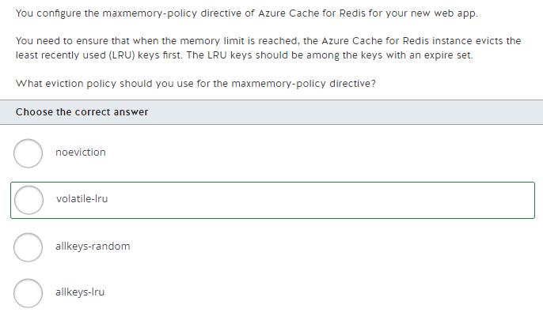

You should use the volatile-lru eviction policy. When the memory limit is reached, this policy dictates that the Azure cache for Redis instance should make space for the new data by removing the LRU keys, but only from the set of keys that have their expiry values defined.  
  
You should not use the allkeys-lru eviction policy. With this policy, Azure Cache for Redis tries to remove the LRU keys first. However, it does not consider whether the keys have an expire set or not.  
  
You should not use the allkeys-random eviction policy. With this policy, Azure Cache for Redis evicts keys randomly.  
  
You should not use the noeviction policy. With this policy, no keys are evicted and the Azure cache for Redis instance will return an error when the memory limit is reached.  
  
**References**  
  
[How to configure Azure Cache for Redis](https://docs.microsoft.com/en-us/azure/azure-cache-for-redis/cache-configure)  
  
[Key eviction](https://redis.io/topics/lru-cache)

**PREGUNTA 88**

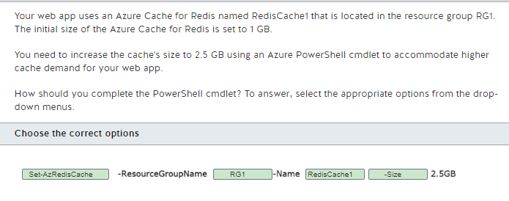

You should complete the cmdlet as follows:  
  
Set-AzRedisCache -ResourceGroupName RG1 -Name RedisCache1 -Size 2.5GB  
  
You should use the Set-AzRedisCache cmdlet to scale your Azure Cache for Redis instance. You should set its -ResourceGroupName parameter value to RG1 and its -Name parameter value to RedisCache1. You should also use the -Size parameter with the value set to 2.5 GB.  
  
You should not use the Reset-AzRedisCache cmdlet. This cmdlet can be used to reboot the nodes of a cache. The reboot operation is only available for the Premium tier of Azure Cache for Redis.

You should not use the Import-AzRedisCache cmdlet. This cmdlet can be used to import data into Azure Cache for Redis from blobs. The import operation is only available for the Premium tier of Azure Cache for Redis.

You should not use the 1 GB value. When scaling up the Azure cache for Redis cache size, the cmdlet requires only the new size value as an input for its -Size parameter.  
  
**References**  
  
[Manage Azure Cache for Redis with Azure PowerShell](https://docs.microsoft.com/en-us/azure/azure-cache-for-redis/cache-how-to-manage-redis-cache-powershell)  
  
[Az.RedisCache](https://docs.microsoft.com/en-us/powershell/module/az.rediscache/?view=azps-5.8.0)

**PREGUNTA 89**

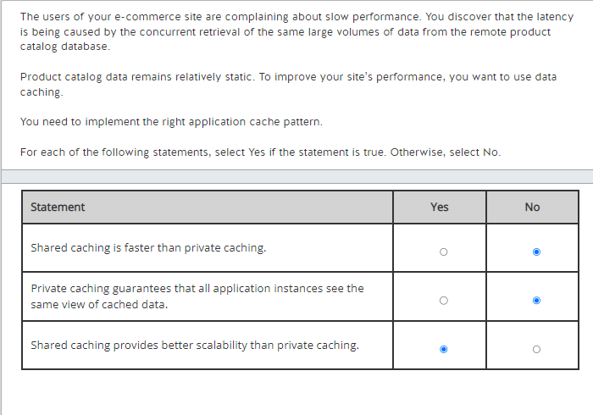

Shared caching is not faster than private caching. With private caching, data is held locally to each application instance and can therefore be accessed faster. With shared caching, data is held in a separate, centralized location, which slows the access from the different application instances.  
  
Private caching does not guarantee that all application instances see the same view of cached data. Data may change over time, so the different application instances may hold different versions of the cached data in their local in-memory store. This concern is addressed in the shared caching approach, where cached data is held in a separate, centralized location.  
  
Shared caching provides better scalability than private caching. With this approach, caching is provided by a dedicated service that runs on a cluster of servers. Adjusting the number of cluster servers enables better scalability than scaling the caching store on the machine of each application instance.  
  
**References**  
  
[Caching guidance](https://docs.microsoft.com/en-us/azure/architecture/best-practices/caching)

**PREGUNTA 90**

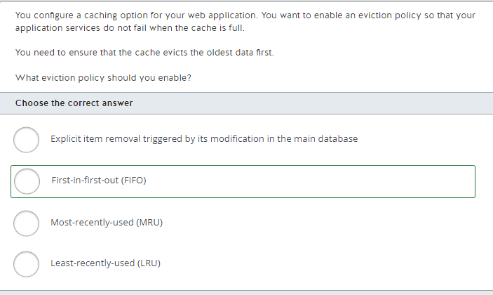

You should enable the FIFO eviction policy. With this policy, the caching solution monitors the order in which the items are added. This ensures that the oldest data, i.e. the first to be added, is evicted first when the cache needs to be freed for new items.  
  
You should not use explicit item removal triggered by its modification in the main database. With this eviction policy, you can replace outdated items in the cache with their more up-to-date versions from the main database.  
  
You should not use the LRU eviction policy. This policy tries to remove the items that have been used least recently. However, the policy does not consider the order in which the items were added to the cache to determine the oldest ones.  
  
You should not use the MRU eviction policy. This policy is useful when the business logic of your app does not require access to items that were already retrieved from the cache at least once. The MRU eviction policy evicts the most recently used items first but ignores the age of the items in the cache.  
  
**References**  
  
[Caching guidance](https://docs.microsoft.com/en-us/azure/architecture/best-practices/caching)  
  
[Azure Cache for Redis Documentation](https://docs.microsoft.com/en-us/azure/azure-cache-for-redis/cache-best-practices)

**PREGUNTA 91**

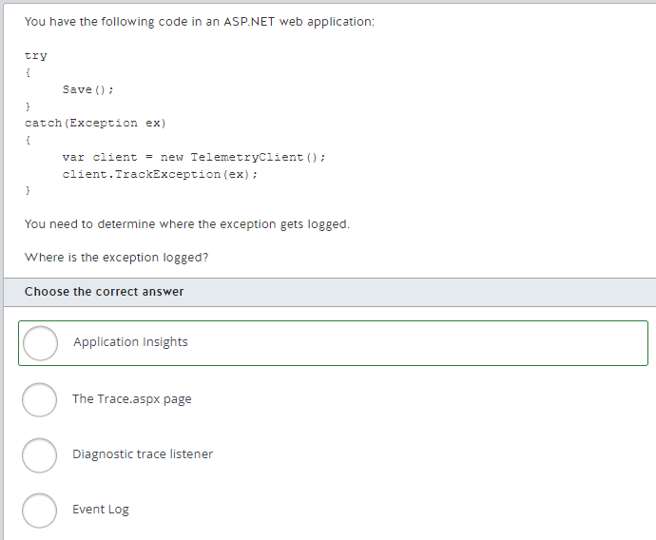

The exception gets logged to Application Insights. The TelemetryClient class allows you to log different types of telemetry data, including exceptions. The TrackException method allows you to log exceptions.  
  
The exception does not get logged to Event Log. The Write method of the EventSource class allows you to log data to the Event Log.  
  
The exception does not get logged to a diagnostic trace listener. The Trace.Error method allows you to log exceptions to a diagnostic trace listener. Alternatively, you would need to use the TrackTrace method of the TelemetryClient class, and configure tracing for the application.  
  
The exception does not get logged to Trace.aspx. To do this, you must call Trace.Write.  
  
**References**[Diagnose exceptions in your web apps with Application Insights](https://docs.microsoft.com/en-us/azure/application-insights/app-insights-asp-net-exceptions)[Explore .NET/.NET Core and Python trace logs in Application Insights](https://docs.microsoft.com/en-us/azure/azure-monitor/app/asp-net-trace-logs)[How to Capture ASP.NET Page Trace Events in IIS 7.0 Tracing](https://docs.microsoft.com/en-us/iis/application-frameworks/building-and-running-aspnet-applications/how-to-capture-aspnet-page-trace-events-in-iis-tracing)

**PREGUNTA 92**

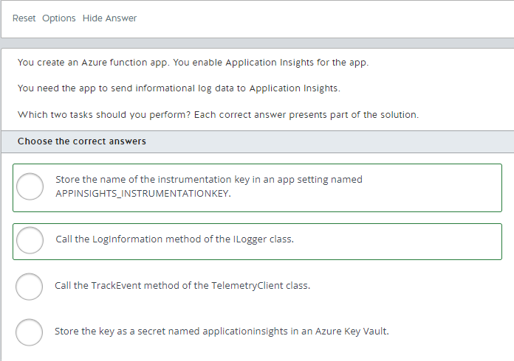

You should store the name of the instrumentation key in an app setting named APPINSIGHTS_INSTRUMENTATIONKEY. This is required so that Azure knows which Application Insights resource to use for logging telemetry data.  
  
You should also call the LogInformation method of the ILogger instance. An instance of this interface can be passed as a parameter to each function in a function app. The LogInformation method allows you to log informational messages.  
  
You should not call TrackEvent of TelemetryClient. This method allows you to log custom data to Application Insights from ASP.NET or a console application. You should not use this method from an Azure function app.  
  
You should not store the key as a secret named applicationinsights in an Azure Key Vault. Azure function apps do not read secrets from Azure Key Vault to find the instrumentation key for Application Insights. Azure function apps read app settings.  
  
**References**[Monitor Azure Functions](https://docs.microsoft.com/en-us/azure/azure-functions/functions-monitoring)  
  
[Develop C# class library functions using Azure Functions](https://docs.microsoft.com/en-us/azure/azure-functions/functions-dotnet-class-library?tabs=v2%2Ccmd)  
  
[Diagnose exceptions in web apps with Application Insights](https://docs.microsoft.com/en-us/azure/application-insights/app-insights-asp-net-exceptions)[Azure Key Vault basic concepts](https://docs.microsoft.com/en-us/azure/key-vault/key-vault-whatis)

**PREGUNTA 93**

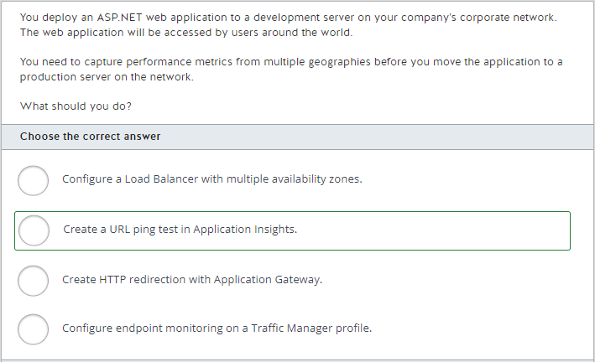

You should create a URL ping test in Application Insights. This allows you to test the performance of your web application from multiple geographical locations, up to 16. You can configure the test to notify you if a response does not contain particular content, or if a response is not received in a particular time frame.  
  
You should not create HTTP redirection with Application Gateway. Application Gateway is a firewall solution that provides load balancing. HTTP redirection allows you to redirect HTTP requests to HTTPS endpoints.  
  
You should not configure endpoint monitoring on a Traffic Manager profile. Traffic Manager allows you to create endpoints that are nearest to the user. This improves performance by ensuring that requests do not have to travel far geographically. Endpoint monitoring allows you to determine which endpoints are healthy and which ones are not by using a Traffic Manager probing agent.  
  
You should not configure a Load Balancer with multiple availability zones. A Load Balancer allows you to distribute inbound TCP and UDP traffic to different virtual machines.  
  
**References**[Monitor availability with URL ping tests](https://docs.microsoft.com/en-us/azure/azure-monitor/app/monitor-web-app-availability)[What is Azure Application Gateway?](https://docs.microsoft.com/en-us/azure/application-gateway/overview)[Application Gateway redirect overview](https://docs.microsoft.com/en-us/azure/application-gateway/application-gateway-redirect-overview)[Traffic Manager endpoint monitoring](https://docs.microsoft.com/en-us/azure/traffic-manager/traffic-manager-monitoring)[What is Traffic Manager?](https://docs.microsoft.com/en-us/azure/traffic-manager/traffic-manager-overview)[What is Azure Load Balancer?](https://docs.microsoft.com/en-us/azure/load-balancer/load-balancer-overview)

**PREGUNTA 94**

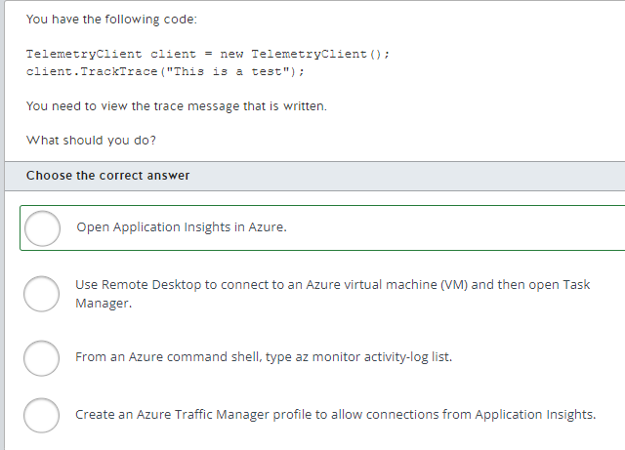

You should open Application Insights in Azure. This service allows you to view telemetry data collected by Azure or from external applications that use the TelemetryClient class.  
  
You should not use Remote Desktop to connect to an Azure VM and then open Task Manager. Telemetry data sent by the TelemetryClient class cannot be found in Task Manager. Task Manager allows you to view performance data related to CPU percentage and memory usage.  
  
You should not type az monitor activity-log list from an Azure command shell. This command does not display telemetry data from Application Insights.  
  
You should not create an Azure Traffic Manager profile. Traffic Manager allows you to deliver web content from Azure regions that are nearest to the user.  
  
**References**[Monitoring and diagnostics guidance](https://docs.microsoft.com/en-us/azure/architecture/best-practices/monitoring)[Application Insights for .NET console applications](https://docs.microsoft.com/en-us/azure/azure-monitor/app/console)[az monitor activity-log](https://docs.microsoft.com/en-us/cli/azure/monitor/activity-log)

**PREGUNTA 95**

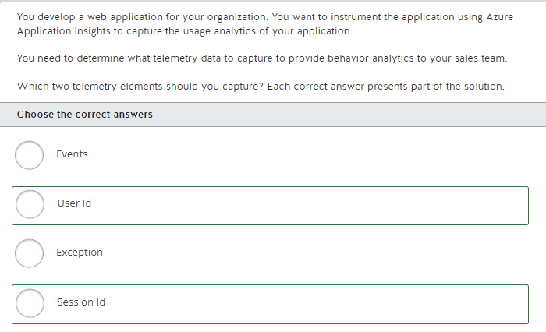

You should capture Session Id and User Id. For Application Insights to provide necessary views about usage behavior by an individual user, you should set the telemetry context on the initialization of the user session and capture the session and user id. Any usage during that session will then log information tied back to the session id and user id associated to the telemetry data.  
  
You should not capture Exceptions. Even though exceptions provide important information about analytics over types of errors in your application, the requirement is to collect data for user behavior analytics.  
  
You should not capture Events. Events are used to capture analytics across user sessions, and run analytics on types of events being raised by your application. They do not provide data that will provide insights into user behavior.  
  
**References**  
  
[Usage analysis with Application Insights](https://docs.microsoft.com/en-us/azure/azure-monitor/app/usage-overview)

**PREGUNTA 96**

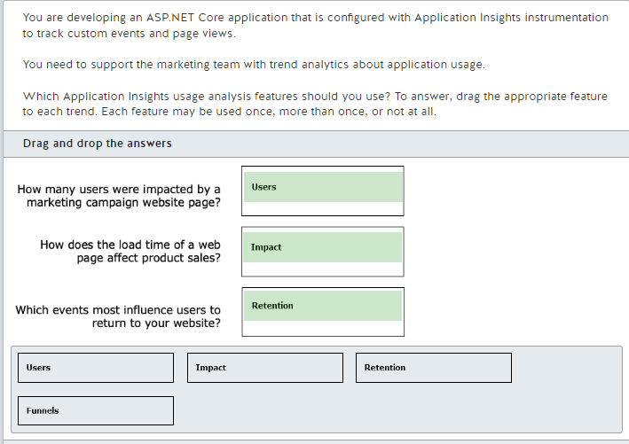

You should use users analytics to determine how many users were impacted by a marketing campaign website page. You can use users analytics to determine how many people used your application and how many users visited the campaign page. Users are counted by using anonymous IDs stored in browser cookies.  
  
You should use impact analytics to determine how a product page load time affects product sales. Impact analytics determine how load times and other properties influence conversion rates, like clicking the purchase button, for your website. Conversion rates are calculated using a statistical technique named the Pearson correlation coefficient.  
  
You should use retention analytics to determine which events most influence users to return to your website. You can use retention analytics to determine how many users return to your app and how often they perform particular tasks, like visiting a sales campaign or the homepage.  
  
You should not use funnels analytics. You can use funnels analytics to determine the dropout rate in a user journey until they perform a specific action, like purchasing a product. For example, 100 percent of your users visit the website homepage, but only 10 percent visit a specific product page, and fewer than than 2 percent click the purchase button and complete the purchase. You can focus and measure actions that reduce dropout between these pages.  
  
**References**  
  
[Usage analysis with Application Insights](https://docs.microsoft.com/en-us/azure/azure-monitor/app/usage-overview)  
  
[Users, sessions, and events analysis in Application Insights](https://docs.microsoft.com/en-us/azure/azure-monitor/app/usage-segmentation)  
  
[Discover how customers are using your application with Application Insights Funnels](https://docs.microsoft.com/en-us/azure/azure-monitor/app/usage-funnels)  
  
[Impact analysis with Application Insights](https://docs.microsoft.com/en-us/azure/azure-monitor/app/usage-impact)  
  
[User retention analysis for web applications with Application Insights](https://docs.microsoft.com/en-us/azure/azure-monitor/app/usage-retention)

**PREGUNTA 97**

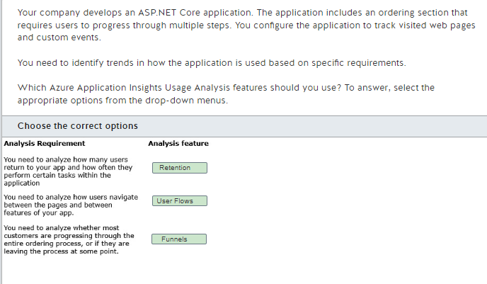 You should use the Retention tool to analyze how many users return to your app and how often they perform particular tasks. This includes the ability to measure events that represent significant business activities. The default display of the Retention tool shows all users who did anything on your site and then came back and did anything else over a period of time. You can also narrow the focus by selecting different combinations of events.  
  
You should use the User Flows tool to analyze how users navigate between the pages and features of your site. This would answer questions such as the places from which users churn most often in your site, and if there are any places where users repeat the same actions over and over. You can also see how users navigate away from a page on your site.  
  
You should use the Funnels feature to analyze if most customers are progressing through the entire ordering process, or if they are ending the process at some point. You would create a funnel based on the specific questions that you want to answer about navigation through the process.  
  
**References**  
  
[What is monitored by Azure Monitor?](https://docs.microsoft.com/en-us/azure/azure-monitor/insights/insights-overview)  
  
[Users, sessions, and events analysis in Application Insights](https://docs.microsoft.com/en-us/azure/azure-monitor/app/usage-segmentation)  
  
[User retention analysis for web applications with Application Insights](https://docs.microsoft.com/en-us/azure/azure-monitor/app/usage-retention)  
  
[Analyze user navigation patterns with User Flows in Application Insights](https://docs.microsoft.com/en-us/azure/azure-monitor/app/usage-flows)  
  
[Discover how customers are using your application with Application Insights Funnels](https://docs.microsoft.com/en-us/azure/azure-monitor/app/usage-funnels)

**PREGUNTA 98**

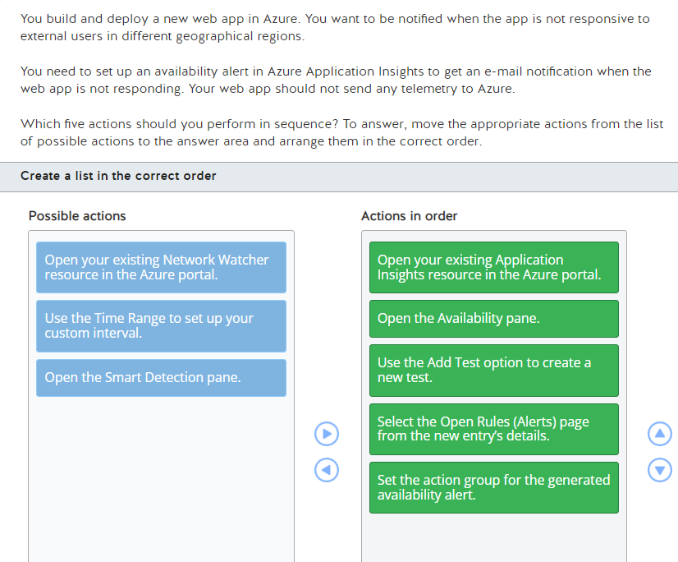

To set up an availability alert, you should perform the following actions in order:

1. Open your existing Application Insights resource in the Azure portal.
2. Open the Availability pane.
3. Use the Add Test option to create a new test.
4. Select the Open Rules (Alerts) page from the new entry's details.
5. Set the action group for the generated availability alert.

First, you should open your existing Application Insights resource in the Azure portal.  
  
Then, you should open the Availability pane and use the Add Test option to create a new test. An availability test allows you to specify the URL of your web app and which geographical locations its availability needs to be tested from. You can also define success criteria.  
  
Once your availability test is created, you should select the Open Rules (Alerts) page from the new entry’s details and set the action group for the generated availability alert. In your action group you can configure who should be notified and how by the availability alert, for example by sending an e-mail or an SMS message.  
  
You should not open your existing Network Watcher resource in the Azure portal. Azure Network Watcher is a service that allows you to monitor and troubleshoot network issues with IaaS (Infrastructure-as-a-Service) solutions in Azure. However, it is not designed to monitor Azure PaaS (Platform-as-a-Service) solutions or provide web analytics.  
  
You should not open the Smart Detection pane and use the Time Range to set up your custom interval. Smart Detection is a feature of Azure Application Insights that analyzes the telemetry of your web app to detect potential performance issues or anomalies. In this scenario, your web app should not send any telemetry data to Azure. That is why you should use the Azure Application Insights availability test functionality to use probes in various geographical locations to check the availability of your web app.  
  
**References**  
  
[Application Insights availability tests](https://docs.microsoft.com/en-us/azure/azure-monitor/app/availability-overview)  
  
[Monitor availability with URL ping tests](https://docs.microsoft.com/en-us/azure/azure-monitor/app/monitor-web-app-availability)  
  
[Availability alerts](https://docs.microsoft.com/en-us/azure/azure-monitor/app/availability-alerts)  
  
[What is Azure Network Watcher?](https://docs.microsoft.com/en-us/azure/network-watcher/network-watcher-monitoring-overview)  
  
[Smart Detection in Application Insights](https://docs.microsoft.com/en-us/azure/azure-monitor/app/proactive-diagnostics)

**PREGUNTA 99**

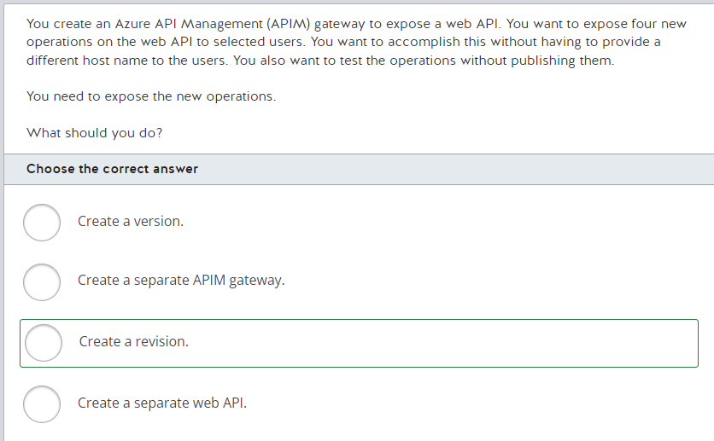

You should create a revision. A revision allows you to add non-breaking changes to a web API, such as the addition of operations. Users can access the revision by using a different query string at the same endpoint.  
  
You should not create a version. A version allows you to expose breaking changes for a web API. A version requires publishing. In this scenario, you want to test the operations without publishing them.  
  
You should not create a separate APIM gateway. This would force the users to access a different endpoint.  
  
You should not create a separate web API. This would force the users to access a different endpoint.  
  
**References**[How to save and configure your API Management service configuration using Git](https://docs.microsoft.com/en-us/azure/api-management/api-management-configuration-repository-git)[Modify the content and layout of pages on the developer portal in Azure API Management](https://docs.microsoft.com/en-us/azure/api-management/api-management-modify-content-layout)[Tutorial: Create and publish a product](https://docs.microsoft.com/en-us/azure/api-management/api-management-howto-add-products)

**PREGUNTA 100**

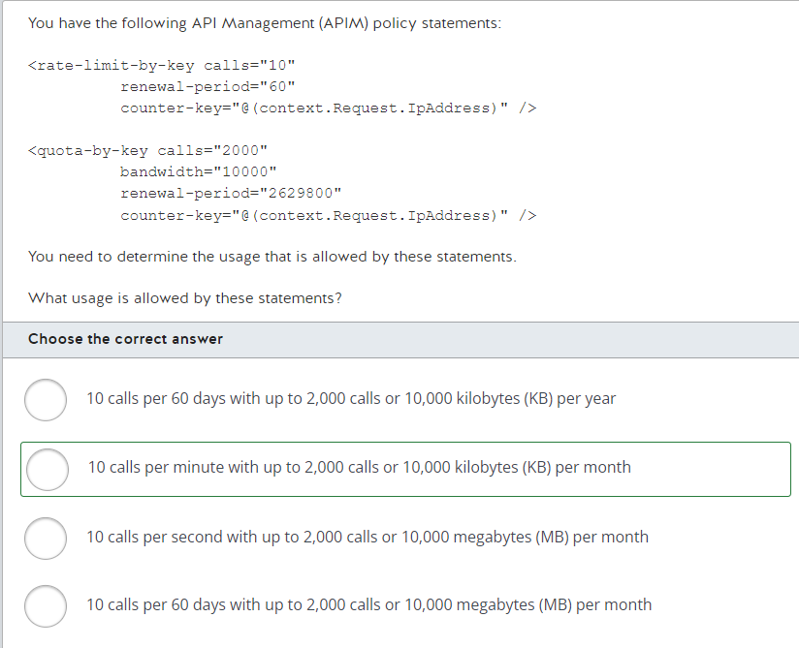

The policy statements allow 10 calls per minute with up to 2,000 calls or 10,000 KB per month. The rate-limit-by-key element allows you to control usage spikes by limiting the number of calls from a specified key during a specific number of seconds. The quota-by-key element allows you to enforce a renewable or lifetime call volume or bandwidth. By setting the calls attribute to 10, and the renewal-period attribute of the rate-limit-by-key element to 60, you allow up to 10 calls every 60 seconds. By setting the calls attribute to 2000, the bandwidth attribute to 10000, and the renewal-period attribute of the quota-by-key element to 2629800, you allow a call maximum of 2,000 or a bandwidth maximum of 10,000 KB every 2,629,800 seconds, or every month.  
  
**References**[Advanced request throttling with Azure API Management](https://docs.microsoft.com/en-us/azure/api-management/api-management-sample-flexible-throttling)[API Management access restriction policies](https://docs.microsoft.com/en-us/azure/api-management/api-management-access-restriction-policies)

**PREGUNTA 101**

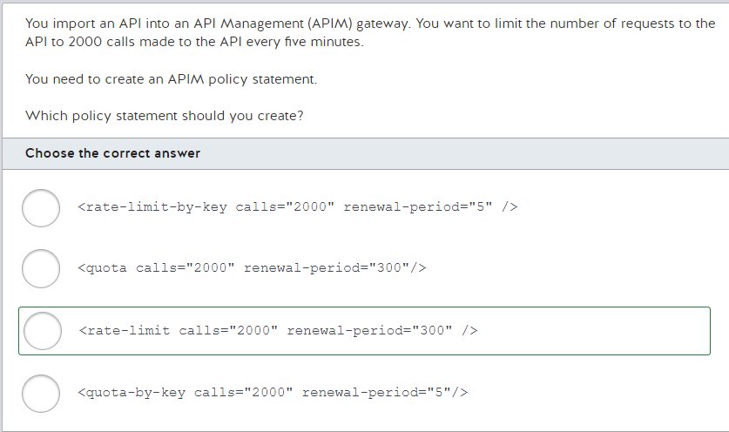

You should create the following policy statement:  
  
<rate-limit calls="2000" renewal-period="300" />  
  
This policy statement restricts calls to the API to 2000 calls every 300 seconds, or five minutes. The calls attribute specifies the number of calls allowed to the API, which is 2000. The renewal-period attribute specifies the number of seconds to which the calls attribute applies, which is 300.  
  
You should not create the following policy statement:  
  
<rate-limit-by-key calls="2000" renewal-period="5" />  
  
This policy statement restricts the total number of calls per second to the API based on a specific key, which must be specified with the counter-key attribute. The value of the renewal-period attribute is also wrong, because it specifies five seconds instead of 300 seconds.  
  
You should not create the following policy statement:  
  
<quota calls="2000" renewal-period="300"/>  
  
The quota element restricts the total number of API calls for a given time period. The renewal-period attribute cannot be set to less than 3600 seconds, or one hour.  
  
You should not create the following configuration:  
  
<quota-by-key calls="2000" renewal-period="5"/>  
  
The quota element restricts the total number of calls to the API based on a specific key, which must be specified with the counter-key attribute. The value of the renewal-period attribute is also wrong, because it specifies five seconds instead of 300 seconds.  
  
**References**[API Management access restriction policies](https://docs.microsoft.com/en-us/azure/api-management/api-management-access-restriction-policies)[Advanced request throttling with Azure API Management](https://docs.microsoft.com/en-us/azure/api-management/api-management-sample-flexible-throttling)[Tutorial: Transform and protect your API](https://docs.microsoft.com/en-us/azure/api-management/transform-api)

**PREGUNTA 102**

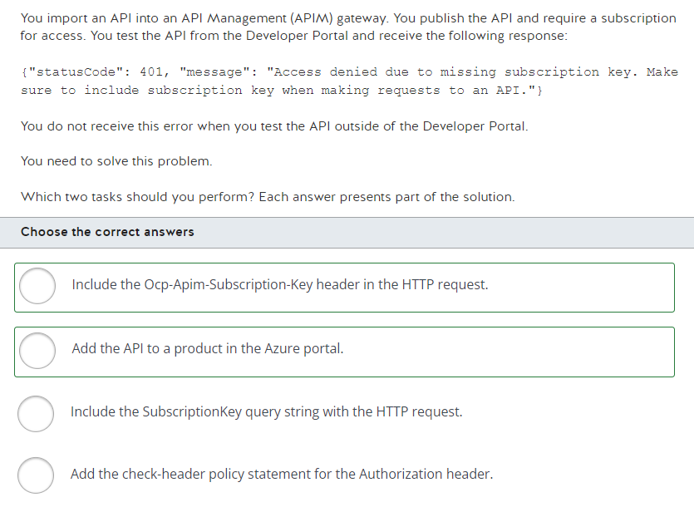

You should add the API to a product in the Azure portal. Every API must be part of a product before it can be consumed through APIM.  
  
You should also include the Ocp-Apim-Subscription-Key header in the HTTP request. This header must specify the subscription key assigned to you when you subscribe to the product. This allows APIM to determine whether or not the subscriber has permission to call a particular API.  
  
You should not include the SubscriptionKey query string with the HTTP request. APIM does not check for this query string when determining whether or not a subscriber has permission to call an API.  
  
You should not add the check-header policy statement for the Authorization header. This policy statement allows you to check for specific HTTP headers. The Authorization header is not required.  
  
**References**[API Management access restriction policies](https://docs.microsoft.com/en-us/azure/api-management/api-management-access-restriction-policies)[About API Management](https://docs.microsoft.com/en-us/azure/api-management/api-management-key-concepts)[Tutorial: Create and publish a product](https://docs.microsoft.com/en-us/azure/api-management/api-management-howto-add-products)

[Tutorial: Import and publish your first API](https://docs.microsoft.com/en-us/azure/api-management/import-and-publish)

**PREGUNTA 103**

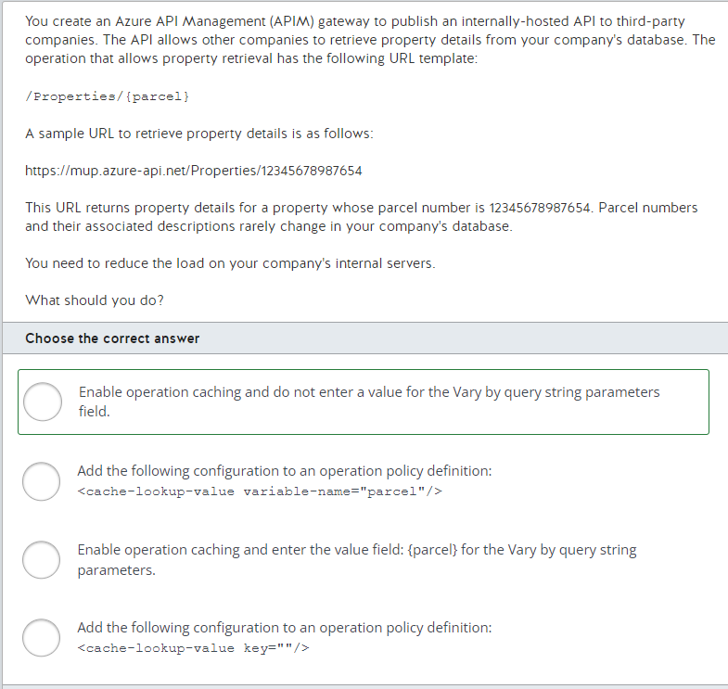

You should enable operation caching and do not enter a value for the Vary by query string parameters field, allowing the entire URL to be used to cache responses. When a URL is used to return data, subsequent responses for that same URL return data from the cache, reducing the load on the company's database servers.  
  
You should not specify {parcel} in the Vary by query string parameters field. In this scenario, the value represented by {parcel} is not a query string parameter. It is a component of the URL.  
  
You should not use either the following policy configurations:  
  
<cache-lookup-value key=""/>  
<cache-lookup-value variable-name="parcel"/>  
  
The cache-lookup-value element uses the key attribute to look up a specific key in the cache, and if it exists, it stores the key's value in a variable specified by the variable-name attribute. These two attributes must be used together.  
  
**References**[Tutorial: Mock API responses](https://docs.microsoft.com/en-us/azure/api-management/mock-api-responses)[Add caching to improve performance in Azure API Management](https://docs.microsoft.com/en-us/azure/api-management/api-management-howto-cache)  
[Custom caching in Azure API Management](https://docs.microsoft.com/en-us/azure/api-management/api-management-sample-cache-by-key)

**PREGUNTA 104**

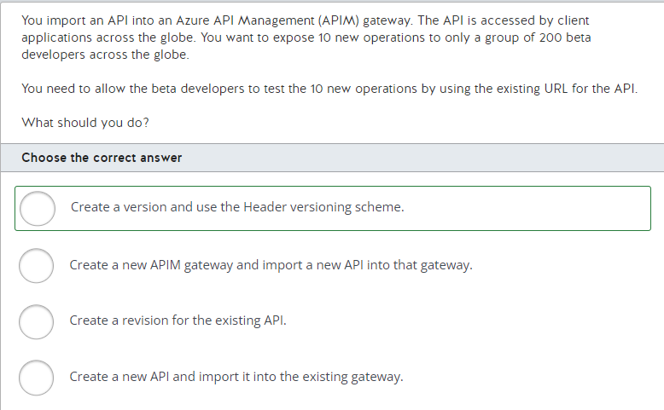

You should create a version in APIM and use the Header versioning scheme. This allows the 200 beta developers to continue using the same URL as before. The Header versioning scheme allows you to specify an HTTP header value that must be present to allow the developers to access the beta version with the 10 new operations.  
  
You should not create a revision for the existing API. A revision requires you to append a path to the original API endpoint, such as ;rev=2. However, you do not want the beta developers to have to change the URL used to access the API in this scenario.  
  
You should not create a new API and import it into the existing gateway. Each API in a gateway must have a unique endpoint.  
  
You should not create a new APIM gateway and import a new API into that gateway. Each APIM gateway must have a unique URL.  
  
**References**[Tutorial: Publish multiple versions of your API](https://docs.microsoft.com/en-us/azure/api-management/api-management-get-started-publish-versions)[Tutorial: Use revisions to make non-breaking changes safely](https://docs.microsoft.com/en-us/azure/api-management/api-management-get-started-revise-api)[About API Management](https://docs.microsoft.com/en-us/azure/api-management/api-management-key-concepts)

**PREGUNTA 105**

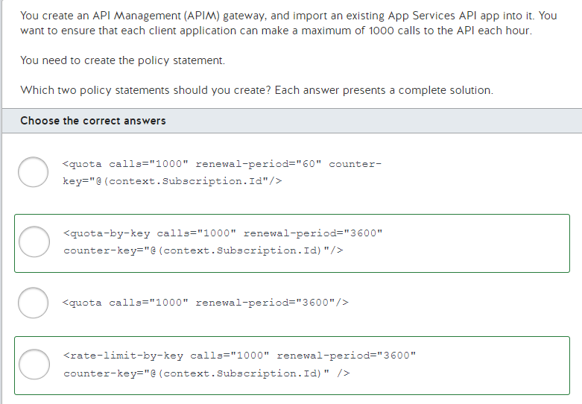

You should create the following policy statement:  
  
<quota-by-key calls="1000" renewal-period="3600" counter-key="@(context.Subscription.Id)"/>  
  
This statement restricts the total number of calls to the API based on a specific key, which is @(context.Subscription.Id) in this scenario. This represents the identifier of an individual subscriber.  
  
You can also create the following policy statement:  
  
<rate-limit-by-key calls="1000" renewal-period="3600" counter-key="@(context.Subscription.Id)" />  
  
This statement implements throttling based on a specific key, which is @(context.Subscription.Id) in this scenario. This represents the identifier of an individual subscriber. The rate-limit-by-key element is typically used in conjunction with the quota-by-key element to implement both throttling and usage quotas.  
  
You should not create the following policy statement:  
  
<quota calls="1000" renewal-period="3600"/>  
  
This statement restricts the total number of API calls for a given time period without taking into consideration a specific subscriber.  
  
You should not use the following policy statement:  
  
<quota calls="1000" renewal-period="60" counter-key="@(context.Subscription.Id"/>  
  
The counter-key attribute should only be used with the quota-by-key element. Also, the renewal-period attribute should specify the number of seconds, not minutes.  
  
**References**[API Management access restriction policies](https://docs.microsoft.com/bs-cyrl-ba/azure/api-management/api-management-access-restriction-policies)[Advanced request throttling with Azure API Management](https://docs.microsoft.com/en-us/azure/api-management/api-management-sample-flexible-throttling)[Tutorial: Transform and protect your API](https://docs.microsoft.com/en-us/azure/api-management/transform-api)

**PREGUNTA 106**

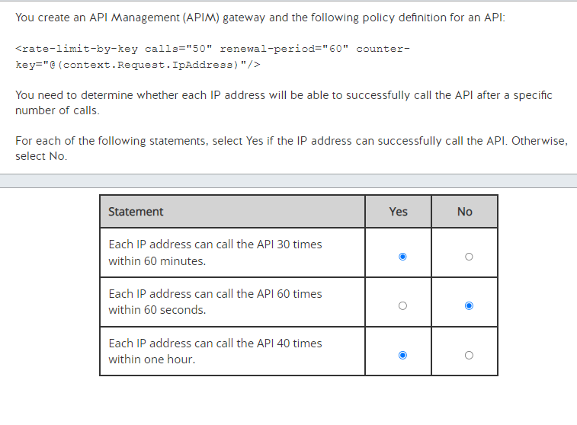

The policy statement in this scenario restricts the total number of calls per second to the API based on a specific key, which must be specified with the counter-key attribute. The key in this scenario is @( context.Request.IpAddress), which represents the IP address of the caller of the API. The calls attribute specifies the number of calls allowed to the API, which is 50. The renewal-period attribute specifies the number of seconds to which the calls attribute applies, which is 60, or one minute.  
  
Therefore, each IP address can call the API 30 times within 60 minutes. Each IP address cannot call the API 60 times within 60 seconds because it is limited to 50 calls. And each IP address can call the API 40 times within one hour.  
  
**References**[API Management access restriction policies](https://docs.microsoft.com/en-us/azure/api-management/api-management-access-restriction-policies)[Advanced request throttling with Azure API Management](https://docs.microsoft.com/en-us/azure/api-management/api-management-sample-flexible-throttling)[Tutorial: Transform and protect your API](https://docs.microsoft.com/en-us/azure/api-management/transform-api)

**PREGUNTA 107**

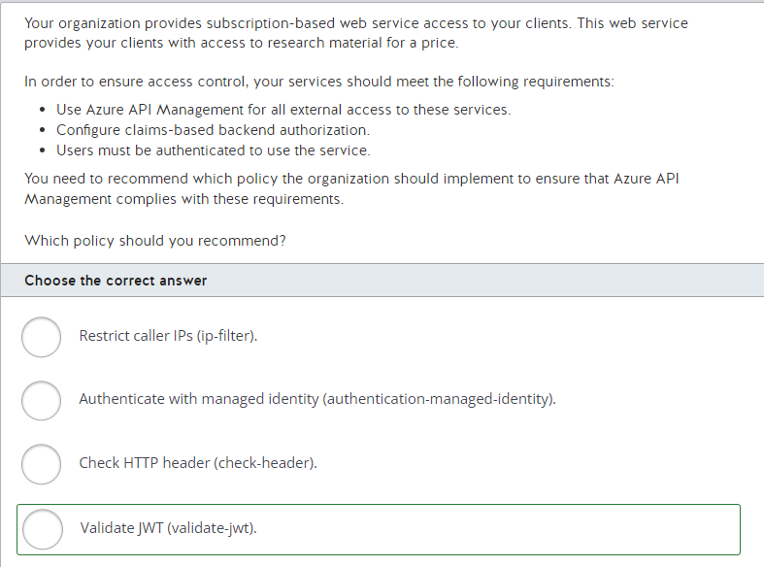

You should recommend the Validate JWT (validate-jwt) policy. You can use the Validate JWT policy to pre-authorize requests in API Management by validating the access tokens for each incoming request. The tokens carry claims that provide authorization to the incoming API requests.  
  
You should not recommend the Authenticate with managed identity (authentication-managed-identity) policy. You would use the authentication-managed-identity policy to authenticate with a backend service using the managed identity of the API Management service. This policy essentially uses the managed identity to obtain an access token from Azure Active Directory for accessing the specified resource. This policy cannot be used for user access control.  
  
You should not recommend the Check HTTP header (check-header) policy. You would use the check-header policy to enforce that a request has a specified HTTP header. You can optionally check to see if the header has a specific value or check for a range of allowed values. You cannot extract any claims information about the user from an HTTP header.  
  
You should not recommend the Restrict caller IPs (ip-filter) policy. The ip-filter policy filters (allows/denies) calls from specific IP addresses and/or address ranges. This type of policy will not authorize users by the claims they are carrying in their authentication token.  
  
**References**  
  
[API Management policy reference](https://docs.microsoft.com/en-us/azure/api-management/api-management-policies)  
  
[API Management access restriction policies](https://docs.microsoft.com/en-us/azure/api-management/api-management-access-restriction-policies)  
  
[Protect an API in Azure API Management using OAuth 2.0 authorization with Azure Active Directory](https://docs.microsoft.com/en-us/azure/api-management/api-management-howto-protect-backend-with-aad)  
  
[API Management authentication policies](https://docs.microsoft.com/en-us/azure/api-management/api-management-authentication-policies)

**PREGUNTA 108**

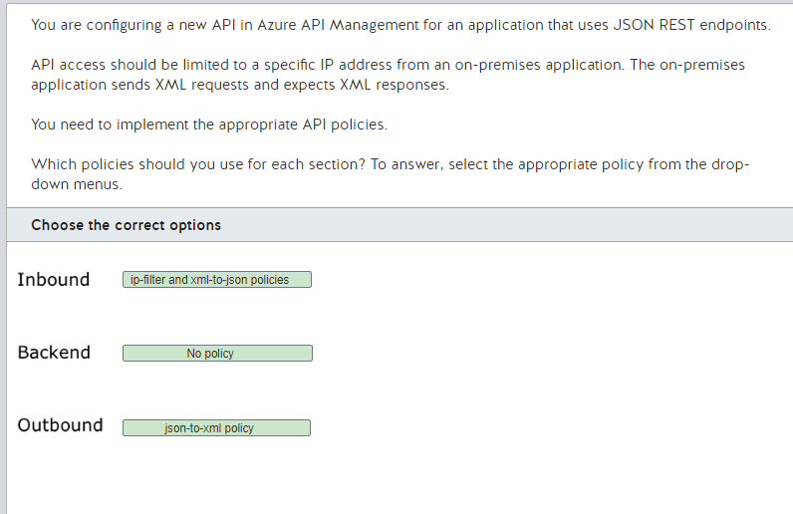

You should configure the ip-filter and xml-to-json policies in the inbound section. You can use the ip-filter policy to deny or allow calls from a specific IP address or address range. You also need to convert the incoming request from XML to JSON with the xml-to-json policy because the REST application you are configuring accepts JSON. Both policies need to be configured in this section.  
  
You should configure none of the policies in the backend section. You can use this section to configure policies such as the set-header policy to modify the HTTP request headers or the set-query-parameter policy to change the HTTP query string parameter. The xml-to-json policy is only applicable to the inbound, outbound, and on-error sections.  
  
You should configure the json-to-xml policy in the output section. This policy will convert the REST application responses from JSON to XML before sending them to the on-premises application.  
  
You should not use the json-to-xml policy in the inbound section and the xml-to-json policy in the outbound section. You need to convert a XML request to JSON and convert a JSON response to XML, however you do not need to convert a JSON request to XML or an XML response to JSON.  
  
**References**  
  
[Policies in Azure API Management](https://docs.microsoft.com/en-us/azure/api-management/api-management-howto-policies)  
  
[API Management access restriction policies](https://docs.microsoft.com/en-us/azure/api-management/api-management-access-restriction-policies)  
  
[API Management transformation policies](https://docs.microsoft.com/en-us/azure/api-management/api-management-transformation-policies)

**PREGUNTA 109**

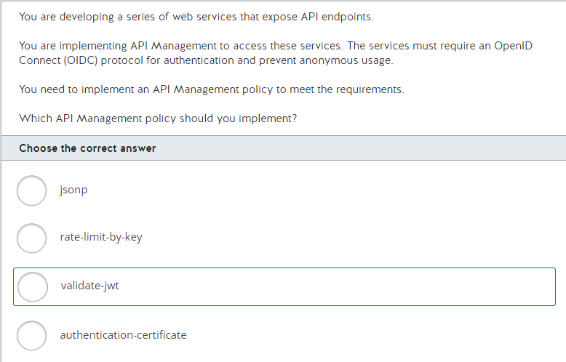

You should use the validate-jwt policy. This policy enforces the existence and validity of a JSON Web Token (JWT) extracted from a specified HTTP Header or a specified query parameter. The JWT is used by the back-end of the web service to authenticate with OIDC.  
  
You should not use the jsonp policy. The jsonp policy adds JSON with padding (JSONP) support to allow cross-domain calls from JavaScript browser-based clients to an API. JSONP uses the <script> tag instead of the XMLHttpRequest object to perform cross-domain JSON requests.  
  
You should not use the authentication-certificate policy. This policy is used to authenticate with a back-end service using a client certificate pre-installed in API Management. The certificate is identified by its thumbprint.  
  
You should not use the rate-limit-by-key policy. This policy prevents API spikes usage on a per-key basis by limiting the call rate to a specified number in a specified time period.  
  
**References**  
  
[Protect an API in Azure API Management using OAuth 2.0 authorization with Azure Active Directory](https://docs.microsoft.com/en-us/azure/api-management/api-management-howto-protect-backend-with-aad)  
  
[API Management access restriction policies](https://docs.microsoft.com/en-us/azure/api-management/api-management-access-restriction-policies)  
  
[API Management cross domain policies](https://docs.microsoft.com/en-us/azure/api-management/api-management-cross-domain-policies)  
  
[API Management authentication policies](https://docs.microsoft.com/en-us/azure/api-management/api-management-authentication-policies)  
  
[Microsoft identity platform and OpenID Connect protocol](https://docs.microsoft.com/en-us/azure/active-directory/develop/v2-protocols-oidc)

**PREGUNTA 110**

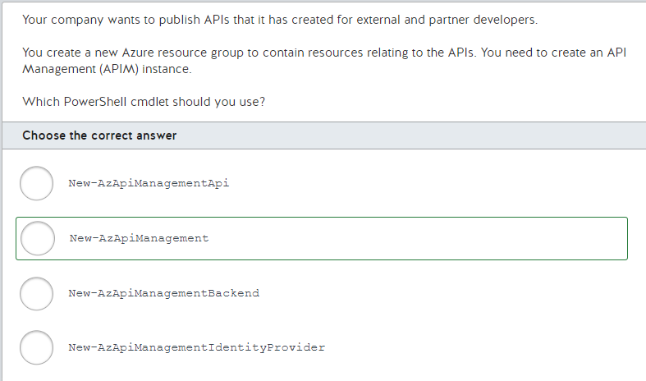

You should use the New-AzApiManagement cmdlet. This cmdlet lets you create an APIM instance that you will use as the base for publishing your API. APIs are added to products to which developers subscribe.  
  
You should not use the New-AzApiManagementIdentityProvider cmdlet. This cmdlet is used to create an Identity Provider on the Developer Portal of the APIM service. This is one of the components you would create after creating the APIM service.  
  
You should not use the New-AzApiManagementApi cmdlet. This cmdlet is used to create an API in an APIM instance based on a source API.  
  
You should not use the New-AzApiManagementBackend cmdlet. This cmdlet is used to create a new back-end entity in an existing APIM service.  
  
**References**  
  
[About API Management](https://docs.microsoft.com/en-us/azure/api-management/api-management-key-concepts)  
  
[Quickstart: Create a new Azure API Management service instance by using PowerShell](https://docs.microsoft.com/en-us/azure/api-management/powershell-create-service-instance)  
  
[New-AzApiManagement](https://docs.microsoft.com/en-us/powershell/module/az.apimanagement/new-azapimanagement?view=azps-4.1.0)  
  
[New-AzApiManagementIdentityProvider](https://docs.microsoft.com/en-us/powershell/module/az.apimanagement/new-azapimanagementidentityprovider?view=azps-4.1.0)  
  
[New-AzApiManagementApi](https://docs.microsoft.com/en-us/powershell/module/az.apimanagement/new-azapimanagementapi?view=azps-4.1.0)  
  
[New-AzApiManagementBackend](https://docs.microsoft.com/en-us/powershell/module/az.apimanagement/new-azapimanagementbackend?view=azps-4.1.0)

**PREGUNTA 111**

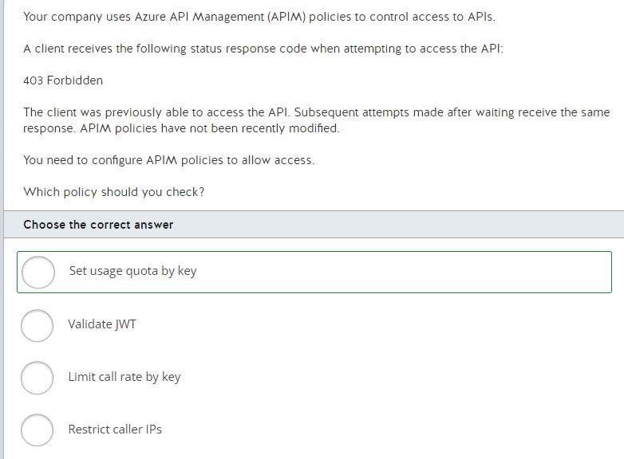

You should check the Set usage quota by key policy. This policy can set an access quota based on renewable or lifetime call volume on bandwidth. When the quota is exceeded, a 403 Forbidden status response code is returned.  
  
You should not check the Restrict caller IPs policy. This is used to allow or restrict access for individual IP addresses or a range of addresses. There is nothing to indicate that this is the problem.  
  
You should not check the Limit call rate by key policy. This policy is used to prevent traffic spikes by limiting the call rate. If access is blocked by this policy, a 429 Too Many Requests status response code is returned.  
  
You should not check the Validate JWT policy. This policy enforces the existence and validity of a JSON web token (JWT) extracted from either a specified query parameter or a specified HTTP Header. There is nothing in the symptoms to indicate that this is the problem.  
  
**References**  
  
[API Management policy reference](https://docs.microsoft.com/en-us/azure/api-management/api-management-policies)  
  
[API Management access restriction policies](https://docs.microsoft.com/en-us/azure/api-management/api-management-access-restriction-policies)  
  
[Policies in Azure API Management](https://docs.microsoft.com/en-us/azure/api-management/api-management-howto-policies)

**PREGUNTA 112**

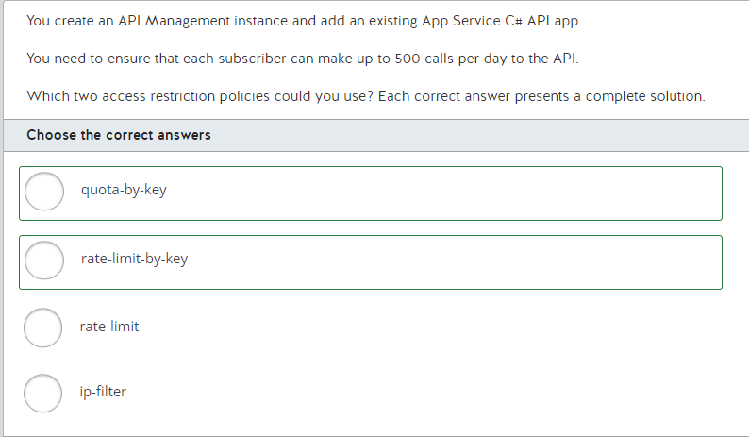

You could use the quota-by-key policy. This policy restricts the total number of calls to the API based on a specific key. You can use the @(context.Subscription.Id) key, which represents the identifier of an individual subscriber.  
  
You could also use the rate-limit-by-key policy. This policy implements throttling based on a specific key, which can be set to @(context.Subscription.Id) to represent a subscriber. You can use rate-limit-by-key and quota-by-key to implement both throttling and usage quotas.  
  
You could not use the rate-limit policy. The rate-limit policy, also referred to as limit call rate by subscription, restricts calls to the API by using throttling without considering which subscribers are calling the API. It is used to prevent API usage spikes on a per subscription basis.  
  
You could not use the ip-filter policy. This policy restricts calls to the API based on an IP address or a range of IP addresses.  
  
**References**  
  
[API Management access restriction policies](https://docs.microsoft.com/en-us/azure/api-management/api-management-access-restriction-policies)  
  
[Advanced request throttling with Azure API Management](https://docs.microsoft.com/en-us/azure/api-management/api-management-sample-flexible-throttling)

**PREGUNTA 113**

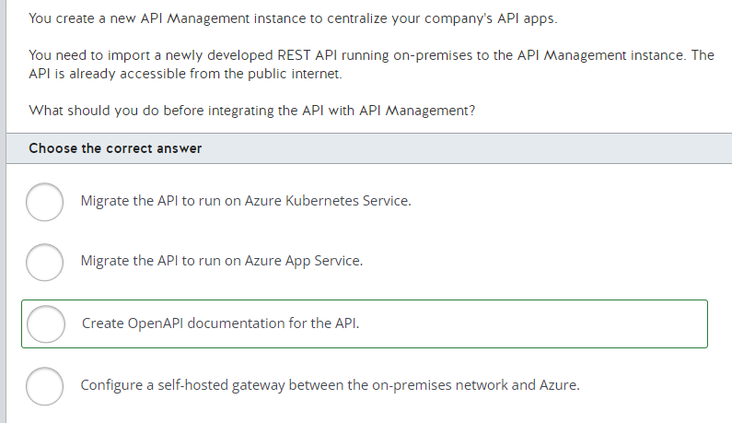

You should create OpenAPI documentation for the API. To import an API to API Management, you can use the OpenAPI Specification to discover all API endpoints from a REST API. You can define an OpenAPI Specification to define a schema for a REST API application, including all endpoints and possible responses from a given API.  
  
You should not migrate the API to run on Azure App Service or Azure Kubernetes Service. You do not need to migrate the API to Azure to integrate it with API Management. You can import APIs to an API Management instance that is deployed outside your Azure subscription, including APIs hosted on-premises or in other cloud providers, as long as the API Management service has network connectivity with it.  
  
You should not configure a self-hosted gateway between the on-premises network and Azure. You can use a self-hosted gateway to connect with APIs hosted in private on-premises networks by deploying an agent to intermediate for the API calls. You do not need to implement it in this case because the REST API is already accessible from the public internet.  
  
**References**  
  
[The OpenAPI Specification Explained](https://oai.github.io/Documentation/specification.html)  
[Tutorial: Import and publish your first API](https://docs.microsoft.com/en-us/azure/api-management/import-and-publish)  
  
[Discover the API Management service](https://docs.microsoft.com/en-us/learn/modules/explore-api-management/2-api-management-overview)  
  
[Self-hosted gateway overview](https://docs.microsoft.com/en-us/azure/api-management/self-hosted-gateway-overview)

**PREGUNTA 114**

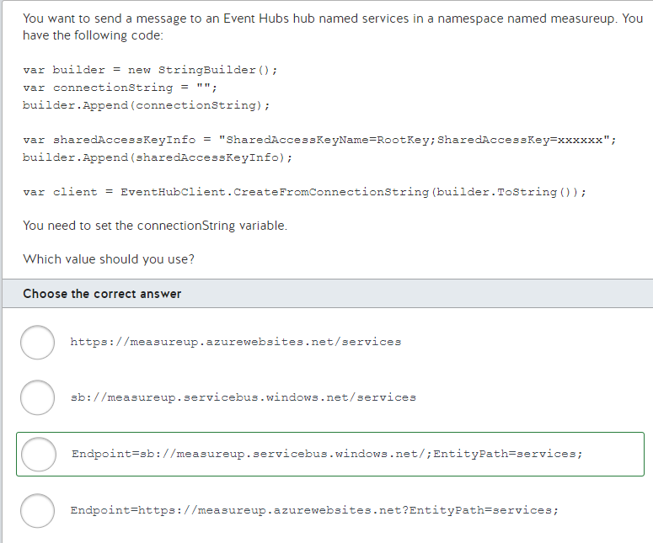

You should use the following URL:  
  
Endpoint=sb://measureup.servicebus.windows.net/;EntityPath=services;  
  
The Endpoint property specifies the Event Hubs namespace, which is a URL. The protocol for an Event Hubs namespace is sb. The host name is the name of the namespace, which is measureup in this scenario. The remainder of the URL is servicebus.windows.net. The EntityPath property specifies the name of the actual Event Hubs hub, which is services in this scenario.  
  
You should not use the following value:  
  
https://measureup.azurewebsites.net/services  
  
This value represents the endpoint for an Azure App Services app.  
  
You should not use the following value:  
  
Endpoint=https://measureup.azurewebsites.net?EntityPath=services;  
  
This value uses https as the protocol, which is incorrect. It should use sb instead.  
  
You should not use the following value:  
  
sb://measureup.servicebus.windows.net/services  
  
This value does not specify Endpoint and EntityPath, which are required.  
  
**References**[Send events to and receive events from Azure Event Hubs - .NET (Azure.Messaging.EventHubs)](https://docs.microsoft.com/en-us/azure/event-hubs/event-hubs-dotnet-standard-getstarted-send)

**PREGUNTA 115**

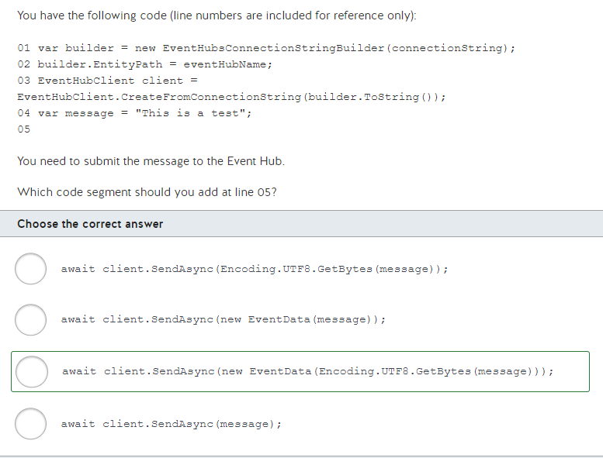

You should use the following code segment:  
  
await client.SendAsync(new EventData(Encoding.UTF8.GetBytes(message)));  
  
The SendAsync method accepts an EventData instance that represents the data to be submitted. The EventData constructor accepts a byte array that represents the message. To convert the message from a string to a byte array, you call the Encoding.UTF8.GetBytes method.  
  
You should not use the following code:  
  
await client.SendAsync(message);  
  
You must pass an EventData instance to the SendAsync method.  
  
You should not use the following code:  
  
await client.SendAsync(Encoding.UTF8.GetBytes(message));  
  
You must pass an EventData instance to the SendAsync method.  
  
You should not use the following code:  
  
await client.SendAsync(new EventData(message));  
  
You must pass a byte array to the EventData constructor.  
  
**References**[Send events to and receive events from Azure Event Hubs - .NET (Azure.Messaging.EventHubs)](https://docs.microsoft.com/en-us/azure/event-hubs/event-hubs-dotnet-standard-getstarted-send)

**PREGUNTA 116**

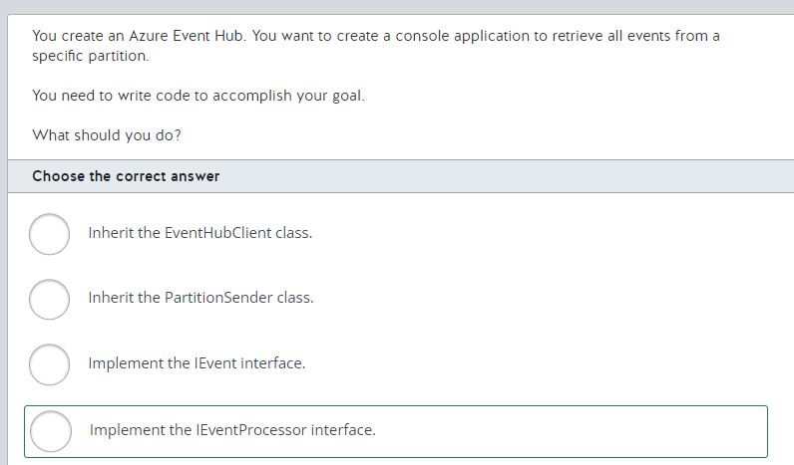

You should implement the IEventProcessor interface. This interface defines a method named ProcessEventAsync that passes a collection of EventData instances representing the messages in the Event Hub.  
  
You should not inherit the EventHubClient class. This class allows you to send messages to an Event Hub.  
  
You should not implement the IEvent interface. This interface represents a Windows Management Instrumentation (WMI) event, not an Azure Event Hubs event.  
  
You should not inherit the PartitionSender class. This class allows you to send messages to a specific partition in an Event Hub.  
  
**References**[Send events to and receive events from Azure Event Hubs - .NET (Azure.Messaging.EventHubs)](https://docs.microsoft.com/en-us/azure/event-hubs/event-hubs-dotnet-standard-getstarted-receive-eph)[PartitionSender.SendAsync Method](https://docs.microsoft.com/en-us/dotnet/api/microsoft.azure.eventhubs.partitionsender.sendasync)[IEvent Interface](https://docs.microsoft.com/en-us/dotnet/api/system.management.instrumentation.ievent)

**PREGUNTA 117**

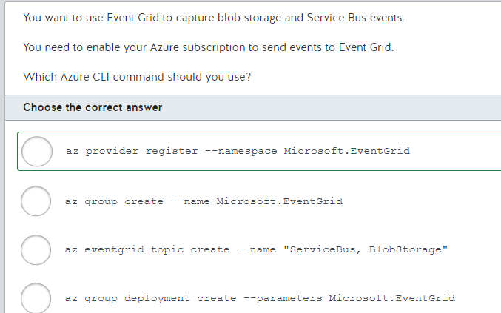

You should use the following command:  
  
az provider register --namespace Microsoft.EventGrid  
  
This command registers the Event Grid resource provider for use with your subscription. This allows resources in your subscription to send events to Event Grid.  
  
You should not use the following command:  
  
az group deployment create --parameters Microsoft.EventGrid  
  
The az group deployment create command deploys a template to a resource group. This does not allow your subscription to send events to Event Grid.  
  
You should not use the following command:  
  
az group create --name Microsoft.EventGrid  
  
The az group create command creates a resource group. It does not register the Event Grid resource provider.  
  
You should not use the following command:  
  
az eventgrid topic create --name "ServiceBus, BlobStorage"  
  
The az eventgrid topic create command creates an Event Grid topic to which you can send events. It does not register the Event Grid resource provider.  
  
**References**[Quickstart: Route custom events to web endpoint with Azure CLI and Event Grid](https://docs.microsoft.com/en-us/azure/event-grid/custom-event-quickstart)

**PREGUNTA 118**

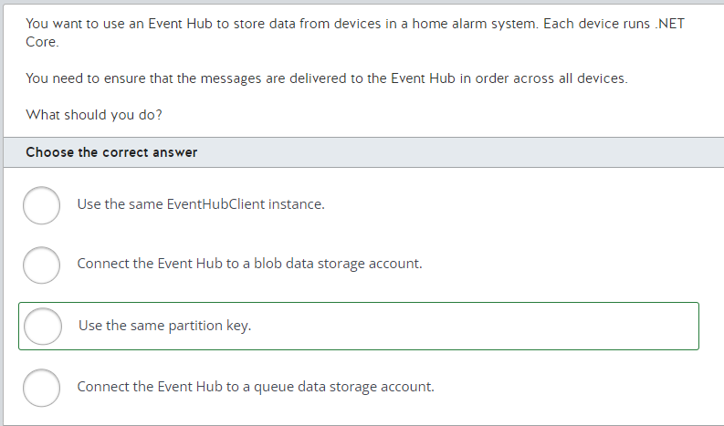

You should use the same partition key. A partition key ensures that messages that are delivered to the same hub and the same partition are delivered in order.  
  
You should not connect the Event Hub to a queue data storage account. This has no effect on delivering messages to an Event Hub. A queue storage account allows you to store data in a first-in, first-out (FIFO) pattern.  
  
You should not connect the Event Hub to a blob data storage account. This has no effect on delivering messages to an Event Hub. A blob data storage account allows you to store unstructured data in the cloud.  
  
You should not use the same EventHubClient instance. EventHubClient allows you to send messages to an Event Hub. However, in this scenario, each device runs .NET Core, so the code on each device must have its own copy of EventHubClient.  
  
**References**[Features and terminology in Azure Event Hubs](https://docs.microsoft.com/en-us/azure/event-hubs/event-hubs-features)[Introduction to Azure Storage](https://docs.microsoft.com/en-us/azure/storage/common/storage-introduction)

**PREGUNTA 119**

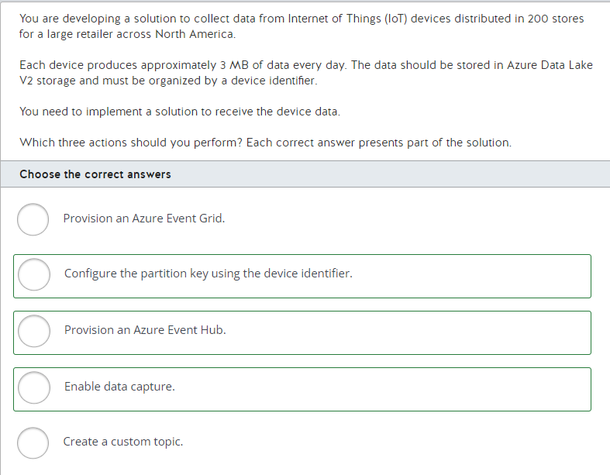

You should provision an Azure Event Hub. Azure Event Hubs is a managed streaming platform and event ingestion service with the capacity to process millions of events per second. You can use Event Hubs to receive the data from IoT devices.  
  
You should also configure the partition key using the device identifier. You can define a partition key when you send data to Event Hubs. Event Hub uses the partition key to organize and store events in a specific partition.  
  
Finally, you should enable data capture. Event Hubs Capture allows you to deliver streaming data in Event Hubs to Azure Blob storage or Azure Data Lake Storage. You can configure the data capture to Azure Data Lake Storage Gen2 and use the partition key to organize the data by device.  
  
You should not provision an Azure Event Grid or create a custom topic. You can use Azure Event Grid to implement event-based applications that handle events from Azure services or events from your own applications. To send events from your own application to Event Grid, you need to create a custom topic and push the events to it.  
  
**References**  
  
[Azure Event Hubs — A big data streaming platform and event ingestion service](https://docs.microsoft.com/en-us/azure/event-hubs/event-hubs-about)  
  
[Features and terminology in Azure Event Hubs](https://docs.microsoft.com/en-us/azure/event-hubs/event-hubs-features)  
  
[Enable capturing of events streaming through Azure Event Hubs](https://docs.microsoft.com/en-us/azure/event-hubs/event-hubs-capture-enable-through-portal)  
  
[Choose between Azure messaging services - Event Grid, Event Hubs, and Service Bus](https://docs.microsoft.com/en-us/azure/event-grid/compare-messaging-services)  
  
[What is Azure Event Grid?](https://docs.microsoft.com/en-us/azure/event-grid/overview)

**PREGUNTA 120**

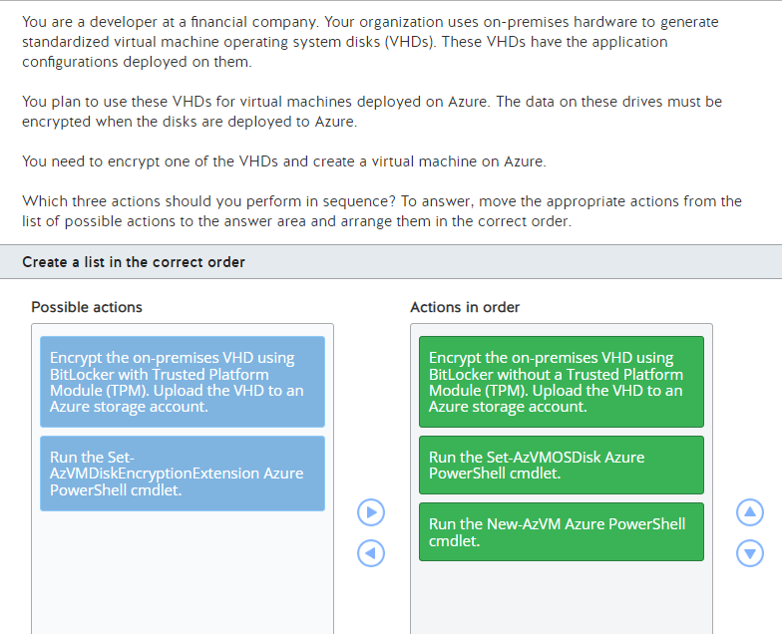

You should perform these steps in sequence:

1. Encrypt the on-premises VHD using BitLocker without a TPM. Upload the VHD to an Azure storage account.
2. Run the Set-AzVMOSDisk Azure PowerShell command.
3. Run the New-AzVM Azure PowerShell command.

You should first encrypt the VHD using BitLocker without a TPM. BitLocker can work with or without a TPM. A TPM is a chip on a physical computer's motherboard, which a virtual machine would not have. Virtual machines do not support TPM disk images.  
  
Once the VHDs are encrypted, you can set them to be the operating system disk in the virtual machine configuration using the Set-AzVMOSDisk cmdlet and then create a virtual machine using that configuration object using the New-AzVM cmdlet.  
  
You should not execute the Set-AzVMDiskEncryptionExtension cmdlet. This disk has already been encrypted before being attached to a virtual machine. The Set-AzVMDiskEncryptionExtension cmdlet is used to encrypt an already running virtual machine on Azure.  
  
You should not use the TPM option with BitLocker. You do not want the VHD to be associated with the hardware where it was encrypted. Virtual machines do not support TPM disk images.  
  
**References**[What is a TPM, and Why Does Windows Need One For Disk Encryption?](https://www.howtogeek.com/237232/what-is-a-tpm-and-why-does-windows-need-one-for-disk-encryption/)  
  
[Set-AzVMDiskEncryptionExtension](https://docs.microsoft.com/en-us/powershell/module/az.compute/set-azvmdiskencryptionextension?view=azps-3.6.1)  
  
[Set-AzVMOSDisk](https://docs.microsoft.com/en-us/powershell/module/az.compute/set-azvmosdisk?view=azps-3.6.1)

**PREGUNTA 121**

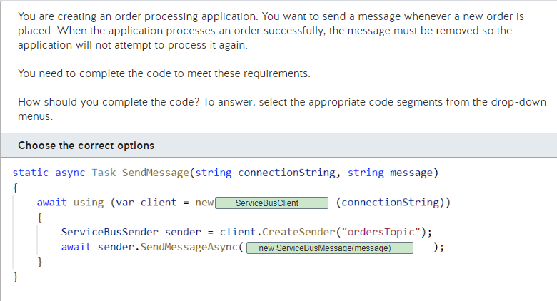

You should use the following code:  
  
static async Task SendMessage(string connectionString, string message)  
{  
    await using (var client = new ServiceBusClient(connectionString))  
    {  
        ServiceBusSender sender = client.CreateSender("ordersTopic");  
        await sender.SendMessageAsync(new ServiceBusMessage(message));  
    }  
}  
  
This code uses the ServiceBusClient class to send a message to a Service Bus queue. A Service Bus queue allows you to create a sender for a specific queue or topic. The SendMessageAsync method of the sender object accepts a ServiceBusMessage instance, which represents the message being sent. The Message constructor accepts a string representing the message.  
  
You should not create an instance of the EventHubProducerClient class. This class represents a connection to an event hub, not a Service Bus queue. You need to use a Service Bus queue because the message should be removed from the queue after it is processed successfully.  
  
You should not use the message option to pass a string as an argument to the SendMessageAsync method. You must wrap the string in a ServiceBusMessage instance.  
  
You should not pass an EventData instance to the SendMessageAsync method. The EventData instance represents an event sent to an event hub, not a Service Bus queue.  
  
**References**[Service Bus queues, topics, and subscriptions](https://docs.microsoft.com/en-us/azure/service-bus-messaging/service-bus-queues-topics-subscriptions)[Get started with Azure Service Bus topics and subscriptions (.NET)](https://docs.microsoft.com/en-us/azure/service-bus-messaging/service-bus-dotnet-how-to-use-topics-subscriptions) [Features and terminology in Azure Event Hubs](https://docs.microsoft.com/en-us/azure/event-hubs/event-hubs-features)

**PREGUNTA 122**

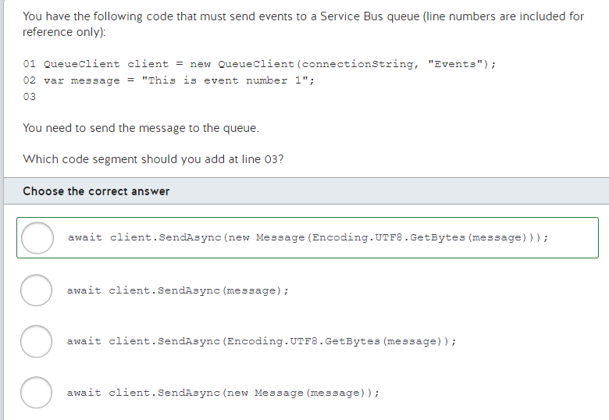

You should use the following code:  
  
await client.SendAsync(new Message(Encoding.UTF8.GetBytes(message)));  
  
The SendAsync method accepts a Message instance representing the data to be submitted. The Message constructor accepts a byte array that represents the message. To convert the message from a string to a byte array, you call the Encoding.UTF8.GetBytes method.  
  
You should not use the following code:  
  
await client.SendAsync(message);  
  
To meet the requirements, you must pass a Message instance to the SendAsync method.  
  
You should not use the following code:  
  
await client.SendAsync(Encoding.UTF8.GetBytes(message));  
  
To meet the requirements, you must pass a Message instance to the SendAsync method.  
  
You should not use the following code:  
  
await client.SendAsync(new Message(message));  
  
To meet the requirements, you must pass a byte array to the Message constructor.  
  
**References**[Get started with Azure Service Bus queues (.NET)](https://docs.microsoft.com/en-us/azure/service-bus-messaging/service-bus-dotnet-get-started-with-queues)

**PREGUNTA 123**

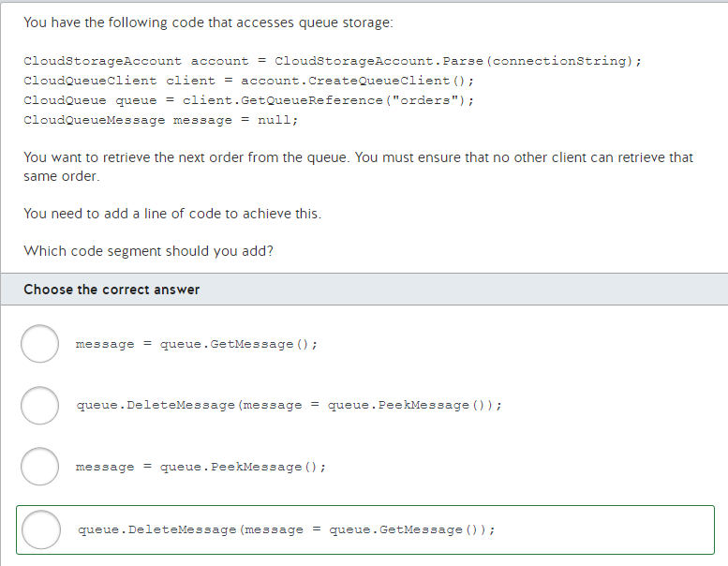

You should use the following code:  
  
queue.DeleteMessage(message = queue.GetMessage());  
  
This code first calls GetMessage to de-queue the next order from the queue. When this method is called, no other code can access that order. The order stays invisible for 30 seconds by default to ensure that the order can still be de-queued if there is a software or hardware failure. The DeleteMessage method then removes the order from the queue.  
  
You should not use the following code segment:  
  
queue.DeleteMessage(message = queue.PeekMessage());  
  
The PeekMessage method does not de-queue the next order from the queue. It peeks at the message, which allows code to view the next message without retrieving it. The message remains available for other clients to retrieve.  
  
You should not use the following code segment:  
  
message = queue.GetMessage();  
  
This code does not remove the message after retrieving it. It only retrieves it.  
  
You should not use the following code segment:  
  
message = queue.PeekMessage();  
  
This code does not retrieve or remove the message. It peeks at the message, which allows code to view the next message without retrieving it. The message remains available for other clients to retrieve.  
  
**References**[Get started with Azure Queue Storage using .NET](https://docs.microsoft.com/en-us/azure/storage/queues/storage-dotnet-how-to-use-queues)

**PREGUNTA 124**

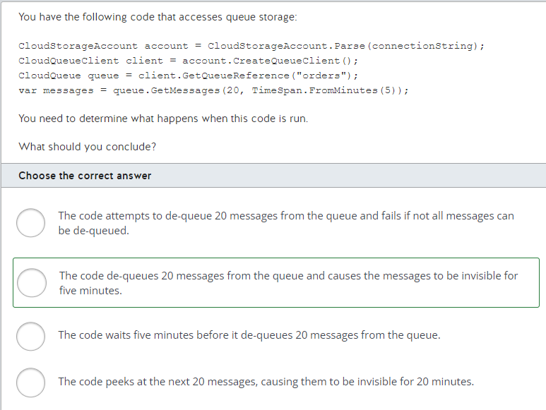

In the code provided, the GetMessages(20, TimeSpan.FromMinutes(5)); method retrieves the specified number of messages from the Azure Storage queue using the specified request options and operation context. The second parameter specifies the time during which the messages should remain invisible to other clients. In its generic form, the GetMessage method is represented as GetMessages (int messageCount, TimeSpan? visibilityTimeout = default, Microsoft.Azure.Storage.Queue.QueueRequestOptions options = default, Microsoft.Azure.Storage.OperationContext operationContext = default). In this scenario, this code de-queues 20 messages from the queue, and causes the messages to be invisible for a total period of five minutes.  
  
This code does not attempt to de-queue 20 messages from the queue and fails if not all messages can be de-queued. Rather the two parameters for GetMessages are messageCount (messages to retrieve) and visibilityTimeout (a timespan which specifies the visibility timeout interval).  
  
This code does not wait five minutes before it de-queues 20 messages from the queue. Rather the two parameters for GetMessages are messageCount (messages to retrieve) and visibilityTimeout (a timespan which specifies the visibility timeout interval).  
  
This code does not peek or hide the next 20 messages. The first parameter to GetMessages specifies the number of messages to de-queue. The second parameter specifies the time during which the messages should remain invisible to other clients.  
  
**References**[CloudQueue.GetMessages(Int32, Nullable<TimeSpan>, QueueRequestOptions, OperationContext) Method](https://docs.microsoft.com/en-us/dotnet/api/microsoft.azure.storage.queue.cloudqueue.getmessages?view=azure-dotnet)[Get started with Azure Queue storage using .NET](https://docs.microsoft.com/en-us/azure/storage/queues/storage-dotnet-how-to-use-queues)

**PREGUNTA 125**

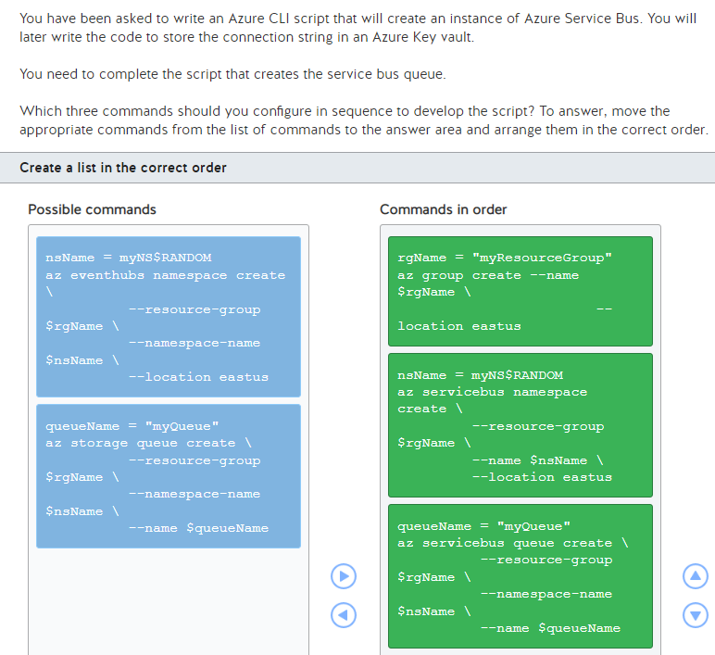

You should complete the script as follows:  
  
rgName = "myResourceGroup"  
az group create --name $rgName --location eastus  
  
nsName = myNS$RANDOM  
az servicebus namespace create --resource-group $rgName --name $nsName --location eastus  
  
queueName = "myQueue"  
az servicebus queue create --resource-group $rgName --namespace-name $nsName --name $queueName  
  
You should first create the resource group using the az group create command. You should then use the az servicebus namespace create command to create a namespace for the queue. The namespace is the container where the queues will reside. Finally, you should use the az servicebus queue create command to create the queue inside the namespace.  
  
You should not use az storage queue create. You would use this command if you wanted to create a queue inside of a storage account. In this case you want to create the queue for the service bus resource.  
  
You should not use az eventhubs namespace create. You would use this command to create namespaces for eventhubs. You cannot host a service bus queue within an eventhubs namespace.  
  
**References**  
  
[Use the Azure CLI to create a Service Bus namespace and a queue](https://docs.microsoft.com/en-us/azure/service-bus-messaging/service-bus-quickstart-cli)  
  
[az eventhubs namespace](https://docs.microsoft.com/en-us/cli/azure/eventhubs/namespace?view=azure-cli-latest)

**PREGUNTA 126**

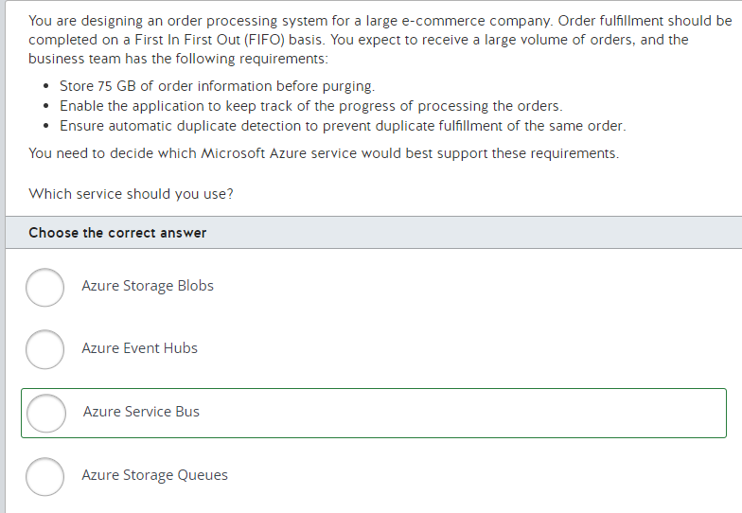

You should use Azure Service Bus. Azure Service Bus provides a queuing feature, which ensures First In First Out (FIFO) logic. The size of the data does not exceed 80 GB, which makes Azure Service Bus the right service to implement the queue logic. Azure Service Bus also provides support for automatic duplicate detection.  
  
You should not use Azure Storage Queues. Azure Storage Queues do not guarantee ordering for messages, and do not provide FIFO logic.  
  
You should not use Azure Storage Blobs. Azure Storage Blobs are ideal for storing and accessing large volumes of messages, but they are not designed to be queues. FIFO capability is not available with blobs.  
  
You should not use Event Hubs. Event hubs provide queuing and can provide processing capabilities for high volumes of data, but they are not suitable for batching large volumes of data. Event hubs also do not guarantee the sequence of processing for FIFO logic.  
  
**References**  
  
[Storage queues and Service Bus queues - compared and contrasted](https://docs.microsoft.com/en-us/azure/service-bus-messaging/service-bus-azure-and-service-bus-queues-compared-contrasted)

**PREGUNTA 127**

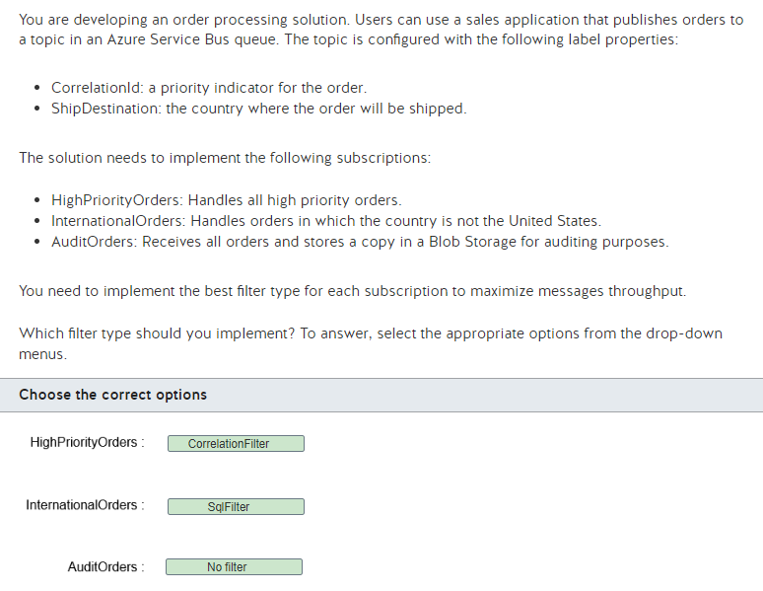

You should implement a CorrelationFilter for the HighPriorityOrders subscription to filter messages based on a set of conditions that are matched against one or more properties. You can use the CorrelationId defined in the message to match messages for this subscription. Correlation filters are preferred because they are more efficient than SQL filters in processing, and they have less impact on throughput.  
  
You should implement a SqlFilter for the InternationalOrders subscription. You must use a SQL-like conditional expression to filter messages in which the ShipDestination is not United States.  
  
You should implement no filter for the AuditOrders subscription. This subscription receives all orders published in the topic, and you do not need to implement any type of filter.  
  
You should not implement a TrueFilter or FalseFilter in this scenario. You can use these filters to filter messages based on Boolean conditions in the messages properties.  
  
**References**  
  
[Topic filters and actions](https://docs.microsoft.com/en-us/azure/service-bus-messaging/topic-filters)

**PREGUNTA 128**

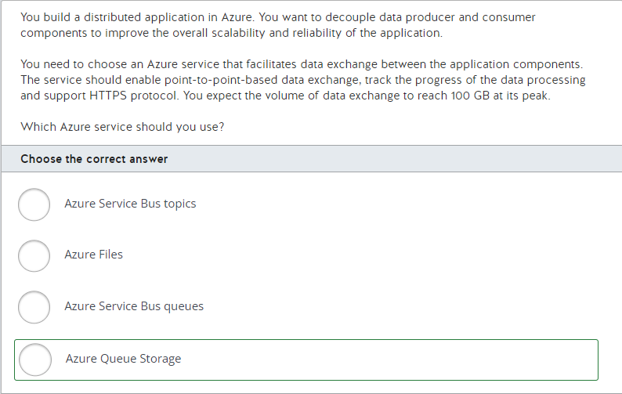

You should use Azure Queue Storage. Azure Queue Storage is a core Azure Storage service that facilitates data exchange between your application components in a point-to-point connection via HTTPS protocol. Azure Queue Storage can handle large volumes of data messages (up to 500 TB) and tracks the progress of the data processing in the queue.  
  
You should not use Azure Files. Azure Files is also a core Azure Storage service, but it is not designed to support data exchange between app components and it does not track the progress of message processing. Azure Files enables cloud file shares using SMB (Server Message Block) protocol.  
  
You should not use Azure Service Bus topics or Azure Service Bus queues. Both are Azure Service Bus offerings that support HTTPS protocol. Azure Service Bus queues are intended for point-to-point connections, while Azure Service Bus topics work in a one-to-many scenario where the publisher can insert a message about a topic in order for topic subscribers to receive that message. However, both the queue and topic features in Azure Service Bus cannot store more than 80 GB of messages.  
  
**References**  
  
[What is Azure Queue Storage?](https://docs.microsoft.com/en-us/azure/storage/queues/storage-queues-introduction)  
  
[What is Azure Files?](https://docs.microsoft.com/en-us/azure/storage/files/storage-files-introduction)[What is Azure Service Bus?](https://docs.microsoft.com/en-us/azure/service-bus-messaging/service-bus-messaging-overview)  
  
[Storage queues and Service Bus queues - compared and contrasted](https://docs.microsoft.com/en-us/azure/service-bus-messaging/service-bus-azure-and-service-bus-queues-compared-contrasted)